Joining Rittal management from 01.10.22: Philipp Guth
Corporate Communications
Dr Carola Hilbrand
Phone: +49 2772 505- 2527
E-mail: hilbrand.c@rittal.de
Steffen Maltzan
Phone: +49 2772 505-2680
E-mail: maltzan.s@rittal.de
Rittal GmbH & Co. KG
Auf dem Stützelberg
35745 Herborn, Germany
www.rittal.com

Philipp Guth appointed new CTO at Rittal
Responsibility for the research & development activities of Herborn-based enclosure and system specialist Rittal was passed on to Philipp Guth on 1st October 2022. In this capacity, he will be driving future innovation at the company, especially in the integration of mechanical product design with software development and digital processes.
Herborn, 30. July 2026 – Philipp Guth (45) has been appointed new CTO at Rittal, the world-leading system supplier for enclosures, power distribution, climate control, IT infrastructure and software & services. With effect from 1st October 2022, he is assuming responsibility for company-wide and international product system development. “We are delighted to gain the services of an experienced top manager like Philipp Guth,” says Markus Asch, CEO Rittal International and Rittal Software Systems. “He possesses outstanding technical expertise and experience in the leveraging of innovation leadership through digitalisation and in the expansion of international development networks.”
Philipp Guth has held various top management positions at Bosch Rexroth AG and Wittenstein AG over the past 10 years, most recently as central project director for digital transformation at Bosch Rexroth, and until 2021 as CEO of the business unit Automation & Electrification Solutions. Having grown up in Brussels, he went on to study mechanical engineering at the University of Stuttgart.
“Philipp Guth is taking on tasks of eminent future importance for Rittal International,” says Asch. The integration of mechanical product design with software development and digital processes at all levels of the company will be a key aspect of his work.
“I am looking forward to working with my future colleagues in this innovative and globally active family-owned company,” says Philipp Guth. “I would like to thank Professor Loh and the Rittal management for the confidence they have placed in me.”
(1.867 characters)
■
Caption
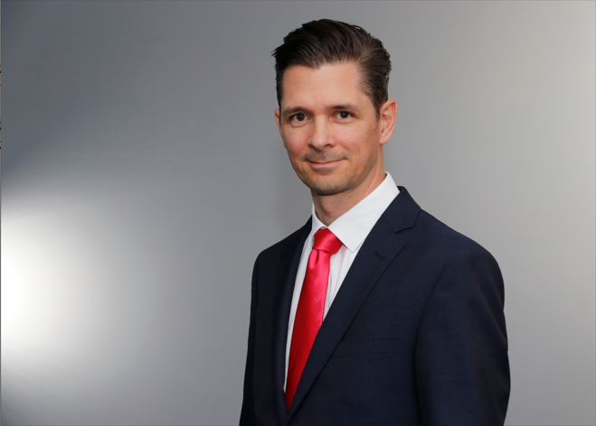
fri22210600.jpg: Philipp Guth has assumed responsibility for the research & development activities of Herborn-based enclosure and system specialist Rittal with effect from 1st October 2022.
May be reproduced free of charge. Please name Rittal GmbH & Co. KG as the source.

About Rittal
Rittal, headquartered in Herborn, Germany, is a leading global provider of solutions for industrial enclosures, power distribution, climate control and IT infrastructure, as well as software and services. Systems made by Rittal are deployed in over 90 per cent of all industries across the world, including machine building and plant engineering, food and beverages, and IT and telecommunications.
The international market leader’s product portfolio includes configurable enclosures, with data available across the entire production process. Smart Rittal cooling systems, with up to 75 per cent lower power and a great carbon advantage can communicate with the production landscape, enabling predictive maintenance and servicing. The offering also includes innovative IT products, from IT racks and modular data centres, to edge and hyperscale computing solutions.
Leading software providers Eplan and Cideon support the value chain, providing interdisciplinary engineering solutions, while Rittal Automation Systems offers solutions for switchgear. Within Germany, Rittal can supply products on demand within 24 hours – with precision, flexibility and efficiency.
Founded in 1961, Rittal is the largest company in the owner-operated Friedhelm Loh Group. The Friedhelm Loh Group is active worldwide, with 12 production sites and 90 international subsidiaries. It has more than 11,600 employees and posted revenues of 2.5 billion euros in fiscal 2021. In 2022, the family-run business was named one of Germany’s leading employers by the Top Employers Institute, for the 14th year running. Within the scope of a Germany-wide survey, Focus Money magazine identified the Friedhelm Loh Group as one of the nation's best providers of vocational training for the fifth time in 2021. In 2022, Rittal was awarded the Top 100 Seal as one of Germany’s most innovative medium-sized companies.
For more information, visit www.rittal.com and www.friedhelm-loh-group.com.

