Rittal at the 2024 OCP Global Summit
Rittal enables AI with megawatt cooling
Herborn/San Jose, 2024-10-10.
- Rittal has developed a modular cooling distribution unit (CDU) that delivers a cooling capacity of over 1 MW. It uses direct liquid cooling based on water – and is thus a perfect example for new IT infrastructure technologies which are enablers for AI applications.
- New technology made manageable: Rittal used Open Rack V3, OCP principles and modularization to design their CDU in such a way that the modules fit to the usual handling of servers.
- Outlook: liquid-to-liquid solutions will become more and more the standard, while liquid-to-air solutions will still remain for existing data centres without facility water at row level.

The 2024 OCP Global Summit theme is "From Ideas to Impact". That reflects OCP’s commitment to fostering innovation that transforms theoretical discussions into real-world solutions. One such example is generative AI. AI applications promise revolutionary benefits. But is the IT infrastructure ready yet? The power density for applications such as the training and operation of large language models (LLMs) or high-performance computing will rapidly push current conventional air cooling to its physical and economic limits. Hence, cooling is about to undergo a radical technology change that will affect the entire data center as a system. In close cooperation with hyperscalers and server OEMs, Rittal has developed a modular cooling distribution unit (CDU) that delivers a cooling capacity of over 1 MW. It will be the centerpiece exhibit at Rittal’s booth A24 at 2024 OCP Global Summit. The CDU uses direct liquid cooling based on water – and is thus an example for new IT infrastructure technologies that are enablers for AI applications.

New technology, familiar handling?
“To put the technology into practice, it is not enough to simply provide the cooling capacity and integrate the solution into the facility - which also still poses challenges”, says Lars Platzhoff, Head of Rittal’s Business Unit Cooling Solutions : “Despite the new technology, the solutions must remain manageable by the data centre team as part of the usual service. At best, this should be taken into account already at the design stage.”

OCP as a model for user-centered design
How does this work? With modularisation and the design advantages of the Open Rack V3, the development of which Rittal has driven forward in the Open Compute Project (OCP): Following the OCP design example of the power supply, the server in the rack is connected to the central inlets and outlets of the water circuit via standardised connections at the manifold. Power is supplied via the rack’s standardised DC busbar. Functional units of the CDU such as the central controller unit and several coolant circulation units (CCUs) are completely modular and can be easily slid into the rack. This concept offers a major benefit in terms of service: Components such as controller, sensors, filters and the pump units of the In-Row solution can be maintained during operation and easily replaced via "hot swap". The structure is designed in such a way that the modules can be moved in a similar way to the usual handling of servers.

What will become the next best practice? And how?
“We are convinced that the powerful liquid-to-liquid solution will be a crowd puller at the 2024 OCP Summit. This kind of set-up will be used mainly by hyperscalers and other operators of large data centres”, Platzhoff explains: “The approaches taken by international hyperscalers after extensive testing will quite probably set the standards in the medium term. But the agile colocation sector cannot wait so long.” Most colocators are highly customer-focused and want to rapidly offer their customers good conditions for AI and HPC as well. Several of them are also planning data centers with liquid-to-liquid solutions. Rittal will also offer alternatives without the need for a water connection. The liquid-to-air versions cool the processors with water but dissipate the heat into the air through the rear door of the rack or a side cooler. They do not achieve the same cooling output and efficiency as liquid-to-liquid solutions, but they can be deployed more quickly in data centers without a water connection. Thus, they enable data center operators to perform their tests with less effort and investment or to create individual ‘HPC islands’ in air-cooled data centres for their users. “These versions have a leverage function, bringing direct liquid cooling into data centres as an enabling technology for AI”, Platzhoff explains.
The topic will also be addressed on the Expo Hall Stage on October 16 from 4:10pm - 4:25pm PDT.
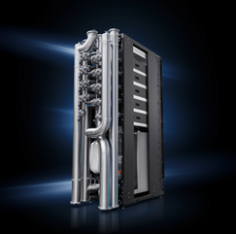 |  | 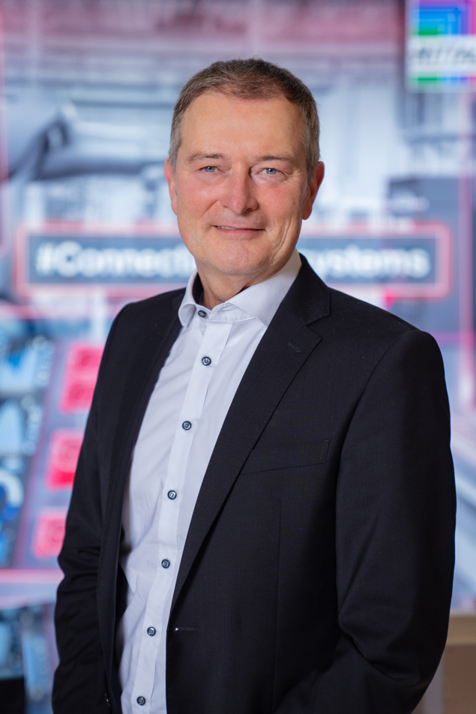
Caption Image 1  Thanks to direct liquid cooling, the new modular bayed solution delivers a cooling output of over 1 megawatts, ideal for the high power densities of AI applications.  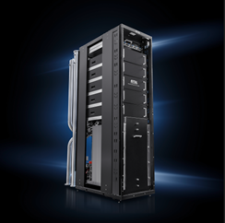  Caption Image 3  Compact rack integration and modular design make the new technology easy to use and maintain in datacentre operations. |  | Caption Image 2  Lars Platzhoff, Head of Rittal’s Business Unit Cooling Solutions: “To put the new technology into practice, it is not enough to simply provide the cooling capacity and integrate the solution into the facility. The solutions must remain manageable by the data centre team as part of the usual service.”

May be reproduced free of charge. Rittal GmbH & Co. KG

Rittal

Rittal is a leading global supplier of enclosure systems, automation and infrastructure with its industrial, IT, energy and power, cooling and service units. Rittal products and solutions are used in over 90% of global industries – standardised, customised, and always of the very best quality.
Our approach and methodology: Rittal, Rittal Software Systems (Eplan, Cideon and German Edge Cloud) and Rittal Automation Systems (RAS, Ehrt, Alfra) combine their hardware and software expertise to streamline, optimise and digitalise processes across the entire value chain for our customers including their IT infrastructure – from control and switchgear construction, machine building to factory operators or the energy sector.
Our delivery promise: Rittal standard products are delivered in Germany within 24 hours, and within 48 hours throughout Europe.
Customer focus
Improving efficiency and increasing productivity through automation and digitalisation is one of the biggest challenges for our customers. This requires in-depth knowledge and expertise, the combination of hardware and software, and cross-sector networking. We are convinced that creating and connecting data rooms is crucial to the success of industrial transformation. And that is exactly our speciality and field of competence.
Eplan and Rittal are driving the development of the digital automation twin, making data accessible and useable in operations as well. Cideon is improving data consistency in the digital product twin context with its CAD/CAM, PDM/PLM and product configuration expertise. German Edge Cloud’s ONCITE Digital Production System (DPS) makes production process data transparent, enabling it to be optimised – right through to energy management using digital production twins.
Sustainability
Environmental and climate protection, social commitment and ethical corporate management are a given for Rittal. We take our responsibility for a sustainable future seriously. Our approach to resource management and conservation involves continuous improvement of our own production processes and ensuring that our products have the lowest possible Product Carbon Footprint. Our solutions support our customers in achieving their own climate targets.
Family business and global player
Founded in 1961, Rittal is the largest company in the owner-operated Friedhelm Loh Group. The group operates worldwide, with 12 production sites and 95 international subsidiaries. It has 12,100 employees and posted revenues of 3 billion euros in fiscal 2023. In 2023, the Friedhelm Loh Group was presented with the “Best Place to Learn” and “Employer of the Future” awards. In 2024, Rittal was awarded the Top 100 Seal as one of Germany’s most innovative medium-sized companies for the third time in a row.
For more information, visit www.rittal.com and www.friedhelm-loh-group.com

Corporate Communications
Dr. Carola Hilbrand Rittal GmbH & Co. KG
Corporate & Brand Communications Auf dem Stützelberg
Tel.: 02772/505-2527 35745 Herborn
hilbrand.c@rittal.de www.rittal.com

Follow us:

