RiLineX from Rittal
Rittal and Eplan at the 2024 SPS
12 to 14 November in Nuremberg
Hall 3C, Booth 321
A new lightning fast platform for power distribution
Herborn, 7 November 2024
RiLineX from Rittal is a newly developed, open platform for power distribution systems. A click system of boards and components simplifies the previously laborious process of assembling power distribution systems in enclosures. The end result is a time saving of up to 30 percent in engineering and 50 percent in assembly compared to conventional busbar systems. A further advantage is that RiLineX boosts sustainability by reducing plastic waste and increasing decentralised supply opportunities, with fewer shipments of heavy copper required. The innovative solution has been declared a winner by the German Design Award 2025 for its product design.

Any business or organisation that needs a fast and reliable power distribution solution up to 1000 V AC or ± 1500 V DC will benefit from RiLineX. This means everybody from conventional panel building and switchgear manufacturers through to the energy storage industry, photovoltaic system installers and the IT sector. After all, the new power distribution platform brings an end to complex dimensioning of the system, the loss of space when components are installed and the cutting to size of protective covers.

No need to plan supports
RiLineX significantly speeds up the planning and installation process. Since the copper bars are integrated directly in the board, components can be planned and mounted anywhere. This completely eliminates the convoluted process of arranging supports on a project-by-project basis. The complicated cutting process of covers is no longer necessary, either. This also reduces trimming waste and plastic refuse – by an average of 1.9 kilograms per system. In this solution, the bars are covered over end-to-end in the system from the outset, providing protection against accidental contact. This contact hazard protection is certified to protection category IP2XB, which means penetration by a solid foreign object with a diameter of 12 millimetres or more is prevented. The contact hazard protection at the front can also be upgraded to protection category IP4X. In that configuration, Rittal is protecting the system against penetration by a solid foreign object with a diameter from 1 millimetre up. In either case, there is no possibility of finger contact with live parts. The design means that the entire system has been pre-tested for short circuit resistance up to 52.5 kA, so planners and users alike can rely on a completely safe solution.

30 to 50 percent faster
The solution significantly reduces the amount of work involved in everything from planning and assembly to maintenance. What’s more, it makes plant engineering much more efficient. The result is savings of up to 30 percent in engineering and up to as much as 50 percent in assembly. An innovative click system for boards and components ensures simple installation. This means that project-specific modular solutions can be implemented with far less outlay.
Complete board or modular system
Depending on the customer application, Rittal offers two different approaches for greater flexibility of use. In one of these options, the RiLineX platform is available as a complete board including copper bars – which can be installed in next to no time – for Rittal AX compact and VX25 bayable enclosures up to 1,200 mm. It can also be supplied already installed in the enclosure. The board is therefore ideal for standard applications. This reduces costs for users and gives them a clearer overview. What’s more, they can install the system without needing any special prior knowledge.

Alternatively, the open modular system version offers complete configuration freedom for customised system design, with baying connections extending this to 2.4 metres or even more. Users simply need to know the length of the mounting plate and can then flexibly combine modules in 200 mm increments. What’s more, the drilling pattern is identical on every mounting plate from Rittal. It’s then simply a case of cutting standard busbars to size for the system. The copper bars are subsequently fixed securely in the board so that short circuit resistance is ensured at all times. This version is also available as a system kit without bars. For international applications, eliminating the need to ship heavy metal from one continent to another offers both cost and environmental benefits. With RiLineX, the boards can simply be used on site with cost-effective standard bars made from copper or aluminium in various cross-sections. Baying across several enclosures, even retrospectively, is easy. When it comes to planning, Rittal supports users with the new RiPower planning tool.

Four-pole solution planned
With RiLineX, Rittal is taking power distribution in enclosures into the future. Initially, the system will be available as a three-pole solution for currents up to 800 A. End-to-end four-pole systems are to follow. Moreover, the platform is equally suitable for use in direct current applications, which play an important role, especially in relation to efficient industrial applications and renewable energies as part of the journey to an all-electric society. By the time of Hannover Messe 2025, all relevant connection adapters, fuses, disconnectors, etc. will be available for the three-pole system.

Rittal is taking the platform concept beyond its own company. Even before the sales launch, Rittal started work with numerous technology partners to kick off a whole ecosystem. Device and component manufacturers receive the interface data they need to develop products and can create and distribute solutions that are “ready for RiLineX”.

Award-winning product design
RiLineX also impressed the judges of the German Design Council, with the platform securing the German Design Award 2025 as a winner of the Energy category. The German Design Council was founded by a resolution of Germany’s national parliament, the Bundestag. It presents awards to outstanding products, highlighting how functional design can contribute to the sustainable transformation of the economy.

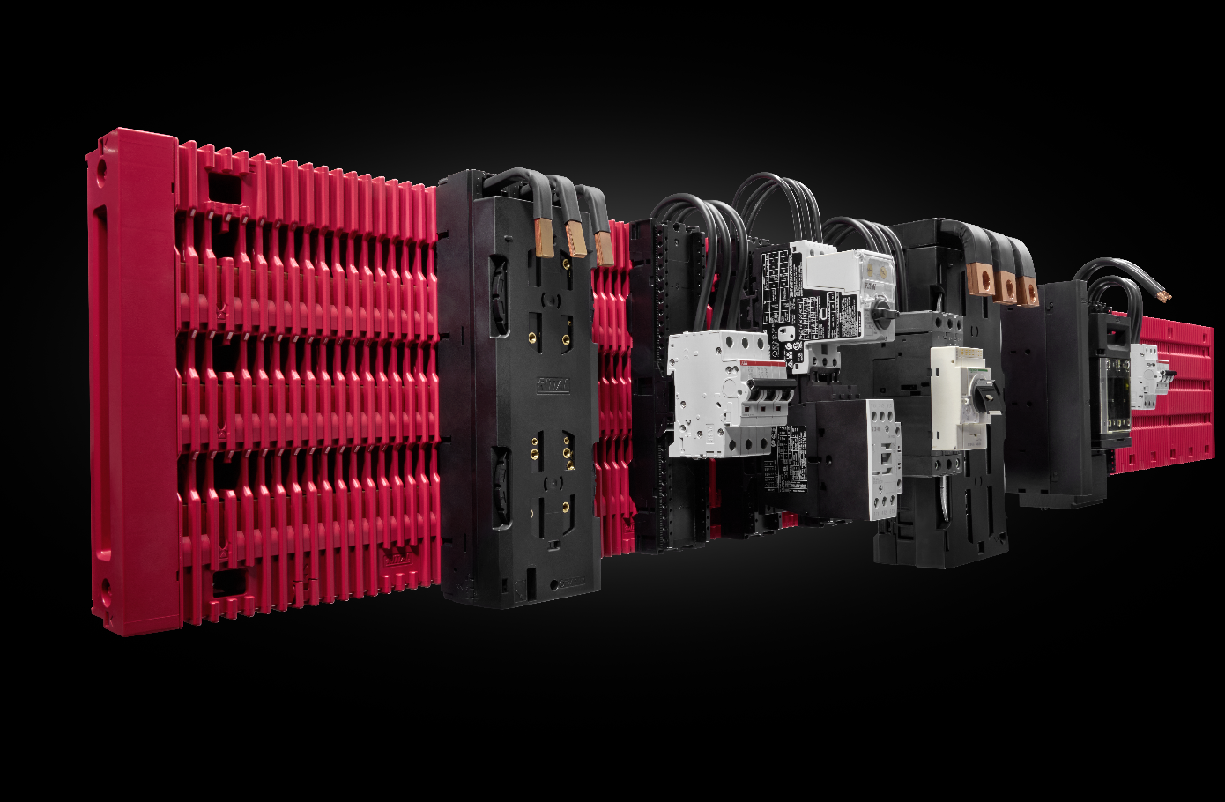 |  | 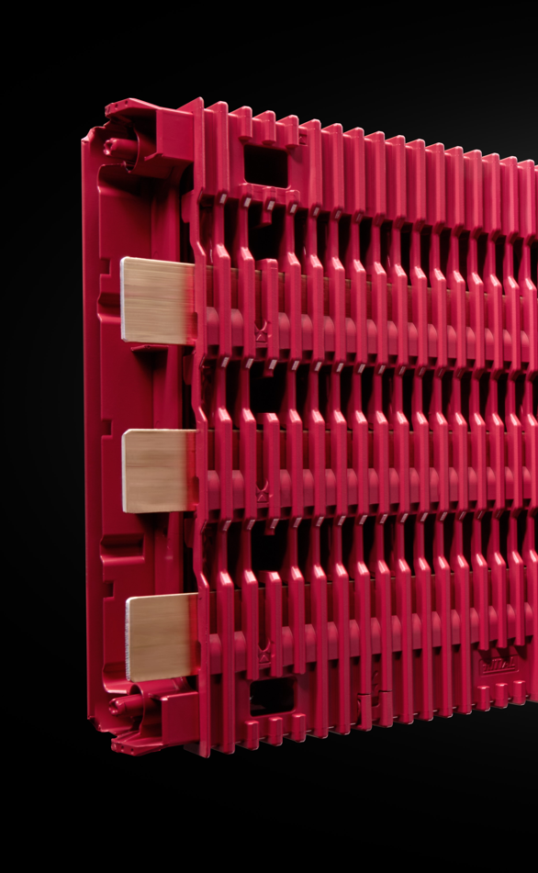
Caption, image 1  The new platform simplifies the previously laborious assembly process in enclosures, delivering a time saving of up to 30 percent in engineering and 50 percent in assembly.  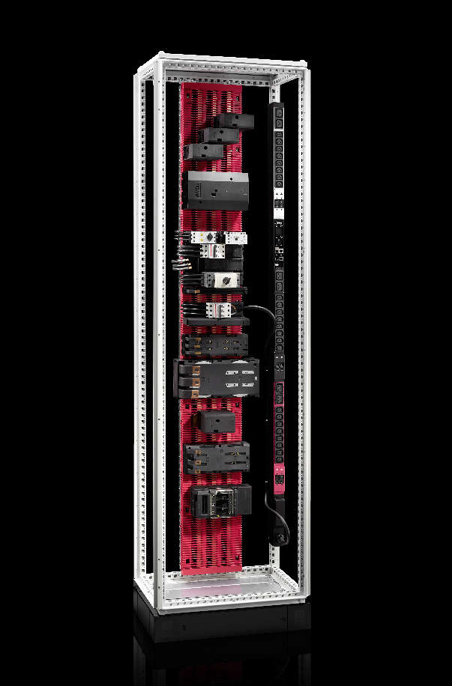  Caption, image 3  The RiLineX board can be installed vertically, which is especially desirable in IT applications. |  | Caption, image 2  Components can be planned or mounted anywhere because the copper bars are secured directly in the board with RiLineX, with no need for special supports.
May be reproduced free of charge. Please name Rittal GmbH & Co. KG as the source.

Rittal

Rittal is a leading global supplier of enclosure systems, automation and infrastructure with its industrial, IT, energy and power, cooling and service units. Rittal products and solutions are used in over 90% of global industries – standardised, customised, and always of the very best quality.
Our approach and methodology: Rittal, Rittal Software Systems (Eplan, Cideon) and Rittal Automation Systems (RAS, Ehrt, Alfra) combine their hardware and software expertise to streamline, optimise and digitalise processes across the entire value chain for our customers including their IT infrastructure – from control and switchgear construction, machine building to factory operators or the energy sector.
Our delivery promise: Rittal standard products are delivered in Germany within 24 hours, and within 48 hours throughout Europe.
Customer focus
Improving efficiency and increasing productivity through automation and digitalisation is one of the biggest challenges for our customers. This requires in-depth knowledge and expertise, the combination of hardware and software, and cross-sector networking. We are convinced that creating and connecting data rooms is crucial to the success of industrial transformation. And that is exactly our speciality and field of competence.
Eplan and Rittal are driving the development of the digital automation twin, making data accessible and useable in operations as well. Cideon is improving data consistency in the digital product twin context with its CAD/CAM, PDM/PLM and product configuration expertise.
Sustainability
Environmental and climate protection, social commitment and ethical corporate management are a given for Rittal. We take our responsibility for a sustainable future seriously. Our approach to resource management and conservation involves continuous improvement of our own production processes and ensuring that our products have the lowest possible Product Carbon Footprint. Our solutions support our customers in achieving their own climate targets.
Family business and global player
Founded in 1961, Rittal is the largest company in the owner-operated Friedhelm Loh Group. The group operates worldwide, with 12 production sites and 95 international subsidiaries. It has 12,100 employees and posted revenues of 3 billion euros in fiscal 2023. In 2023, the Friedhelm Loh Group was presented with the “Best Place to Learn” and “Employer of the Future” awards. In 2024, Rittal was awarded the Top 100 Seal as one of Germany’s most innovative medium-sized companies for the third time in a row.
For more information, visit www.rittal.com and www.friedhelm-loh-group.com.

Corporate Communications
Dr. Carola Hilbrand Rittal GmbH & Co. KG
Corporate & Brand Communications Auf dem Stützelberg
Tel.: 02772/505-2527 35745 Herborn
hilbrand.c@rittal.de www.rittal.com


Follow us:

