Industrialisation based on the mechanical engineering model
Eplan and Rittal at the E-world in Essen
Hall 5, Booth D116
Standards and data-driven automation for energy transition
Herborn/Monheim, 28 January 2025
Renewable energy usage and energy storage capacities continue to grow. Despite a shortage of skilled workers, grid operators are rapidly expanding their infrastructure to provide intelligent networks for energy transition. At the E-world in Essen, Eplan and Rittal will present solutions using engineering and system technology standards to accelerate plant construction in the energy sector. Eplan focuses on engineering standards for grid infrastructure components like transformer stations and renewable energy solutions. With support from Eplan and Rittal, standardised data, system technology, and digital continuity from engineering to automated production to service form the basis for an efficient restructuring of energy systems.

Power is the order of the day at the E-world in Essen. Around 900 exhibitors from 30 nations will be showcasing their offers for the energy sector from 11 to 13 February. Eplan and Rittal will also be there to demonstrate innovative solutions as their contribution to a rapid and cost-efficient energy transition. “The main course of action is to industrialise entire process chains," says Verena Freund, Solutions Sales Management Energy at Rittal. “The infrastructure expansion can gain the pace it urgently needs through consistent data, coordinated software, system technology and suitable automation solutions.”
Data consistency makes all the difference
“For a digital workflow to be truly effective, data must be accurate – right from the start. Experience in mechanical engineering, which already has a high degree of industrialisation, shows the potential that exists. Now we want to bring these opportunities for boosting efficiency and acceleration to the energy sector – right up to ‘automated engineering’,” explains Stephanie Kudak, Vertical Market Manager Energy at Eplan. In Essen, visitors can expect bundled Eplan expertise on digital twins for substations, transformer stations, energy storage or charging infrastructure, which has already passed practical tests.

Energy transition: data packages make implementation easier
A compact transformer station with pre-planned project documentation being displayed in Essen makes it clear how implementation can be achieved with Eplan. The planning and designing of the transformer station with a medium and low-voltage system is presented; this is available in the Eplan Cloud as a standard industrial project. In practice, it can be used to plan grid stations or develop complete decentralised energy systems in a more standardised manner. A special equipment and parts list, considered necessary in the energy sector, is also supplied as default.
Power distribution made easy: RiLineX
In Essen, Rittal is presenting RiLineX, a new platform for 60-mm busbar systems for power distribution. The “click-on” system made up of boards and components simplifies the previously time-consuming construction of power distribution in enclosure population, with time savings of as much as 30% in engineering and 50% in installation. Rittal is also promoting standardisation with a consistent platform approach. A platform ecosystem with technology partners was started even before sales began. Manufacturers of devices and components also receive the interface data needed for product development. The relevant system data is already stored in Eplan Pro Panel.

RiPower also offers digital support for planning: The configuration software accelerates the safe planning and construction of low-voltage switchgear and collaboration on a cloud platform, thanks to simplified workflows. Specialist planners and switchgear manufacturers receive straightforward support when planning their systems. Climate control is a crucial factor, especially with a high power density in the enclosure. Planners using the RiTherm software can deploy data from Eplan and integrate the climate control requirements into the seamless planning process.

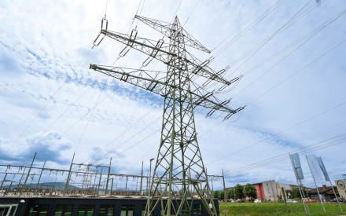 |  | 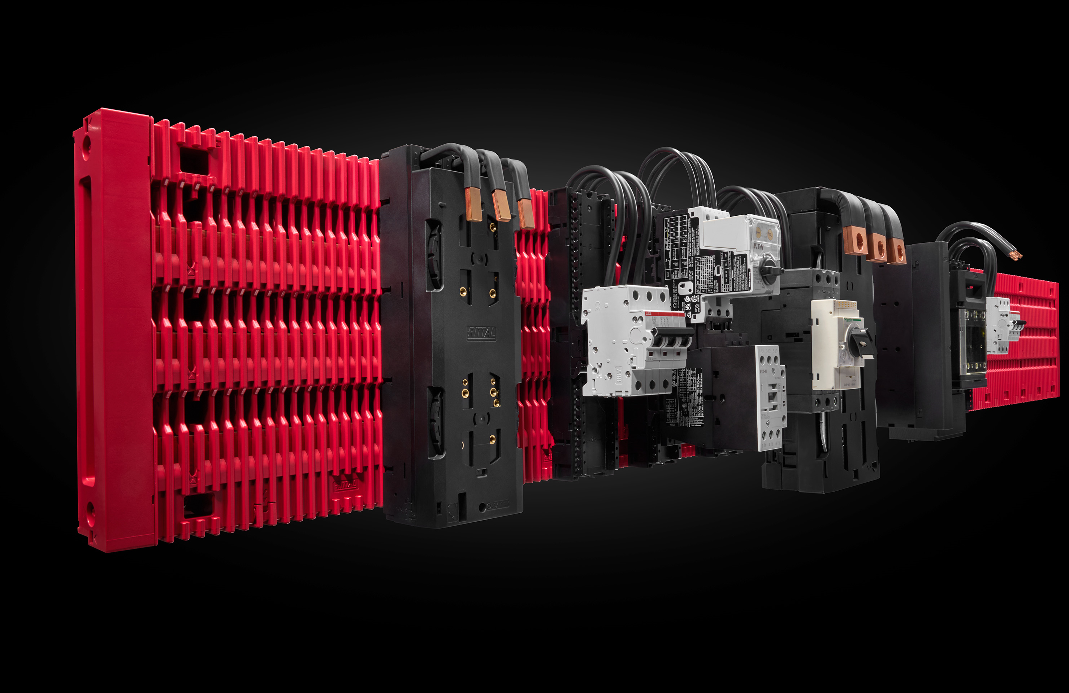
Caption, image 1  At the E-world in Essen, Eplan and Rittal are jointly presenting tailor-made solutions for the energy sector based on the efficient interaction of engineering, system technology and automation. |  |  |  | Caption, image 2  Assembled in half the time: RiLineX, an open platform system for 60-mm busbar systems based on standard busbars that are available everywhere.
 | eView AR  Eplan eView AR gives you all the data at a glance: Split-screen view of a circuit diagram and digital twin in augmented reality |  |  |  | eView AR  Fast localization of relevant components in the enclosure through visual overlay

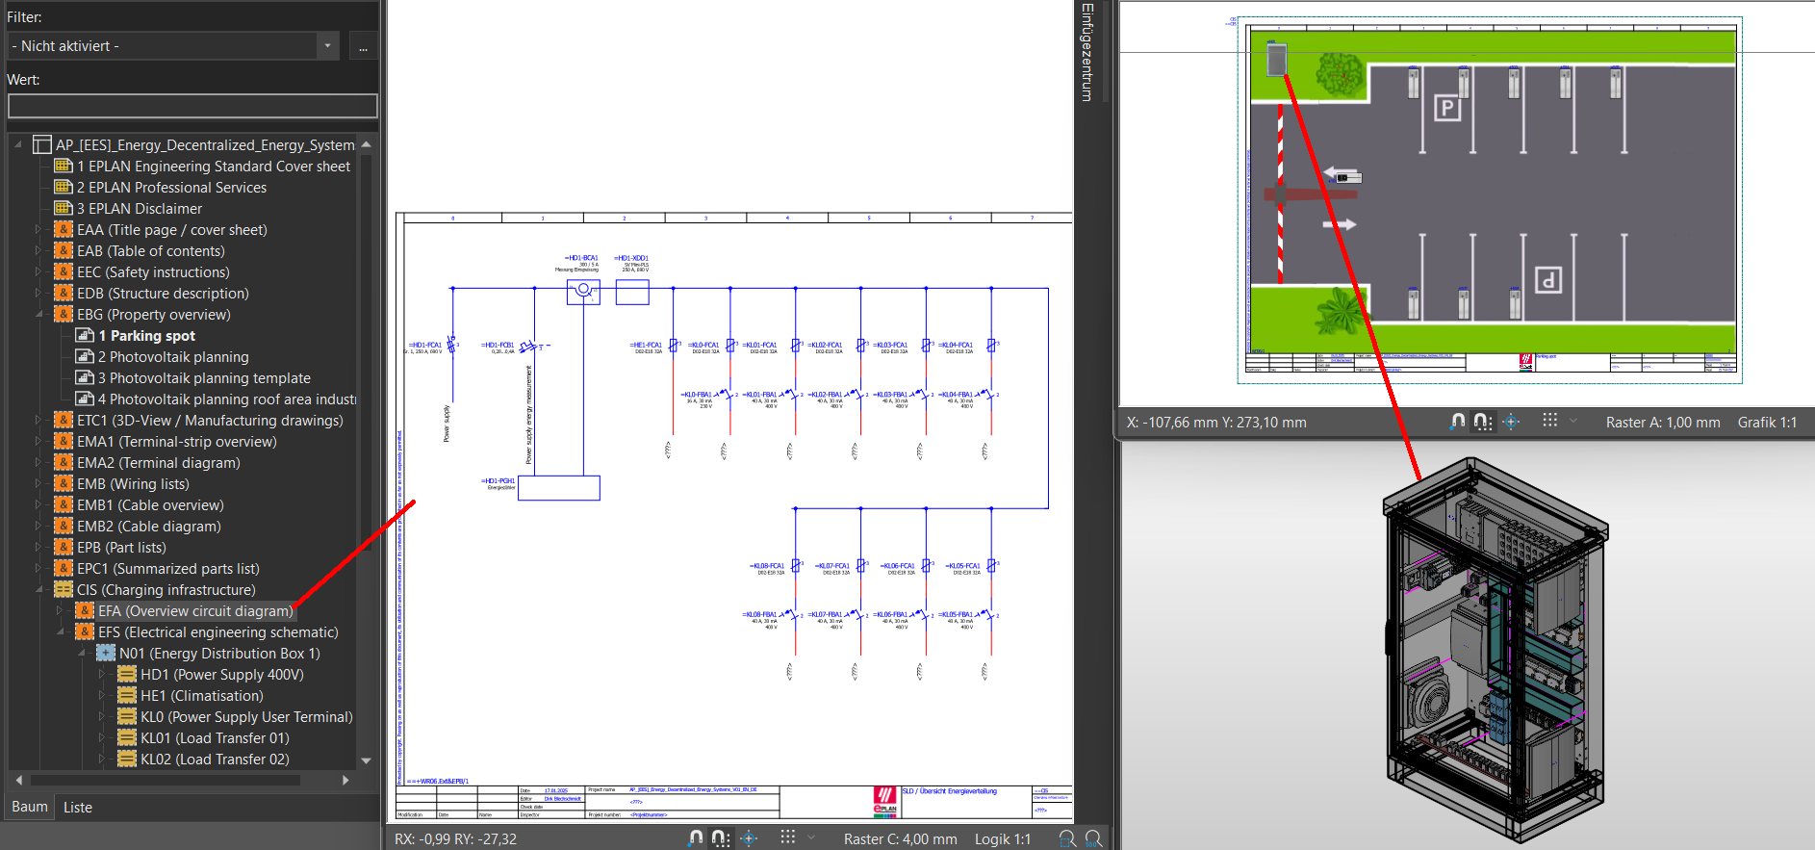
Caption, image 3
Various systems can be planned in Eplan; this is an example of a charging park that forms part of the charging infrastructure for renewable energies.

May be reproduced free of charge. Please state EPLAN GmbH & Co. KG as the source.

Eplan

Eplan provides software and service solutions in the fields of electrical, automation and mechatronic engineering. The company develops one of the world’s leading design software solutions for machine and panel builders. Eplan is also the ideal partner to streamline challenging engineering processes.
Both standardised as well as customised interfaces to ERP and PLM/PDM systems ensure data consistency along the whole value chain. Working with Eplan means boundless communication across all engineering disciplines. No matter whether small or large enterprises: Customers can apply their expertise more efficiently. Worldwide, EPLAN supports 68,000 customers. Eplan wants to grow further with customers and partners and pushes integration and automation in engineering forward. Within the Eplan Partner Network, open interfaces and seamless integrations are realised together with partners. “Efficient engineering” is the focus.
Eplan was founded in 1984 and is part of the owner-operated Friedhelm Loh Group. The Friedhelm Loh Group operates worldwide with 12 production sites and 95 international subsidiaries. The entire group employs 12.100 people and generated revenues of €3 billion in fiscal 2023. In 2023, the Friedhelm Loh Group was named “Best Place to Learn” and “Employer of the Future”.
For more information visit: www.eplan-software.com and www.friedhelm-loh-group.com

Corporate Communications
Birgit Hagelschuer Eplan GmbH & Co. KG
Press- and public relations An der alten Ziegelei 2
Phone: 02173 3964-180 40789 Monheim am Rhein
Hagelschuer.b@eplan.de www.eplan.com


Follow us:

Rittal

Rittal is a leading global supplier of enclosure systems, automation and infrastructure with its industrial, IT, energy and power, cooling and service units. Rittal products and solutions are used in over 90% of global industries – standardised, customised, and always of the very best quality.
Our approach and methodology: Rittal, Rittal Software Systems (Eplan, Cideon) and Rittal Automation Systems (RAS, Ehrt, Alfra) combine their hardware and software expertise to streamline, optimise and digitalise processes across the entire value chain for our customers including their IT infrastructure – from control and switchgear construction, machine building to factory operators or the energy sector.
Our delivery promise: Rittal standard products are delivered in Germany within 24 hours, and within 48 hours throughout Europe.
Customer focus
Improving efficiency and increasing productivity through automation and digitalisation is one of the biggest challenges for our customers. This requires in-depth knowledge and expertise, the combination of hardware and software, and cross-sector networking. We are convinced that creating and connecting data rooms is crucial to the success of industrial transformation. And that is exactly our speciality and field of competence.
Eplan and Rittal are driving the development of the digital automation twin, making data accessible and useable in operations as well. Cideon is improving data consistency in the digital product twin context with its CAD/CAM, PDM/PLM and product configuration expertise.
Sustainability
Environmental and climate protection, social commitment and ethical corporate management are a given for Rittal. We take our responsibility for a sustainable future seriously. Our approach to resource management and conservation involves continuous improvement of our own production processes and ensuring that our products have the lowest possible Product Carbon Footprint. Our solutions support our customers in achieving their own climate targets.
Family business and global player
Founded in 1961, Rittal is the largest company in the owner-operated Friedhelm Loh Group. The group operates worldwide, with 12 production sites and 95 international subsidiaries. It has 12,100 employees and posted revenues of 3 billion euros in fiscal 2023. In 2023, the Friedhelm Loh Group was presented with the “Best Place to Learn” and “Employer of the Future” awards. In 2024, Rittal was awarded the Top 100 Seal as one of Germany’s most innovative medium-sized companies for the third time in a row.
For more information, visit www.rittal.com and www.friedhelm-loh-group.com.

Corporate Communications
Dr. Carola Hilbrand Rittal GmbH & Co. KG
Corporate & Brand Communications Auf dem Stützelberg
Phone: 02772/505-2527 35745 Herborn
hilbrand.c@rittal.de www.rittal.com

Follow us:

