New issue of the Friedhelm Loh Group “be top” magazine
“Our path to growth” –
be top magazine presents “game changers”
Herborn, 2025-04-07
Which technologies are real game changers and can put companies on the right path for growth, especially right now? The new issue of “be top” magazine highlights the many opportunities that exist, particularly in the US market. This issue’s cover story profiles three renowned plant engineering companies from Texas and Wisconsin and showcases how they have made a breakthrough with data-driven industrial automation. Be top takes readers on a fascinating journey through interesting customer projects from Rittal, Eplan, Cideon, Stahlo and LKH on both sides of the Atlantic.
While massive investment programmes are boosting the US market, Germany is threatened by stagnation. “In terms of industrial experience, expertise and technology, we are still very strong in Europe and Germany,” asserts Professor Friedhelm Loh, owner and CEO of the Friedhelm Loh Group in his editorial for the latest issue of be top. In a decisive interview, Professor Niko Mohr, Member of the Executive Board of the Friedhelm Loh Group, explores the opportunities offered by combining “skills from the old industrial curve with skills from the new one.” And in a guest article, Bertram Kawlath, President of the VDMA (Germany’s Mechanical Engineering Industry Association) calls for everyone to work together to speed up innovations and processes.
Technology development as a game changer
The cover story illustrates just how this expertise can be used successfully. It takes the reader to Texas and Brad Howell from R&D Specialties, who build switchgear for the oil and gas industry. In rural Texas, economic growth is being undermined by the chronic shortage of skilled labour. Extensive automation using Eplan software and with solutions from Rittal Automation Systems has resulted in time savings of as much as 40 percent. Usemco from Wisconsin manufactures switchgear for pumps. Although business is booming, their processes were much too slow. In fact only a few years ago, CAD drawings were still being scanned in and circuit diagrams were only available in 2D. Sean Rezin, Vice President of Usemco, broke with tradition and ventured into new territory by turning to automated wire assembly and end-to-end 3D engineering. It proved a great success. And finally with the help of Eplan and Rittal, tech visionary John Miller of Engineering Specialists Inc – a turnkey industrial automation and controls specialist, also in Wisconsin, succeeded in introducing integrated end-to-end data-driven automation across all their processes.

Time savings of 75% with Wire Terminal W TC and Eplan Smart Wiring
Comprehensive integrated digitalisation and automation can also help with the challenge of a shortage of skilled workers in Germany. An interesting read that illustrates how plant manager Christian Diekmann from of Elektrotechnik Janssen in Nordenham, Lower Saxony successfully brought about and put in place a major automation project. The switchgear manufacturer lacked the skilled workforce to take on a major order to equip the automated stacker cranes for the port of Hamburg with switchgear. Rittal’s fully automated Wire Terminal WT C and seamless end-to-end integration with Eplan significantly increased efficiency for the plant manufacturer that enabled the company to secure additional major orders running right through to 2028. Zahnen Technik in Arzfeld, Rhineland-Pfalz, also lacked the skilled staff needed to manufacture a large number of switchgear systems for water and wastewater treatment. Thanks to WTC, Eplan Smart Mounting and Eplan Smart Wiring, less skilled staff can now be used instead, resulting in time savings of 75 per cent.

Sustainable materials and processes
Several be top articles deal with the subject of sustainability. The drive for resource-friendly and clean processes motivated Huhtamaki Foodservice, a Scandinavian manufacturer of composite-fibre containers, BORA, an Austrian supplier of premium built-in kitchen appliances, and German packaging specialist Poly-clip System. While one company used the switch to more sustainable manufacturing methods – using composite-fibre instead of plastic thermoforming plastics to convert printed system documentation to paper-free information with the digital “Rittal ePocket” wiring plan pocket, the other planned a high-availability data centre with a sustainable cooling solution. Poly-clip System teamed up with LKH to develop sustainable materials and a return system for plastic spools.

Student in the morning – apprentice in the afternoon
The Friedhelm Loh Group is also taking a sustainable approach to combating the shortage of skilled workers. The number of young people taking on apprenticeships is falling dramatically, making it essential to reach out to and support young talent. The latest be top showcases the unique “SchulePlus” (Schools-Plus) initiative that bridges the gap between pupils, schools and companies to give students an insight into working life. Together with the Johann-Textor-Schule in Haiger, around 100 companies from the region offer school pupils the chance to gain practical experience in a company, without being under any pressure to make any final career decision. Rittal alone has received 100 registrations for the next academic year. And for automotive enthusiasts, there is a completely unique and distinct approach to technology by the Nationales Automobilmuseum with a dedicated on-site learning facility and educational centre, a “class-room on wheels” as Professor Wolfgang Henseler, Head of the Educational Campus, explains in an interview.

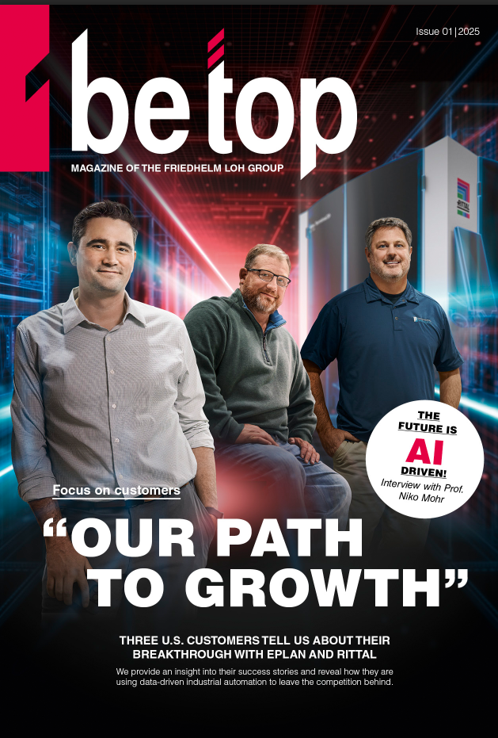 | The new issue of “be top” magazine highlights the many opportunities that exist, particularly in the US market. This issue’s cover story profiles three renowned plant engineering companies from Texas and Wisconsin and showcases how they have made a breakthrough with data-driven industrial automation.

May be reproduced free of charge. Image rights reserved by Friedhelm Loh Group / Rittal GmbH.

Friedhelm Loh Group

The companies of the globally successful Friedhelm Loh Group invent, develop and produce innovative system solutions for industry, IT and energy, as well as other important sectors worldwide. They are among the top addresses in their respective industries.
With their combined hardware and software expertise, Rittal, Rittal Software Systems (Eplan and Cideon) and Rittal Automation Systems (RAS, Ehrt, Alfra) optimize, digitize and automate processes along the entire customer value chain, including the IT infrastructure – from panel building and switchgear manufacturing to mechanical engineering, factory operators and the energy sector. Stahlo and LKH round off the portfolio with end-to-end manufacturing expertise in the modern materials of steel and plastic.
The Group is internationally successful, with 12 production sites and 95 subsidiaries. The family-owned company employs 12,100 people and generated a turnover of 3 billion euros in 2023. In 2023, the Friedhelm Loh Group was recognized as a “Best Place to Learn” and “Employer of the Future.
For more information, visit www.friedhelm-loh-group.com.

Corporate Communications
Dr. Carola Hilbrand Friedhelm Loh Group
Corporate & Brand Communications Rudolf-Loh-Straße 1
Phone: 02772/505-2527 35708 Haiger
hilbrand.c@rittal.de www.friedhelm-loh-group.com

