Data-driven automation live in Oberaargau
W. Althaus AG is Switzerland’s first Rittal and Eplan Application Center Partner
Herborn, 16 April 2025
Swiss industry is renowned for its precision, efficiency, and highly sophisticated technologies – not only in the fields of fintech (financial technology), medicine, and biotech, but also in mechanical engineering. Yet, technologically prominent automation solutions in panel building and switchgear manufacturing are also interesting, though not as well known. Here, one of the pioneers is W. Althaus AG. The company from Oberaargau has now become Switzerland’s first “Rittal + Eplan Application Center Partner”, and serves as a multiplier for the industry in data-driven industrial automation.

W. Althaus AG, with a Swiss workforce of around 160, is setting standards in innovation, automation, and digitalisation. As a leading specialist in automation technology, the company develops flexible, customer-specific solutions and offers all-round expertise in software and hardware engineering, enclosure construction and mechatronics.

Thanks to its comprehensive full-service range, Althaus supports its customers throughout the entire product life cycle, backed by a digital twin for process and automation optimisation. The company is considered a pioneering expert in data-driven industrial automation, both in internal processes and in developing customised automation solutions.

As a long-standing development partner for Rittal Automation Systems’ machines in panel building and switchgear manufaturing, the two companies are currently collaborating on innovative solutions, including the robot-assisted wiring of terminal strips and components.

As a result, it is hardly a surprise that Althaus has also consistently developed its own enclosure construction capability in accordance with the company’s mission statement, “Leading in Automation.” The entire process, from engineering and machining to wiring enclosures, is already fully digital and highly automated, utilising Eplan software, Rittal system technology, and machines from Rittal Automation Systems.
“As the first Rittal + Eplan Application Center partner in Switzerland, we will provide the industry with this expertise even more readily and continue to expand our long-standing collaboration for the benefit of our customers. We are delighted with the confidence that has been shown in us,” says Marco Schneider, CEO of Althaus AG. “Althaus is an ideal partner for our partner network. The company recognised early on how consistent data can drive automation when its quality is already built into the engineering,” says Dr. Marco Litto, Senior Vice President Strategy & Corporate Program at Eplan.

It all depends on practical testing
Jochen Trautmann, Managing Director of Rittal Automation Systems (RAS), explains the concept: “If we want to broaden the use of data-driven automation as the key to industrial competitiveness, each solution must demonstrate its capabilities under practical conditions.” After all, it is seldom a question of simply ‘all or nothing’. Even small steps can have a huge impact on efficiency if they are tailored precisely to individual processes. Interested parties can experience the solutions live in action at Althaus AG and converse with experts about the efficiency benefits they can gain in their workflow through the combination of software and hardware,” Mr. Trautmann explains: “The partner network is not only intended to provide customers with orientation as a seal of quality and expertise. Consequently, the partners in the Application Centers will become cross-company multipliers for digitalisation and automation in the industry.”

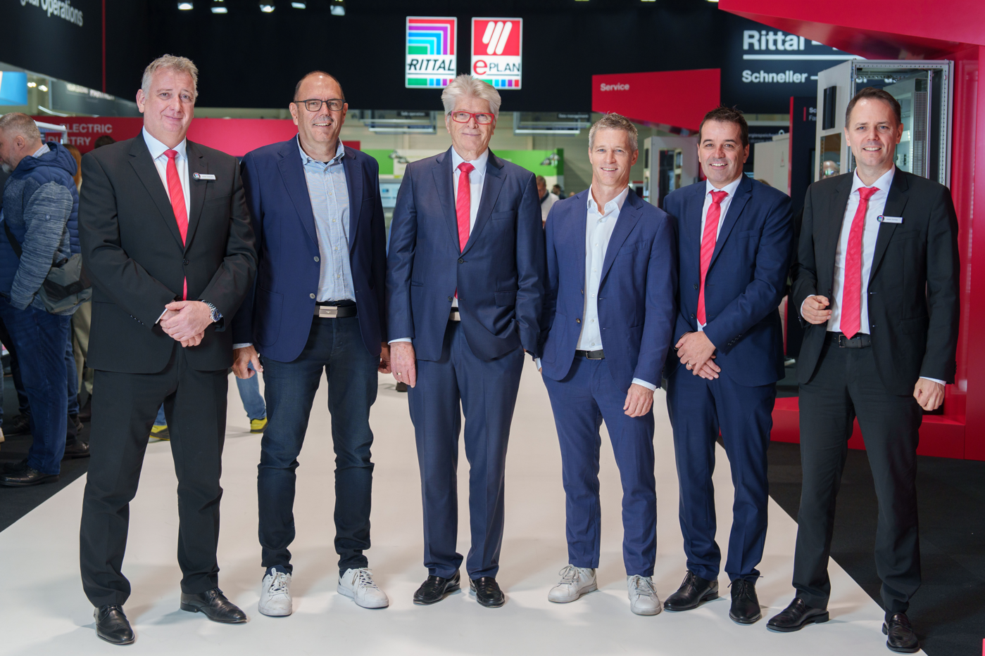
Caption
The new partners for data-driven automation: From left to right: Jochen Trautmann (Managing Director RAS), Walter Althaus (Owner W. Althaus AG), Professor Friedhelm Loh (Owner and CEO Friedhelm Loh Group), Marco Schneider (CEO W. Althaus AG), Manfred Sac (Managing Director Eplan Switzerland), and Stefan Güntner (Managing Director Rittal Switzerland).

May be reproduced free of charge. Please state EPLAN GmbH & Co. KG as the source.

Rittal

Rittal is a leading global supplier of enclosure systems, automation and infrastructure with its industrial, IT, energy and power, cooling and service units. Rittal products and solutions are used in over 90% of global industries – standardised, customised, and always of the very best quality.
Our approach and methodology: Rittal, Rittal Software Systems (Eplan, Cideon) and Rittal Automation Systems (RAS, Ehrt, Alfra) combine their hardware and software expertise to streamline, optimise and digitalise processes across the entire value chain for our customers including their IT infrastructure – from control and switchgear construction, machine building to factory operators or the energy sector.
Our delivery promise: Rittal standard products are delivered in Germany within 24 hours, and within 48 hours throughout Europe.
Customer focus
Improving efficiency and increasing productivity through automation and digitalisation is one of the biggest challenges for our customers. This requires in-depth knowledge and expertise, the combination of hardware and software, and cross-sector networking. We are convinced that creating and connecting data rooms is crucial to the success of industrial transformation. And that is exactly our speciality and field of competence.
Eplan and Rittal are driving the development of the digital automation twin, making data accessible and useable in operations as well. Cideon is improving data consistency in the digital product twin context with its CAD/CAM, PDM/PLM and product configuration expertise.
Sustainability
Environmental and climate protection, social commitment and ethical corporate management are a given for Rittal. We take our responsibility for a sustainable future seriously. Our approach to resource management and conservation involves continuous improvement of our own production processes and ensuring that our products have the lowest possible Product Carbon Footprint. Our solutions support our customers in achieving their own climate targets.
Family business and global player
Founded in 1961, Rittal is the largest company in the owner-operated Friedhelm Loh Group. The group operates worldwide, with 12 production sites and 95 international subsidiaries. It has 12,100 employees and posted revenues of 3 billion euros in fiscal 2023. In 2023, the Friedhelm Loh Group was presented with the “Best Place to Learn” and “Employer of the Future” awards. In 2024, Rittal was awarded the Top 100 Seal as one of Germany’s most innovative medium-sized companies for the third time in a row.
For more information, visit www.rittal.com and www.friedhelm-loh-group.com.

Corporate Communications
Dr. Carola Hilbrand Rittal GmbH & Co. KG
Corporate & Brand Communications Auf dem Stützelberg
Phone: 02772/505-2527 35745 Herborn
hilbrand.c@rittal.de www.rittal.com

Eplan

Eplan provides software and service solutions in the fields of electrical, automation and mechatronic engineering. The company develops one of the world’s leading design software solutions for machine and panel builders. Eplan is also the ideal partner to streamline challenging engineering processes.
Both standardised as well as customised interfaces to ERP and PLM/PDM systems ensure data consistency along the whole value chain. Working with Eplan means boundless communication across all engineering disciplines. No matter whether small or large enterprises: Customers can apply their expertise more efficiently. Worldwide, EPLAN supports 68,000 customers. Eplan wants to grow further with customers and partners and pushes integration and automation in engineering forward. Within the Eplan Partner Network, open interfaces and seamless integrations are realised together with partners. „Efficient engineering“ is the focus.
Eplan was founded in 1984 and is part of the owner-operated Friedhelm Loh Group. The Friedhelm Loh Group operates worldwide with 12 production sites and 95 international subsidiaries. The entire group employs 12.100 people and generated revenues of €3 billion in fiscal 2023. In 2023, the Friedhelm Loh Group was named “Best Place to Learn” and “Employer of the Future”.
For more information visit: www.eplan-software.com and www.friedhelm-loh-group.com

Corporate Communications
Birgit Hagelschuer Eplan GmbH & Co. KG
Press- and public relations An der alten Ziegelei 2
Phone: 02173 3964-180 40789 Monheim am Rhein
Hagelschuer.b@eplan.de www.eplan.com

