Rittal expands its top management team
New CSO: Mario De Marco heads international sales at Rittal
Herborn, 2025-08-22.
Mario De Marco has been Rittal’s new Chief Sales Officer (CSO) since July 2025. The company has reintroduced this position to its management team so it can better serve its international customers and their local needs. The world’s leading system provider for hardware, software and automation is thus making its organisation closer to its customers in increasingly differentiated markets. Mario De Marco, an experienced specialist from within the company, has now joined the management team, following more than two decades of driving international customer business.
“Rittal is supporting customers in their digital transformation for future growth, thereby effectively strengthening their competitiveness. As the new CSO, Mario De Marco will ensure that the company, including its international sales subsidiaries, can fulfil this task close to customers and markets, even in times of increasing de-globalisation,” says Professor Niko Mohr, member of the Board of Management of the Friedhelm Loh Group and CEO of Rittal International and Rittal Software Systems. “Mr. De Marco is an experienced sales expert with a keen sense for international customers and markets. He has played a significant role in developing our international sales structures.”

As Executive Vice President for International Market Management and International Subsidiary Management, he has already achieved notable success. He is highly regarded as the interface between the international sales companies, customers and headquarters. In his 23 years at Rittal, Mario De Marco has held several management positions in export and sales, supporting the development of international markets, building up dealer structures, and helping establish multiple subsidiaries.

“I am delighted to have been trusted to make my contribution to Rittal with a higher level of responsibility. Business and markets are changing at a rapid pace. We must demonstrate a high degree of agility to continue offering our customers services that effectively move them forward,” says Mario De Marco, CSO Rittal International: “Despite all the dynamics of geopolitics, global economy and technology, there is one constant that applies all over the world: In sales and management, what matters is listening carefully and connecting the right people.”

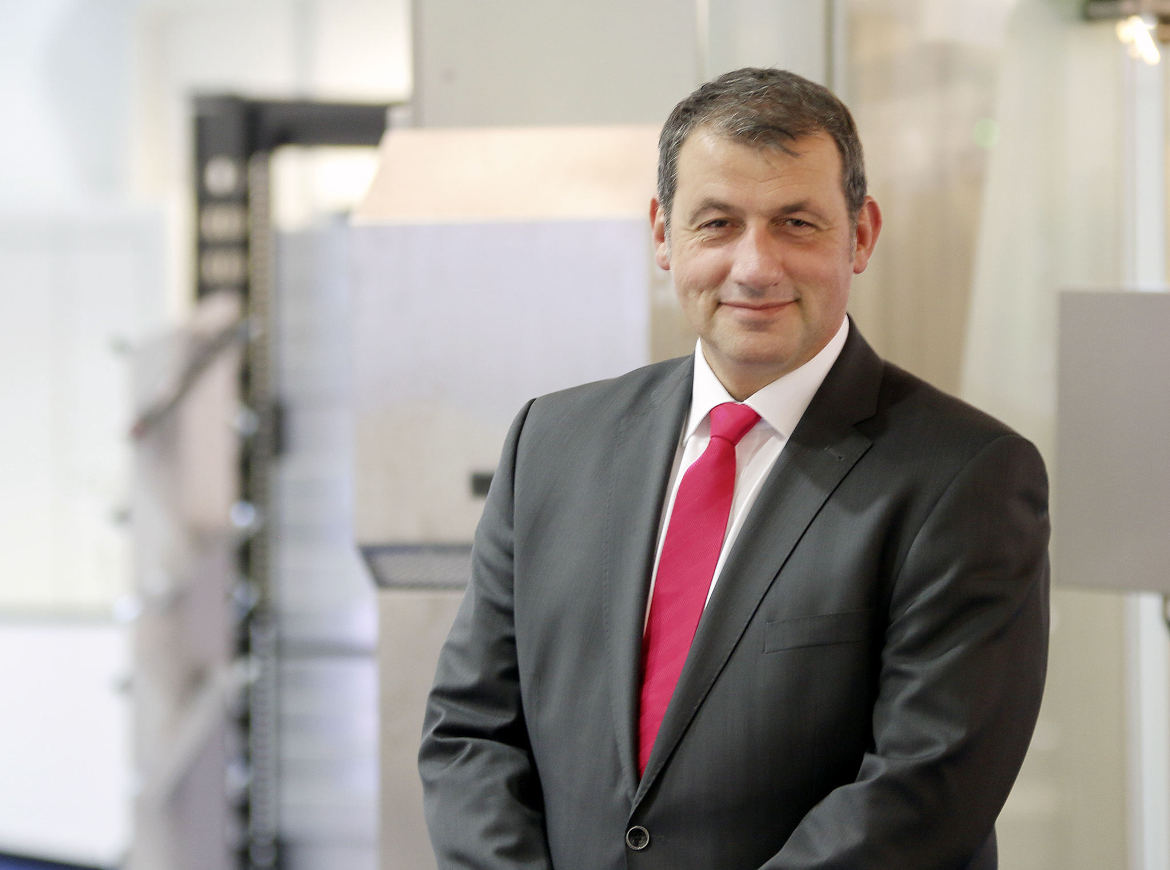
Caption
Mario De Marco now holds the new position of CSO International at Rittal.

May be reproduced free of charge. Please name Rittal GmbH & Co. KG as source.

Rittal

Rittal is a leading global supplier of enclosure systems, automation and infrastructure with its industrial, IT, energy and power, cooling and service units. Rittal products and solutions are used in over 90% of global industries – standardised, customised, and always of the very best quality.
Our approach and methodology: With their combined hardware and software expertise, Rittal, Rittal Software Systems (Eplan and Cideon) and Rittal Automation Systems (RAS, Ehrt, Alfra) optimize, digitize and automate processes along the entire customer value chain, including the IT infrastructure – from panel building and switchgear manufacturing to mechanical engineering, factory operators and the energy sector.
Our delivery promise: Rittal standard products are delivered in Germany within 24 hours, and within 48 hours throughout Europe.
Customer focus
Improving efficiency and increasing productivity through automation and digitalisation is one of the biggest challenges for our customers. This requires in-depth knowledge and expertise, the combination of hardware and software, and cross-sector networking. We are convinced that creating and connecting data rooms is crucial to the success of industrial transformation. And that is exactly our speciality and field of competence.
Eplan and Rittal are driving the development of the digital automation twin, making data accessible and useable in operations as well. Cideon is improving data consistency in the digital product twin context with its CAD/CAM, PDM/PLM and product configuration expertise.
Sustainability
Environmental and climate protection, social commitment and ethical corporate management are a given for Rittal. We take our responsibility for a sustainable future seriously. Our approach to resource management and conservation involves continuous improvement of our own production processes and ensuring that our products have the lowest possible Product Carbon Footprint. Our solutions support our customers in achieving their own climate targets.
Family business and global player
Founded in 1961, Rittal is the largest company in the owner-operated Friedhelm Loh Group. The group operates worldwide, with 13 production sites and 95 international subsidiaries. It has 12,600 employees and posted revenues of 3.1 billion euros in fiscal 2024. In 2023, the Friedhelm Loh Group was presented with the “Best Place to Learn” and “Employer of the Future” awards. In 2025, Rittal was awarded the Top 100 Seal as one of Germany’s most innovative medium-sized companies for the fourth time in a row.
For more information, visit www.rittal.com and www.friedhelm-loh-group.com.

Corporate Communications
Dr. Carola Hilbrand Rittal GmbH & Co. KG
Corporate & Brand Communications Auf dem Stützelberg
Tel.: 02772/505-2527 35745 Herborn
hilbrand.c@rittal.de www.rittal.com

