EcoVadis rating: Rittal is among the top 5 per cent worldwide
Gold for sustainability at Rittal
Herborn, 2025-11-06.
This is a strong signal for the future: Rittal was not only successfully assessed by EcoVadis, but it was also awarded the gold medal for its sustainability, putting the company among the top 5 per cent worldwide.
Taking responsibility for the environment and the society we live in, as well as for fair supply chains, sustainable business practices and transparency: Rittal has firmly anchored this principle of action, and not just in its company principles. It is a key concern of the globally operating family-run business. Having recently been awarded the title “Factory of the Year 2025” for one of the world’s most modern manufacturing facilities for its efficient, end-to-end digitalised production, it now also ranks among the top 5 per cent worldwide in terms of sustainability.

Consistently sustainable
This has now been certified with the EcoVadis Gold Medal, an assessment based on international sustainability standards such as the ten principles of the UN Global Compact, the conventions of the International Labour Organisation (ILO), the Global Reporting Initiative (GRI) standard, and the ISO 26000 standard. It is proof of internationally consistent sustainability management and supply chain transparency. Ecovadis evaluates companies in four key areas: environment, labour and human rights, ethics, and sustainable procurement. Rittal reported significant gains across every category, totalling 18 percentage points.

Decisive improvements
These reasons led to the high ranking: For one thing, Rittal optimised its international emissions management, including the calculation of CO₂ data. Numerous projects have been implemented to increase energy efficiency, including a significant reduction in paint shop temperatures. In 2024 alone, this led to savings of several million kilowatt-hours of energy. Moreover, Rittal has introduced Product Carbon Footprint (PCF) for many of its products. Customers can now view the emission values directly online. The products themselves have also become more energy-efficient: Blue e+ cooling units cut energy consumption by up to 75 per cent and save around one tonne of CO₂ per device annually, as much as one beech tree can absorb in 80 year.

Responsibility goes without saying
The products themselves have also become more energy-efficient: Blue e+ cooling units cut energy consumption by up to 75 per cent and save around one tonne of CO₂ per device annually, as much as one beech tree can absorb in 80 year. ISO 27001 certification underscores the high standards for information security. And what’s more, sustainability doesn’t stop at the factory gates. The company also ensures that its supply chain partners comply with the high standards.

“As a family-run business and global player, we aim to act responsibly in the interests of the people and to safeguard our livelihoods for future generations – in everything we do,” emphasises Philipp Guth, Rittal’s Chief Technology Officer (CTO): “We operate in global markets and supply chains with this attitude, ensuring that we are 100% reliable as a supplier for our customers.”

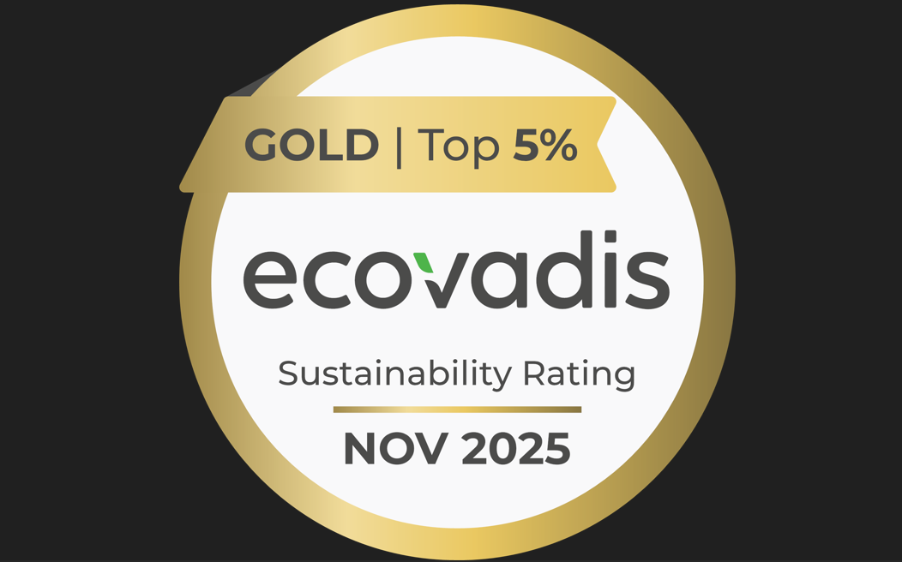 |  | 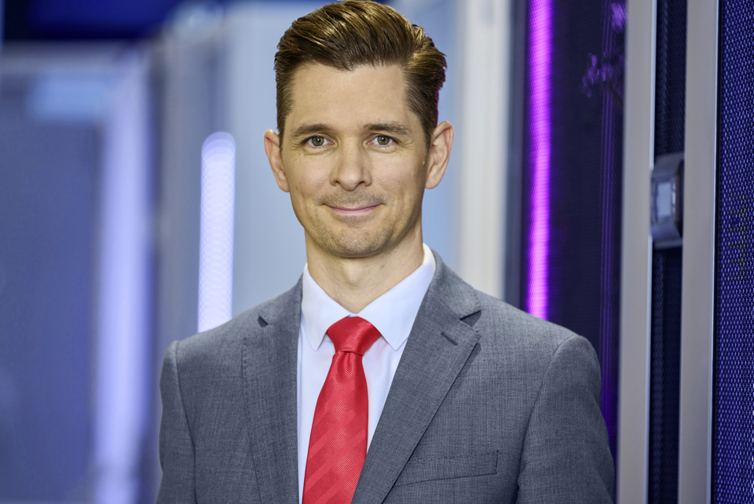
Image 1  The EcoVadis rating is the international standard for company sustainability management and transparency. In this regard. Rittal ranks among the top 5 per cent worldwide. |  | Image 2  Philipp Guth, CTO: “Rittal is part of globally networked supply chains, and responsibility is part of Rittal. We operate in global markets and supply chains with this attitude.”

May be reproduced free of charge. Please name Rittal GmbH & Co. KG as the source.

Rittal

Rittal is a leading global supplier of enclosure systems, automation and infrastructure with its industrial, IT, energy and power, cooling and service units. Rittal products and solutions are used in over 90% of global industries – standardised, customised, and always of the very best quality.
Our approach and methodology: Rittal, Rittal Software Systems (Eplan, Cideon and German Edge Cloud) and Rittal Automation Systems (RAS, Ehrt, Alfra) combine their hardware and software expertise to streamline, optimise and digitalise processes across the entire value chain for our customers including their IT infrastructure – from control and switchgear construction, machine building to factory operators or the energy sector.
Our delivery promise: Rittal standard products are delivered in Germany within 24 hours, and within 48 hours throughout Europe.
Customer focus
Improving efficiency and increasing productivity through automation and digitalisation is one of the biggest challenges for our customers. This requires in-depth knowledge and expertise, the combination of hardware and software, and cross-sector networking. We are convinced that creating and connecting data rooms is crucial to the success of industrial transformation. And that is exactly our speciality and field of competence.
Eplan and Rittal are driving the development of the digital automation twin, making data accessible and useable in operations as well. Cideon is improving data consistency in the digital product twin context with its CAD/CAM, PDM/PLM and product configuration expertise. German Edge Cloud’s ONCITE Digital Production System (DPS) makes production process data transparent, enabling it to be optimised – right through to energy management using digital production twins.
Sustainability
Environmental and climate protection, social commitment and ethical corporate management are a given for Rittal. We take our responsibility for a sustainable future seriously. Our approach to resource management and conservation involves continuous improvement of our own production processes and ensuring that our products have the lowest possible Product Carbon Footprint. Our solutions support our customers in achieving their own climate targets.
Family business and global player
Founded in 1961, Rittal is the largest company in the owner-operated Friedhelm Loh Group. The group operates worldwide, with 13 production sites and over 95 international subsidiaries. It has more than 12,600 employees and posted revenues of 3.1 billion euros in fiscal 2023. In 2023, the Friedhelm Loh Group was presented with the “Best Place to Learn” and “Employer of the Future” awards. In 2025, Rittal was awarded the Top 100 Seal as one of Germany’s most innovative medium-sized companies for the fourth time in a row.
For more information, visit www.rittal.com and www.friedhelm-loh-group.com.

Corporate Communications
Dr. Carola Hilbrand Rittal GmbH & Co. KG
Corporate & Brand Communications Auf dem Stützelberg
Tel.: 02772/505-2527 35745 Herborn
hilbrand.c@rittal.de www.rittal.com

