Direct Liquid Cooling in practical use

AI calls for a cool head:
Rittal and GSI are propelling a data centre transformation
Herborn, 2025-11-14.
Artificial intelligence promises enormous opportunities for both business and research. But are the required data centres ready? Given their power density, AI and high-performance computing are making completely new demands, especially when it comes to cooling. AI applications cannot be operated on a large scale without direct liquid cooling for the processors. One pioneering project for this necessary data centre revolution is now being developed in the German state of Hesse: For the first time, Rittal and the GSI Helmholtz Centre for Heavy Ion Research are putting a new type of water-based liquid cooling system into productive use, so providing a blueprint for the data centres of the future.
Data centres and, consequently, economic growth through AI in Germany could run into a heat trap. Modern applications, such as AI and high-performance computing, demand maximum performance: over 150 kilowatts of power per rack will soon become the standard. This also means something else: a massive amount of heat.
Liquid cooling, rather than the air still commonly used today, must be supplied directly to the new AI chips. This is because the physical limit of air cooling has easily been exceeded.
Rittal, the provider of hardware, automation, and software, has now developed a novel cooling solution to fill this gap: a cooling distribution unit with a cooling output of over one megawatt in compact rack format, which, through its modular construction, can be integrated more easily with data centres in practical operations. The technology has been developed in cooperation with US hyperscalers and server OEMs, who Rittal supplies worldwide. It was used and optimised under real high-load conditions during a collaboration with the GSI in Darmstadt.

The “Universe in the laboratory” in Darmstadt – a lot of computing power for research
The GSI Helmholtz Centre for Heavy Ion Research is bringing the universe to Darmstadt in Germany. A new international accelerator centre, named FAIR, is currently being built here, one of the world’s largest research projects. Here, matter can be investigated in the laboratory in a way that could otherwise only be performed in space. Researchers from around the world can expect new insights into the structure of matter and the evolution of the universe, from the Big Bang to the present.
Green IT Cube: Maximum performance in computing power and energy efficiency
In the future, scientific experiments conducted at FAIR are expected to generate one terabyte of data per second. That’s why the data centre is also setting standards. The “Green IT Cube” on the GSI/FAIR campus is one of the world’s most powerful scientific data centres, as well as one of the most energy-efficient. Racks are now cooled with water from the rear door. The energy needed for cooling is less than seven per cent of the electrical power used for computing (PUE<1.07). With Rittal, GSI is now closing the last air-cooled gap and taking the water right up to the processors. This also creates the optimal conditions for highly efficient heat recovery, resulting in an even smaller carbon footprint. The waste heat is already warming an office and canteen building on the campus. “With the new type of direct chip cooling in cooperation with Rittal, we are breaking new technical ground together, and at the same time performing pioneering work into how such systems can be used on a larger scale in data centres,” says Professor Thorsten Kolleger, Head of IT at GSI. The collaboration between Rittal and GSI extends beyond on-site deployment to setting an example for the data centre world.
Technology multipliers from Hesse
Uwe Scharf, Rittal Managing Director for Sales in Germany, says: “If we want to achieve added value for industry and advance research through AI and high-performance computing, we also quickly have to create the necessary conditions in data centres. Together with GSI in Darmstadt, we are showing how this can be done in practice.” The better the solutions for the practical problems of installation, operation and maintenance, the more likely it is that operators of large data centres will use such solutions. “In Germany, this infrastructure must also be established quickly so that AI can drive growth for industry, research and the digital business,” explains Scharf.
GSI also promotes economic innovation in other ways: It is also opening up capacities in the high-performance data centre to external cooperation partners. The “Digital Open Lab” provides infrastructure and IT expertise for joint development projects and collaborations in the fields of data centres, high-performance computing and AI. It represents an opportunity for SMEs and start-ups.

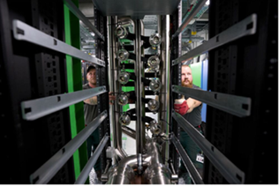 |  | 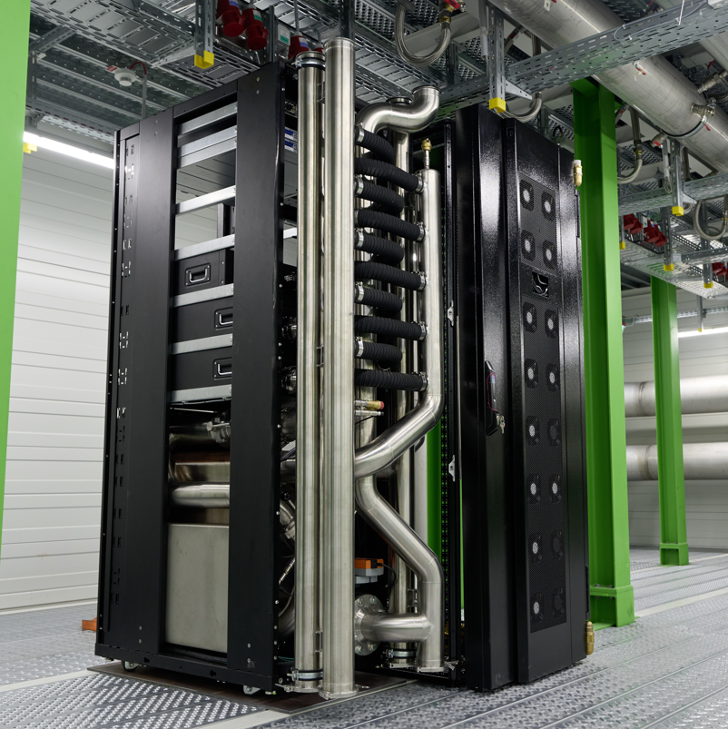
Caption, figure 1  How does the cooling solution get into the data centre? And how is it integrated into the service? These practical issues are highly relevant for use on a large scale. |  | Caption, figure 2  Cooling output of over 1 MW for direct chip cooling with water: Rittal and the GSI are using new cooling technology.

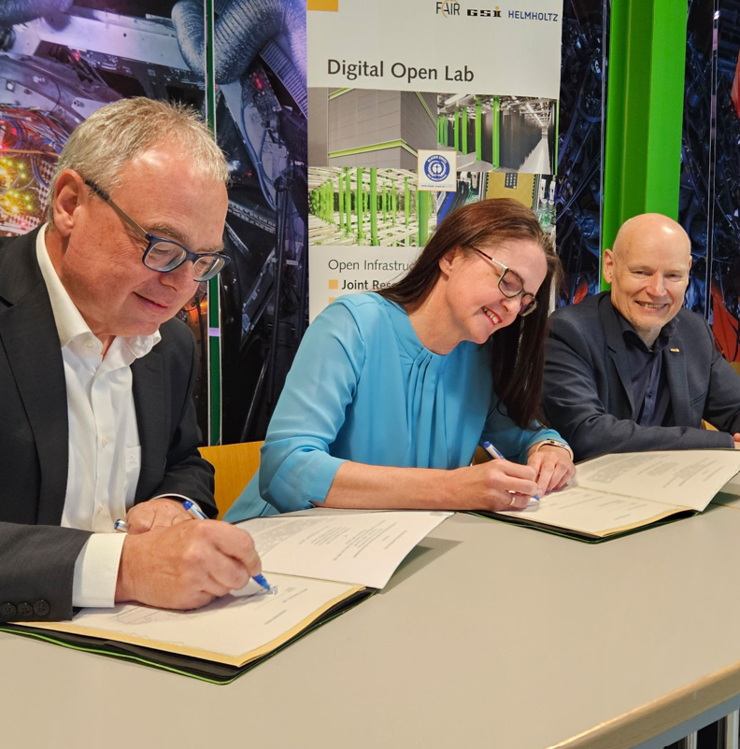

Caption, figure 3
Rittal and GSI sign a cooperation agreement for AI-capable IT cooling (from left to right): Uwe Scharf, Managing Director Rittal Sales Germany, Dr. Katharina Stummeyer, Administrative Managing Director of GSI and FAIR, and Professor Thomas Nilsson, Scientific Managing Director of GSI and FAIR (image: K. Göbel, GSI)

May be reproduced free of charge. Please name as source: Figure 1: K. Göbel, GSI; Figure 2-3: Rittal GmbH & Co. KG

Rittal

Rittal is a leading global supplier of enclosure systems, automation and infrastructure with its industrial, IT, energy and power, cooling and service units. Rittal products and solutions are used in over 90% of global industries – standardised, customised, and always of the very best quality.

Our approach and methodology: Rittal, Rittal Software Systems (Eplan, Cideon) and Rittal Automation
Systems (RAS, Ehrt, Alfra) combine their hardware and software expertise to streamline, optimise and
industiralise processes across the entire value chain of their customers including their IT infrastructure – from control and switchgear construction, machine building to manufacturing companies or the energy
sector.

Our delivery promise: Rittal standard products are delivered in Germany within 24 hours, and within 48 hours throughout Europe.
Customer focus
Improving efficiency and increasing productivity through automation and digitalisation is one of the biggest challenges for our customers. This requires in-depth knowledge and expertise, the combination of hardware and software, and cross-sector networking. We are convinced that creating and connecting data rooms is crucial to the success of industrial transformation. And that is exactly our speciality and field of competence.

Eplan and Rittal are driving the development of the digital automation twin, making data accessible and useable in operations as well. Cideon is improving data consistency in the digital product twin context with its CAD/CAM, PDM/PLM and product configuration expertise.
Sustainability
Environmental and climate protection, social commitment and ethical corporate management are a given for Rittal. We take our responsibility for a sustainable future seriously. Our approach to resource management and conservation involves continuous improvement of our own production processes and ensuring that our products have the lowest possible Product Carbon Footprint. Our solutions support our customers in achieving their own climate targets.
Family business and global player
Founded in 1961, Rittal is the largest company in the owner-operated Friedhelm Loh Group. The group operates worldwide, with 13 production sites and 95 international subsidiaries. It has 12,600 employees and posted revenues of 3.1 billion euros in fiscal 2024. In 2023, the Friedhelm Loh Group was presented with the “Best Place to Learn” and “Employer of the Future” awards. In 2025, Rittal was awarded the Top 100 Seal as one of Germany’s most innovative medium-sized companies for the fourth time in a row.

For more information, visit www.rittal.com and www.friedhelm-loh-group.com.

Corporate Communications
Dr. Carola Hilbrand Rittal GmbH & Co. KG
Corporate & Brand Communications Auf dem Stützelberg
Tel.: 02772/505-2527 35745 Herborn
hilbrand.c@rittal.de www.rittal.com

