Rittal and Eplan at the Hannover Messe “Automation – Do it.”
More speed and scalability with Rittal and Eplan:
This is how industry can maintain its competitiveness
Herborn/Monheim, 13 March 2026.
Industry is under enormous pressure. To stay competitive, companies need to accelerate product development, cut manufacturing costs and deliver clear added value. Mechanical and plant engineers can do this by intelligently linking software, hardware and automation. At the Hannover Messe trade fair (Hall 27, booth D50), Rittal and Eplan are displaying how this three-step approach can also give smaller companies a significant boost in speed and scalability. Solutions will be on show that range from engineering and sourcing to systems technology, automation and service. The continued development of the Eplan product range, the introduction of Eplan Smart Sourcing and Product Change Notification (PCN), new platforms for power supply and cooling for industry and AI-enabled IT infrastructure, a new compact fully automatic wire assembly machine, and a future-proof range of cooling units and chillers to meet the new EU refrigerant requirements are among the highlights.
“Speed is becoming the deciding factor in industry. If you don’t keep up, you’ll lose out to the competition,” says Uwe Scharf, Rittal’s Managing Director Sales Germany and Europe. “Software, hardware and automation must work as an integrated system. This synergy provides the speed and scalability that companies need to plan and manufacture more quickly and run their applications more efficiently.”

Data consistency: The basis for rapid industrial processes
The starting point is in engineering, as this is where the data that controls planning, procurement, manufacturing and operations is generated. The more structured and consistent this data is, the greater the potential to automate and accelerate processes.

“The opportunities offered by automation and AI can only be leveraged if the database is correct,” says Sebastian Seitz, Managing Director of Eplan. “Well-prepared engineering data is becoming a strategic resource in industry”, he adds. In Hanover, Eplan will demonstrate how engineering processes can be simplified and data consistency systematically enhanced. Thanks to the ongoing development of Eplan software, the product range has been significantly streamlined and is now even more focused on typical user workflows. Engineering disciplines can be integrated more easily and form the basis for a digital twin as a ‘single source of truth’.

This data provides new perspectives throughout the entire value chain, all of which will be presented in Hanover. In the future, Eplan Smart Sourcing will make component availability and delivery times visible as early as the engineering stage. Design engineers will be able to recognise early on whether components will be available on time or whether alternatives need to be planned; long rounds of coordination with the purchasing department or suppliers will then be a thing of the past.

Change management for components will also become more transparent. The keyword is ‘Product Change Notification’ (PCN). This permits the sharing of information on component changes. The Eplan application obtains this information from the component manufacturer via the Asset Administration Shell (AAS) and uses it to update the data portal. Then, a message will appear in the portal – automatically, consistently and free of errors. Based on this, users receive advance notice of discontinuations, technical changes or important updates and can immediately take these into account in their engineering work.

From data to automated manufacturing
Structured engineering data also forms the basis for automated production processes. At the Hannover Messe, Rittal will demonstrate how this data can be translated directly into faster, more stable manufacturing processes in plant engineering. The new Wire Terminal WT L from Rittal Automation Systems demonstrates how even smaller panel builders can benefit from fully automatic wire processing. This compact and cost-effective development lowers the barrier to entry for automation and makes these technologies accessible to more companies.

Digital industry needs a new type of IT infrastructure for AI
The Hannover Messe is showcasing the potential of AI for industry through countless use cases. However, large-scale implementation requires breaking new technological ground in terms of IT infrastructure. Artificial intelligence and high-performance computing are pushing data centre power densities to new heights, thus calling for entirely new concepts, especially in power supply and cooling.

At the trade fair, Rittal is showcasing novel infrastructure solutions that enable the necessary data centre transformation for AI. New architectures are bringing power distribution closer to IT systems and enabling modular power supply precisely in the data centre’s white space, even with direct current. Power distribution platforms such as RiLineX and Ri4Power provide the necessary technological foundation. ‘Sidecar’ solutions, in which power electronics components are installed in separate power racks directly next to the server racks, are one example of such architectures. These enable a scalable and standardised power supply for high-density data centre infrastructures.

Cooling is becoming an increasingly important issue as power density rises, not least due to the deployment of AI. Conventional air-based concepts are reaching their physical limits; chips need to be directly cooled with liquid. That’s why Rittal is presenting solutions for direct chip cooling in a special display. These will also open up new possibilities for heat recovery, so addressing the conflict between AI usage and CO₂ footprint.

Visitors will also find solutions that meet the growing demand for industrial and outdoor applications, such as battery storage. Regulatory requirements are also changing the technology here. Starting in 2027, stricter requirements for refrigerants in cooling units and chillers will apply in the EU. Rittal provides a future-proof portfolio that enables mechanical and plant engineers to design their applications in line with regulations early on and make them sustainable in the long term.

In Hanover, Rittal and Eplan are demonstrating how digital value creation works through harmonised software, hardware, and automation solutions: consistent data across engineering, automated manufacturing, and infrastructure, supporting the dynamics of digital applications. System expertise is thus creating new industrial power and enhanced competitiveness in industry and the digital economy.

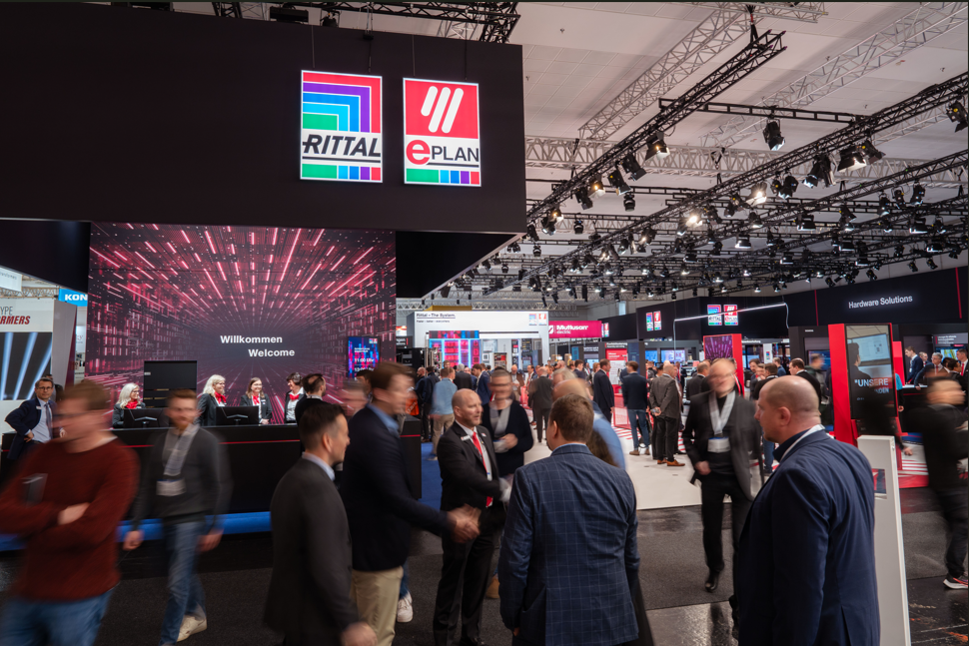 |  | 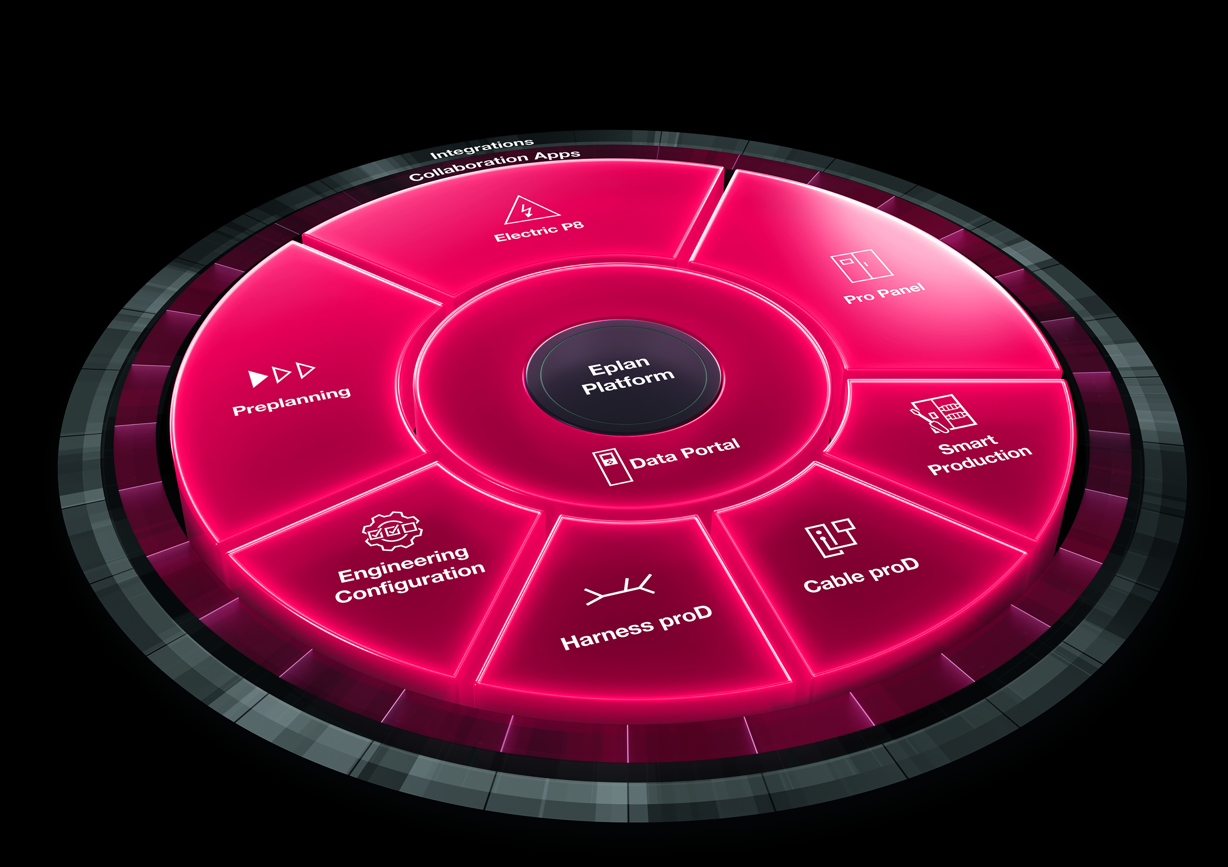
Figure 1  Greater speed and scalability: In Hanover, Rittal and Eplan will show how industry can maintain its competitiveness under the slogan ‘Automation – Do it.’ |  | Figure 2  With the Eplan platform and the newly revamped portfolio, customers are getting real ‘all-in’ packages – at no extra cost.
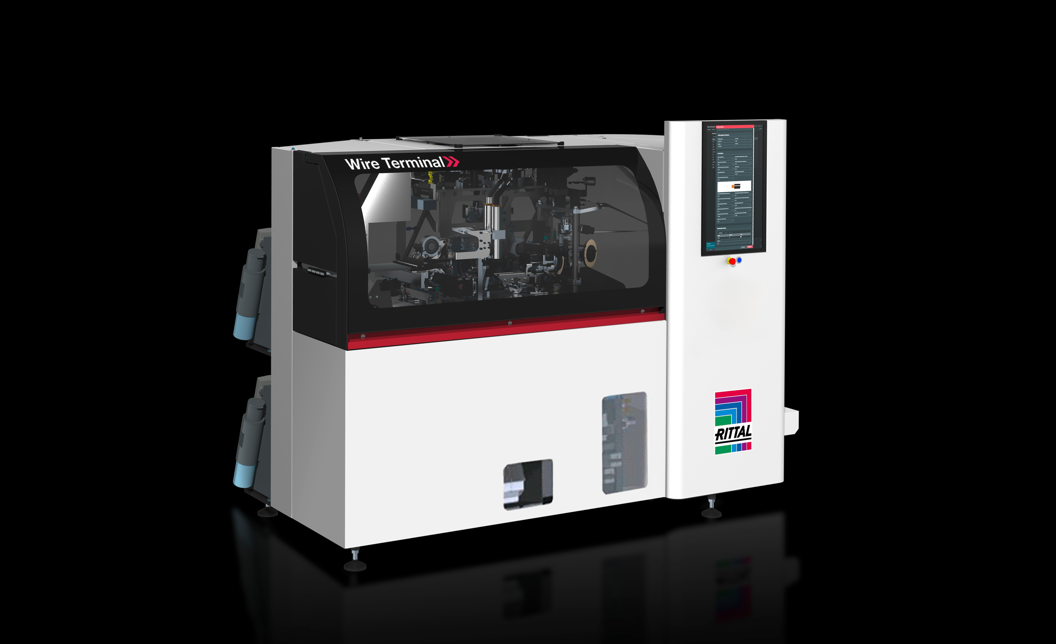  Figure 3  New product at the trade fair: The Wire Terminal WT L lowers the threshold to automation. The new fully automatic wire assembly machines are based on the familiar platform of their larger counterpart. Their use pays off, even with lower throughputs. |  | 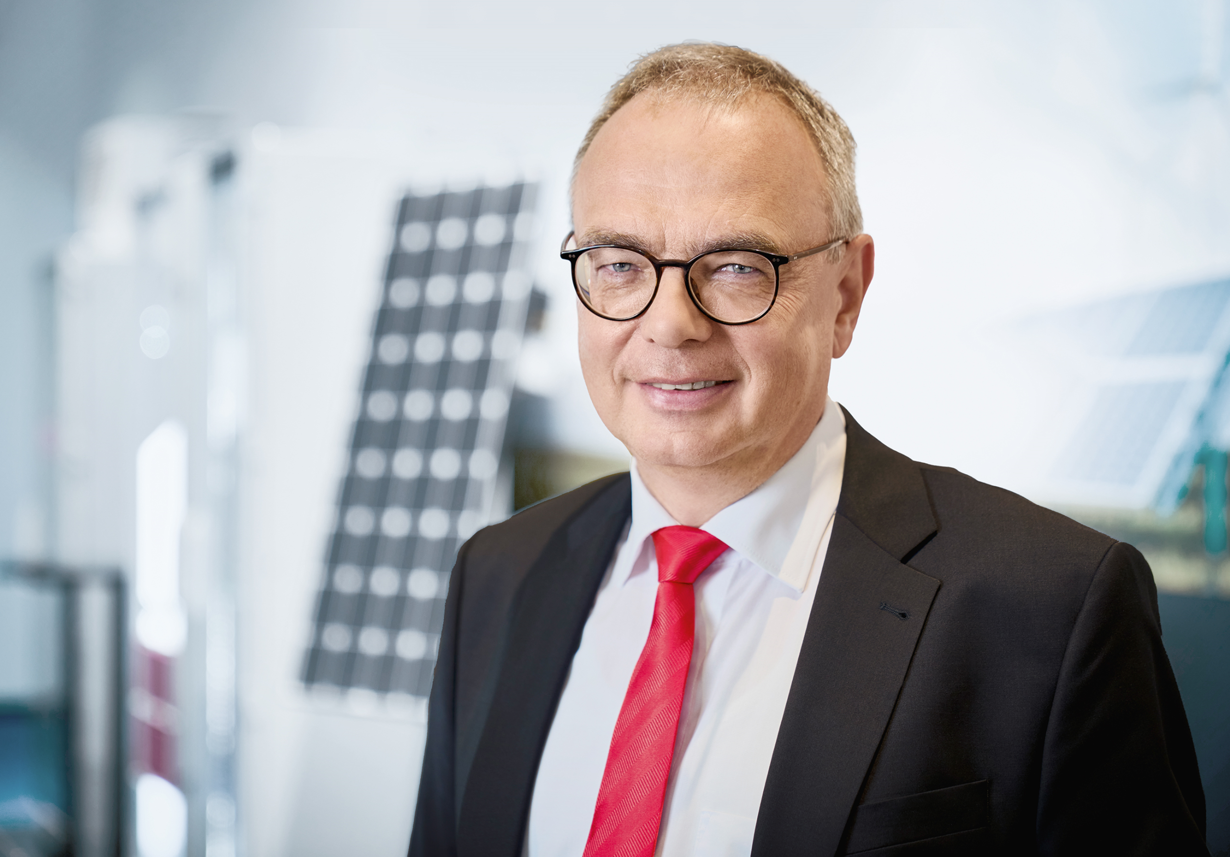  Figure 4  Uwe Scharf, Managing Director Sales Germany and Europe at Rittal: “Speed is becoming the deciding factor in industry. If you don’t keep up, you’ll lose out to the competition. Software, hardware and automation must work as an integrated system.”
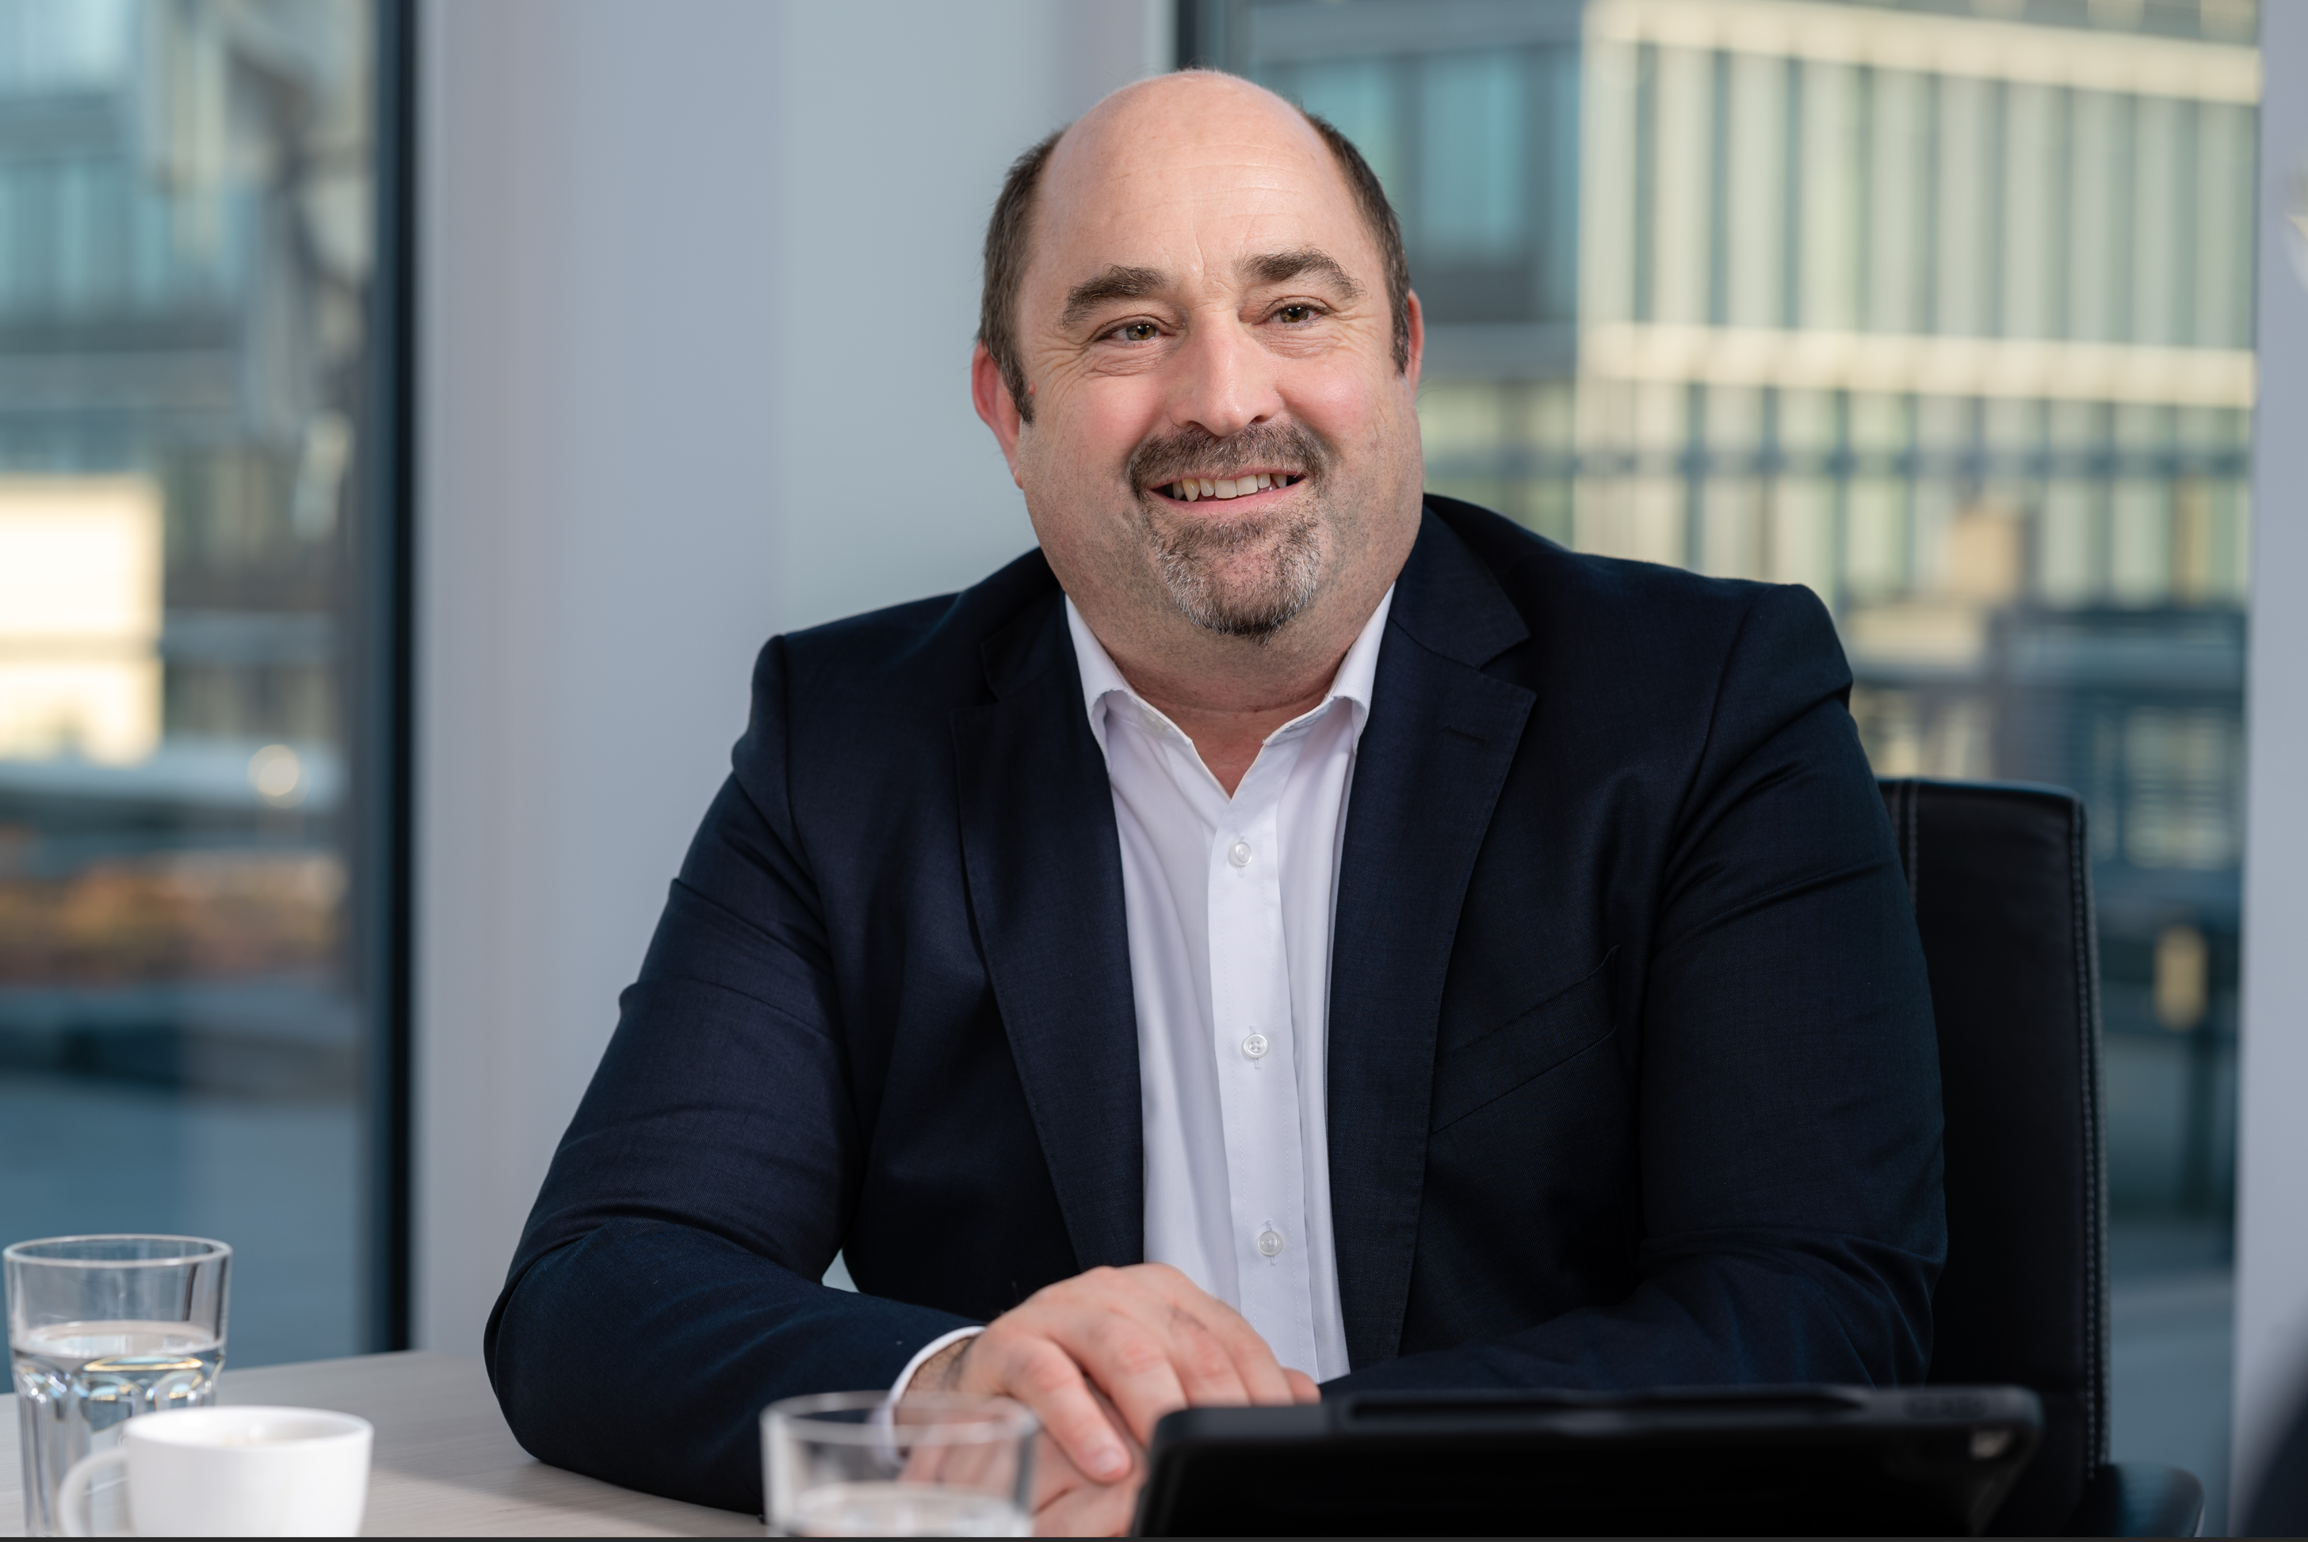

Figure 5
Sebastian Seitz, Managing Director of Eplan: “The opportunities offered by automation and AI can only be leveraged if the database is correct. Well-prepared engineering data is becoming a strategic resource in industry.”

May be reproduced free of charge. Please name Rittal GmbH & Co. KG / Eplan GmbH & Co. KG as the source.
About Rittal and Eplan
Rittal is a leading global systems supplier for hardware, software and automation. Rittal solutions for industrial, IT, energy, power and cooling applications are used in over 90% of global industries. Eplan established one of the world’s leading design software solutions for machine and panel builders and supports customers with software and service solutions in the fields of electrical, automation and mechatronic engineering. Rittal and Eplan are pioneers in advancing AI in software and enabling the capable IT infrastructure. They are part of the owner-operated Friedhelm Loh Group which operates worldwide, with 13 production sites and 95 international subsidiaries. It has 12,600 employees and posted revenues of 3.1 billion euros in fiscal year 2024. In 2023, the Friedhelm Loh Group was presented with the “Best Place to Learn” and “Employer of the Future” awards. In 2026, Rittal was awarded the Top 100 Seal as one of Germany’s most innovative medium-sized companies for the fifth time in a row. The Rittal plant in Haiger achieved overall win in the “Factory of the Year 2025” benchmark competition, confirming its status as one of the best factories in Europe.
For more information, visit www.rittal.com, www.eplan.com and www.friedhelm-loh-group.com.

Corporate & Brand Communications

Birgit Hagelschuer Steffen Maltzan
Spokesperson Eplan Strategy Communications & Press
Tel.: +49 2173/3964-180 Rittal / Friedhelm Loh Group
E-Mail: hagelschuer.b@eplan.de Tel.: +49 2772/505-2680
E-Mail: maltzan.s@rittal.de

