Rittal Toptec and RailwayCube
Outdoor all-rounder for a safe railway infrastructure
Herborn, 2026-03-24
The rail network’s future is digital. Not only must critical IT infrastructure solutions on railway lines and in tunnels withstand heavy loads from rail traffic and environmental conditions, but they must also be securely protected against break-ins and vandalism. Rittal offers robust system solutions that meet the railway industry’s exacting safety requirements. These are the Toptec series of outdoor enclosures designed for railway applications and the RailwayCube – a steel-construction container solution.
The digitalisation wave is also sweeping through the railway sector. From digital signal boxes and train control systems such as the European Train Control System (ETCS), to future partially and fully autonomous trains, yesterday’s standards and analogue-electrical railway technology are being replaced everywhere by intelligent, digital technologies.
Alongside many other solutions, Rittal offers two key products for the rail sector: The Toptec outdoor enclosure, which serves as a solution for FRMCS, transformers, for the dBOS digital radio standard and field element terminal enclosure requirements, as well as for electrical and lighting systems and many other applications, and secondly the RailwayCube, used as a modular container solution for such applications as the Future Railway Mobile Communication System (FRMCS), the Global System for Mobile Communications – Rail (GSM-R), the dBOS public safety radio system, Dense Wavelength Division Multiplexing (DWDM) and track field concentrators (TFCs), or else deployed as a mobile data centre.
Robust enclosures and containers are needed to protect digital equipment along the line, as this is often directly exposed to the elements and to the impacts of passing trains on open stretches of track, in stations, or in the trackside area. In addition to burglar resistance EN 1627, the railway industry requires corrosion protection to safeguard enclosures for 30 years. Last but not least, enclosures need to be climate-controlled and insulated to protect the sensitive digital technology they house from heat, cold and humidity.
On the railways, nothing is possible without certification
Deployment in railway systems requires numerous certifications. Given the major projects currently underway in Germany and across Europe, it is vital that suppliers can not only deliver the correct, certified products but also do so in large quantities, quickly, and at the right time and place. This gives Rittal a considerable advantage as an established supplier of enclosure systems with many years of experience in the railway sector. Rittal’s railway products comply with all specifications, provide appropriate certifications and structural verification, and are designed for easy installation and long-term reliability.
Railway lines can be integrated into the new digital world simply, safely and efficiently with the Toptec range and RailwayCubes from Rittal. This helps tackle the huge challenges facing rail infrastructures in Germany and across Europe.

Toptec: A tried-and-tested model for railway lines
Rittal has been offering outdoor enclosures under the Toptec brand for more than twenty years. The railway-certified models have several distinctive features. They are made entirely of stainless steel, unlike the basic versions, which are aluminium-clad. The enclosures meet resistance class RC2 and can be arranged in any configuration and with doors on all sides. The pre-cast concrete foundation is also bayable and protects the cable harnesses fed in from below, passed through the floor into the enclosure.
The RailwayCube: Well insulated for complex technology
The RailwayCube is a steel-framed container that is three metres wide and three metres high, and up to twelve metres in length, making it somewhat larger than a 40-foot shipping container. Four standard models have been specified to meet the rail industry’s requirements, offering either a single compartment 3, 4.5, or 6.5 metres long, or two separate compartments, each 6.5 metres long. Here too, Rittal offers precast concrete foundations and connecting pipes through which the connection cables can be securely routed into the container. RailwayCubes offer RC4-grade burglar resistance and also meet the KRITIS and NIS2 security requirements.
Toptec enclosures are double-walled, which keeps heat and cold away from the components inside. The RailwayCube series’ insulation meets railway requirements, with a U-value of less than 0.35.
ePocket: Digital documentation for the railways too
As a smart addition, Rittal offers the ePocket system, in which a QR code, affixed to the enclosure or container from the start, eliminates the need for on-site documentation. The documentation for the enclosure or container is already included in the ePocket for every Rittal enclosure; further documents can be very easily added. The result is that every enclosure contains a specific set of documents corresponding to the devices installed within it.

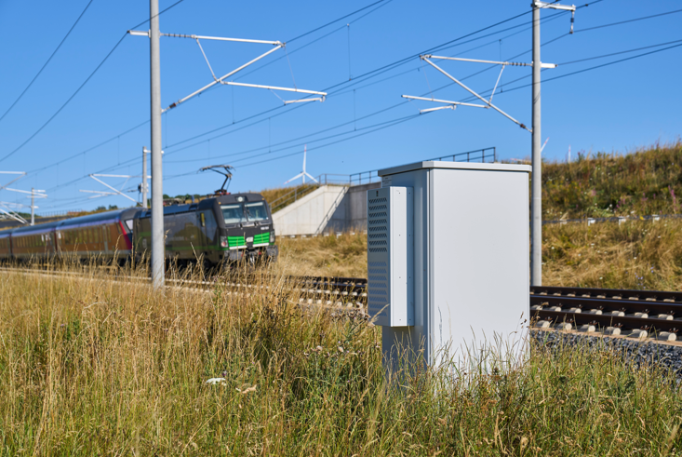

Image 1
Robust enclosures as Rittal Toptec are required to protect digital equipment along railway tracks, as it is often exposed to the elements and to the impacts of passing trains on open stretches of track, stations, or trackside areas.

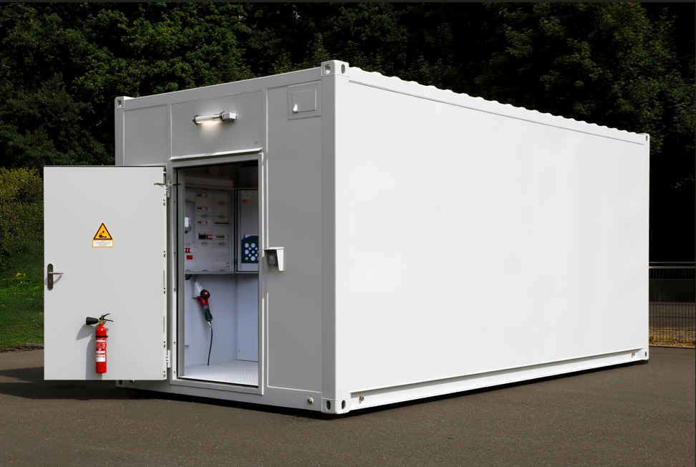

Image 2
The RailwayCube is a steel-framed container that is three metres wide and three metres high, and up to twelve metres in length, making it somewhat larger than a 40-foot shipping container.

May be reproduced free of charge. Please name Rittal GmbH & Co. KG / Eplan GmbH & Co. KG as the source.

Rittal
Rittal is a leading global supplier of enclosure systems, automation and infrastructure with its industrial, IT, energy and power, cooling and service units. Rittal products and solutions are used in over 90% of global industries – standardised, customised, and always of the very best quality.

Our approach and methodology: Rittal, Rittal Software Systems (Eplan, Cideon) and Rittal Automation Systems (RAS, Ehrt, Alfra) combine their hardware and software expertise to streamline, optimise and industrialise processes across the entire value chain of their customers including their IT infrastructure – from control and switchgear construction, machine building to manufacturing companies or the energy sector.

Our delivery promise: Rittal standard products are delivered in Germany within 24 hours, and within 48 hours throughout Europe.
Customer focus
Improving efficiency and increasing productivity through automation and digitalisation is one of the biggest challenges for our customers. This requires in-depth knowledge and expertise, the combination of hardware and software, and cross-sector networking. We are convinced that creating and connecting data rooms is crucial to the success of industrial transformation. And that is exactly our speciality and field of competence.

Eplan and Rittal are driving the development of the digital automation twin, making data accessible and useable in operations as well. Cideon is improving data consistency in the digital product twin context with its CAD/CAM, PDM/PLM and product configuration expertise.
Sustainability
Environmental and climate protection, social responsibility and ethical corporate governance are a matter of course for Rittal. We take our ownership and accountability for a sustainable future seriously. Our commitment to resource management and conservation includes continuous improvement of our own production processes, minimising the carbon footprint of our products and providing solutions that support and help our customers to achieve their own climate goals.
Family business and global player
Founded in 1961, Rittal is the largest company in the owner-operated Friedhelm Loh Group. The group operates worldwide, with 13 production sites and 95 international subsidiaries. It has 12,600 employees and posted revenues of 3.1 billion euros in fiscal 2024. In 2023, the Friedhelm Loh Group was presented with the “Best Place to Learn” and “Employer of the Future” awards. In 2025, Rittal was awarded the Top 100 Seal as one of Germany’s most innovative medium-sized companies for the fourth time in a row. In 2025, the Rittal plant in Haiger won overall first place in the independent and highly-prestigious “Factory of the Year” competition, which recognised it as a hallmark of manufacturing excellence and one of the very best factories in Europe.

For more information, visit www.rittal.com and www.friedhelm-loh-group.com.

Corporate & Brand Communications

Hans Robert Koch Steffen Maltzan
Phone.: +49 2772/505-2693 Phone: +49 2772 505 2680
Mail: koch.hr@rittal.de Mail: maltzan.s@rittal.de

Rittal GmbH & Co. KG, Auf dem Stützelberg, 35745 Herborn, Germany

