Scalable solutions for AI-driven data centre architectures
Rittal at the OCP EMEA Summit 2026
The AI era requires standardised infrastructure
Herborn/Barcelona, 29 April 2026
The rapid spread of artificial intelligence (AI) is bringing about a new era for data centre infrastructure worldwide. Greater computing power, higher power densities and entirely new demands on cooling and power supply require new architectures and ever-increasing use of DC power. At the OCP EMEA Summit 2026 in Barcelona (29–30 April), Rittal will present a practical concept for achieving this transformation. The focus will be on an integrated infrastructure solution combining computing power, cooling and power supply as a standardised unit, designed for high-density AI and high-performance computing applications with OCP architecture.

Artificial intelligence is becoming a key driver of economic growth and causing the demand for high-performance data centre infrastructure to rise rapidly worldwide. Conventional concepts have already reached their physical limits. Within the Open Compute Project (OCP), hyperscalers, server OEMs and other relevant stakeholders are collaborating to develop open, scalable standards for future data centre infrastructure. Rittal is actively shaping these standards within OCP and will present a concept at the OCP EMEA Summit in Barcelona, illustrating the future of data centre infrastructure.

Megawatt AI computing power as a reproducible system
The focus is on a compact infrastructure system (pod) that directly integrates computing power, direct water-based chip cooling and power distribution. It is the answer to the key challenge of high power density and rapid scalability. Over one megawatt of power can be accommodated within a few square metres, which is comparable to the energy requirements of an entire residential district. Such concentration requires precise cooling, a secure power supply and mechanical integration to enable rapid data transfer while ensuring stability and reliability.

The concept compactly bundles the infrastructure into a series of OCP racks as a single system: a central unit for coolant distribution (CDU) on one side, high-performance racks for the computing modules in the middle, and a sidecar for DC power generation and distribution adjacent to the server racks on the other side. This reduces losses, increases scalability, and paves the way for future essential DC infrastructures.

"Such systems are the modern core supply units for the digital future. They are compactly built and designed for high data rates, and they are irreplaceable given the growing importance of AI in business and society," says Thomas Schreiner, Head of Business Development Hyperscale at Rittal. “Hyperscalers are global pioneers of new architectures, which will then serve as conceptual models for other sectors, such as colocation.'

Standardisation for greater speed with Rittal and DG Matrix
The Cooling Distribution Unit, developed by Rittal, delivers over one megawatt of water-based cooling capacity for direct chip cooling in a very compact space. It relies on modularisation for scalability and easy servicing, including 'hot swap'. It utilises the design advantages of the Open Rack V3, which was developed by Rittal within the Open Compute Project (OCP). Rittal’s “Power-Sidecar” uses DG Matrix’s technology to generate DC voltage. It combines the multi-port solid-state transformer (SST) technology from DG Matrix, the world’s leading provider of solid-state transformer solutions, with Rittal’s leading infrastructure systems, including the RiLineX busbar platform. This concept is fully aligned with OCP architectures, including Mount Diablo, as well as NVIDIA’s 800 VDC specifications. Compatibility with 415/480 VAC, ±400 VDC and 800 VDC environments enables flexible deployment. Rittal and DG Matrix will continue to collaborate to expand AI-enabled infrastructure.

Visitors can learn more at Thomas Schreiner’s keynote on the topic: “Infrastructure for the AI Era: High Density Racks, Intelligent Power, Liquid Cooling — Delivered with Speed and Expertise”, on 29 April at 10:50 am, P1-115, P1-116 and P1-117.
At the Rittal stand, visitors will also see further innovations, such as an in-row cooling distribution unit and a new rear-door cooling solution mounted on an MGX rack, which Rittal has developed with NVIDIA for the new architectures.
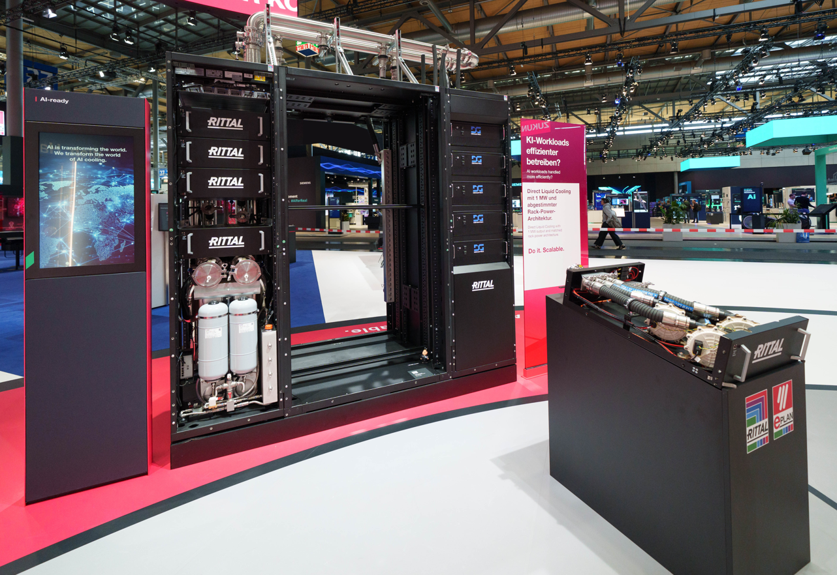 |  | 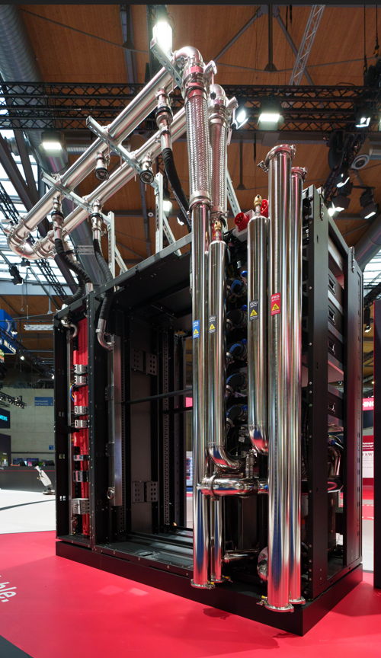
Bild 1  A row of OCP racks configured as a single system provides over a megawatt of power. On the left is the cooling distribution unit (CDU), in the centre are the high-performance racks for the computing modules, and on the right is a sidecar for DC power generation and distribution. |  | Bild 2  The extreme power densities required for AI applications demand not only precise cooling and a reliable power supply, but also mechanical integration that enables rapid data transfer whilst ensuring stability and reliability.
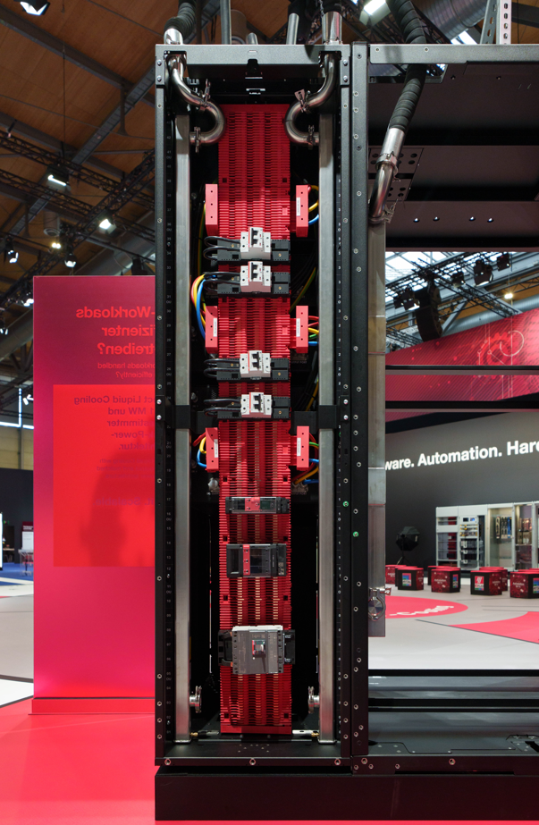

Bild 3
Rittal’s ‘Power-Sidecar’ combines DG Matrix’s Multi-Port Solid-State Transformer (SST) technology with Rittal’s leading infrastructure systems, including the RiLineX busbar platform.

May be reproduced free of charge. Please name Rittal GmbH & Co. KG as the source

Rittal

Rittal is a leading global supplier of enclosure systems, automation and infrastructure with its industrial, IT, energy and power, cooling and service units. Rittal products and solutions are used in over 90% of global industries – standardised, customised, and always of the very best quality.

Our approach and methodology: Rittal, Rittal Software Systems (Eplan and Cideon) and Rittal Automation Systems (RAS, Ehrt and Alfra) combine their hardware and software expertise to streamline, optimise and industrialise processes across the entire value chain of their customers including their IT infrastructure – from control and switchgear construction, machine building to manufacturing companies or the energy sector.

Our delivery promise: Rittal standard products are delivered in Germany within 24 hours, and within 48 hours throughout Europe.
Customer focus
Improving efficiency and increasing productivity through automation and digitalisation is one of the biggest challenges for our customers. This requires in-depth knowledge and expertise, the combination of hardware and software, and cross-sector networking. We are convinced that creating and connecting data rooms is crucial to the success of industrial transformation. And that is exactly our speciality and field of competence.

Eplan and Rittal are driving the development of the digital automation twin, making data accessible and useable in operations as well. Cideon is improving data consistency in the digital product twin context with its CAD/CAM, PDM/PLM and product configuration expertise.
Sustainability
Environmental and climate protection, social responsibility and ethical corporate governance are a matter of course for Rittal. We take our ownership and accountability for a sustainable future seriously. Our commitment to resource management and conservation includes continuous improvement of our own production processes, minimising the carbon footprint of our products and providing solutions that support and help our customers to achieve their own climate goals.
Family business and global player
Founded in 1961, Rittal is the largest company in the owner-operated Friedhelm Loh Group. The group operates worldwide, with 13 production sites and 95 international subsidiaries. It has 12,600 employees and posted revenues of 3.1 billion euros in fiscal year 2024. In 2023, the Friedhelm Loh Group was presented with the “Best Place to Learn” and “Employer of the Future” awards. In 2026, Rittal was awarded the Top 100 Seal as one of Germany’s most innovative medium-sized companies for the fifth time in a row. In 2025, the Rittal plant in Haiger won overall first place in the independent and highly-prestigious “Factory of the Year” competition, which recognised it as a hallmark of manufacturing excellence and one of the very best factories in Europe.

For more information, visit www.rittal.com and www.friedhelm-loh-group.com.

Corporate & Brand Communications

Cornelia Müller Hans Robert Koch Steffen Maltzan
Tel. +49 2772 505-2527 Tel. +49 2772 505-2693 Tel. +49 2772 505-2680
Mail: mueller.co@rittal.de Mail: koch.hr@rittal.de Mail: maltzan.s@rittal.de

Rittal GmbH & Co. KG, Auf dem Stützelberg, 35745 Herborn, Germany
About DG Matrix
DG Matrix has commercialized the world’s first multi-port solid-state transformer to solve the most urgent challenges in deploying power infrastructure for AI datacenters and electrification. Its AI-enabled Interport™ platform acts as the intelligent power fabric of the data center, enabling faster deployment, lower energy costs, and software-controlled integration of all energy sources and loads — at scale, anywhere in the world. Learn more at https://www.dgmatrix.com.

