A new member of the Rittal Partner Network for Energy & Power

Technology partners Rittal and EcoG speed up the integration of charging infrastructure into energy systems

Herborn, 2026-06-22
The rise of electric mobility is driving demand for high-performance charging infrastructure, increasingly so in the commercial vehicle sector. What is needed are modular concepts that can be flexibly integrated into existing energy systems and expanded step by step. Rittal and EcoG are enhancing their partnership to meet this need: The technology company is now a member of the Rittal Partner Network for Energy & Power. Together, the two companies are promoting the development and implementation of modular charging infrastructure as an open system for applications such as electric lorry depots and fleet operations.
“The demands on charging and energy systems grow with the dynamics of the market. Thanks to our partnership with the system specialist Rittal, we can integrate our expertise even more closely and provide customers with better support to implement scalable charging infrastructure at a rapid pace,” says Dr. Jörg Heuer, CEO / Co-Founder EcoG.
“Many operators face the challenge of setting up charging infrastructure without knowing the final stage of development for their sites,” says Dr Christian Maryska, Head of the Energy & Power Solutions Business Unit at Rittal. “This is where modular architectures become relevant. They make it straightforward to expand capacity and charging points in stages, while ensuring seamless integration into existing energy systems. Here, EcoG is the ideal partner. “We need a high degree of standardisation and seamless integration across software and systems engineering to accelerate the urgent expansion of charging infrastructure.”
The results of the collaboration are now available. Together, Rittal and the technology provider EcoG have developed the “Powerblock”, a modular infrastructure platform designed to meet these requirements. The solution permits the gradual expansion of charging capacity and charging points and supports the integration of additional components, such as energy management systems, battery storage systems, or photovoltaic installations.

In contrast to traditional charging infrastructure, the Powerblock takes an open, scalable approach. Operators can adjust their investments to meet actual demand and expand their infrastructure in step with the growth of their vehicle fleets. The design, which incorporates power blocks located behind the charging points, also increases physical flexibility. Since a power block can supply multiple charging points, it takes up less of the often-limited space available in car parks. Integrating the Powerblock as a project within the Eplan platform ensures speed and high data quality from the engineering stage onward.
The partnership combines infrastructure and software expertise
The two companies combine Rittal’s expertise in enclosures, power distribution and climate control with EcoG’s software expertise to deliver the best to their customers. Over the past few years, they have worked closely together on developing the Powerblock, as well as on joint customer projects and trade show appearances. With EcoG’s admission to the Rittal Partner Network, this partnership is now being established for the long term.
The Rittal Partner Network combines expertise from a range of technological fields to offer customers integrated solutions for industrial and energy applications. As a partner in the Energy & Power sector, EcoG is expanding this ecosystem by contributing its expertise in developing and managing modern charging infrastructures.
Electric lorry depots as a key use case
Another focus for future joint activities will be on the charging infrastructure for electric commercial vehicle fleets. In particular, depot solutions are becoming increasingly important as companies continue electrifying their transport and logistics fleets. “The key here is to take an integrated approach to charging points, power supply and energy management. The Powerblock allows us to offer our customers a solution which can be adapted to different sizes of site and power requirements, and which allows for a phased expansion,” says Dr. Christian Maryska.

Joint appearance at the “Smarter E Europe”
Rittal and EcoG will demonstrate how this collaboration actually works at the Smarter E Europe 2026 event, being held in Munich from 23 to 25 June. There, the companies will showcase the Powerblock as well as specific examples of depot charging solutions for commercial vehicles — at Rittal and Eplan at booth B5.310, and as an original replica of a depot with the Powerblock and various dispenser options at the EcoG booth, B6.130. Visitors will learn how to integrate charging infrastructure into modern energy systems and discover how charging capacity, energy supply, and future expansions can be combined within a modular infrastructure architecture.

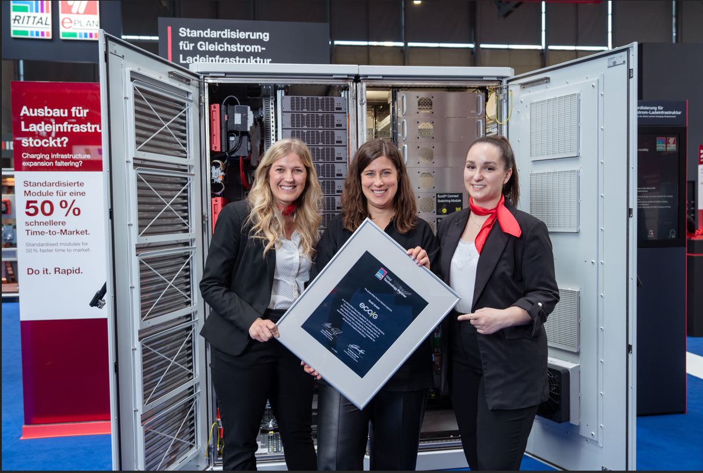 |  | 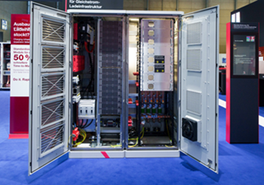
Caption  Alliance for a rapid, modular charging infrastructure: Verena Freund from Rittal, Veronika Dickert from EcoG and Kaja Milberg from Rittal (from the left) |  | Caption  Charging infrastructure for scalable applications in charging parks, electric lorry depots and fleet sites: as a modular infrastructure platform, the “Powerblock” combines Rittal’s system technology for enclosures, power distribution and climate control with EcoG’s software expertise.

May be reproduced free of charge. Please name Rittal GmbH & Co. KG as the source.

About EcoG

EcoG is a leading B2B technology company for EV charging infrastructure with locations in Munich, Detroit (USA), and Pune (India). The company provides, among other things, reference designs and a standardized operating system for charging infrastructure, and offers one of the world's fastest-growing platforms for manufacturers of fast-charging stations. With the EcoG OS platform, manufacturers can efficiently produce charging infrastructure and operators can optimally integrate their charging parks into business processes – from passenger car fleets to large logistics and truck charging hubs. EcoG is a technology leader with over 25,000 systems deployed worldwide and drives standardization for bidirectional and megawatt charging, among others. It was awarded the German Innovation Award and holds around a 15% market share in Europe and 11% in India. Its customers include Siemens, ABB, Valeo, and Dover Fueling Solutions – the largest equipment supplier for gas stations in the USA – as well as other international partners.
About Rittal

Rittal is a leading global supplier of enclosure systems, automation and infrastructure with its industrial, IT, energy and power, cooling and service units. Rittal products and solutions are used in over 90% of global industries – standardised, customised, and always of the very best quality.
Our approach and methodology: Rittal, Rittal Software Systems (Eplan and Cideon) and Rittal Automation Systems (RAS, Ehrt and Alfra) combine their hardware and software expertise to streamline, optimise and digitalise processes across the entire value chain for our customers including their IT infrastructure – from control and switchgear construction, machine building to factory operators or the energy sector.
Our delivery promise: Rittal standard products are delivered in Germany within 24 hours, and within 48 hours throughout Europe.
Customer focus
Improving efficiency and increasing productivity through automation and digitalisation is one of the biggest challenges for our customers. This requires in-depth knowledge and expertise, the combination of hardware and software, and cross-sector networking. We are convinced that creating and connecting data rooms is crucial to the success of industrial transformation. And that is exactly our speciality and field of competence.
Eplan and Rittal are driving the development of the digital automation twin, making data accessible and useable in operations as well. Cideon is improving data consistency in the digital product twin context with its CAD/CAM, PDM/PLM and product configuration expertise.
Sustainability
Environmental and climate protection, social commitment and ethical corporate management are a given for Rittal. We take our responsibility for a sustainable future seriously. Our approach to resource management and conservation involves continuous improvement of our own production processes and ensuring that our products have the lowest possible Product Carbon Footprint. Our solutions support our customers in achieving their own climate targets.
Family business and global player
Founded in 1961, Rittal is the largest company in the owner-operated Friedhelm Loh Group. The group operates worldwide, with 13 production sites and 94 international subsidiaries. It has more than 12,900 employees and posted revenues of 3.2 billion euros in fiscal year 2025. In 2023, the Friedhelm Loh Group was presented with the “Best Place to Learn” and “Employer of the Future” awards. In 2026, Rittal was awarded the Top 100 Seal as one of Germany’s most innovative medium-sized companies for the fifth time in a row. In 2025, the Rittal plant in Haiger won overall first place in the independent and highly-prestigious “Factory of the Year” competition, which recognised it as a hallmark of manufacturing excellence and one of the very best factories in Europe.
For more information, visit www.rittal.com and www.friedhelm-loh-group.com.

Corporate & Brand Communications

Cornelia Müller Hans Robert Koch Steffen Maltzan
Tel. +49 2772 505-2527 Tel. +49 2772 505-2693 Tel. +49 2772 505-2680
E-Mail: mueller.co@rittal.de Mail: koch.hr@rittal.de Mail: maltzan.s@rittal.de

Rittal GmbH & Co. KG, Auf dem Stützelberg, 35745 Herborn

