Future-focussed dialogue leads to agreement
Corporate Communications
Regina Wiechens-Schwake
Phone: +49 2772 505-2527
E-mail: wiechens-schwake.r@rittal.de
Dr Carola Hilbrand
Phone: +49 2772 505-2680
E-mail: hilbrand.c@rittal.de
Rittal GmbH & Co. KG
Auf dem Stützelberg
35745 Herborn, Germany
www.rittal.com

Rittal agrees redundancy programmes with works councils
Excellent progress is being made with the reorientation of the production structure. Four of the five works councils affected have concluded a redundancy programme with company management. Subject to the production plant in Herborn following suit, the way is now clear for investing €250 million in the future of the Rittershausen, Haiger and Hof sites.
Herborn, 21 February 2017 – Following the reconciliation of interests in 2016, intensive consultation has today led to redundancy programmes being concluded for the production facilities in Burbach, Rennerod and Wissenbach that are to close. Agreement has also been reached on the changes at the Hof plant. Herborn is the only production plant where negotiations are still ongoing in the form of arbitration committee proceedings. The works councils that have signed agreements and company management very much regret that this has not yet been achieved with the works council in Herborn despite the efforts of everyone involved.
In addition to severance payments, the redundancy programmes also provide for commuting allowances, interim assistance, recognition of years of service if changing sites, standard wage maintenance agreements, etc. In addition, Rittal will be setting up a temporary transfer company for departing staff to provide them with training/qualifications and help find them new jobs.
“Constructive, future-focussed dialogue during the negotiations produced a socially acceptable result that takes into account employees’ professional and living circumstances in a fair and reasonable way,” explains Markus Betz, Chairman of the Rittal Works Council on behalf of the signatories from the four production plants.
“Our aim is to achieve long-term success in the region. With this jointly devised redundancy programme we are assuming social responsibility while also investing boldly in the future,” says Dr. Friedhelm Loh, owner and CEO of the Friedhelm Loh Group. “I’m grateful that the management’s plans have met with such widespread agreement amongst staff and the works councils. This is a good basis for Rittal’s future. I’d like to say a particular thank you to the works councils for their tough but fair and goal-oriented negotiations,” he adds.
Ultra-modern production at Haiger site
The world’s largest compact enclosure plant will open at the Haiger site in 2018. The design concept is based on introducing state-of-the-art workflow and production processes – from customer order all the way through to delivery in line with Industry 4.0 standards. Rittal already supplies all standard products within 24 hours in Germany. The new fully automated logistics centre and trendsetting production technology will act as a model for structuring Rittal production plants worldwide. With this investment, Rittal is sticking to its strategy of safeguarding jobs in the region as far as possible by rationalising production. “We want to offer the people in the region who have contributed to the success a chance for a good future,” says Dr. Loh.
(3,072 characters)
■

Captions
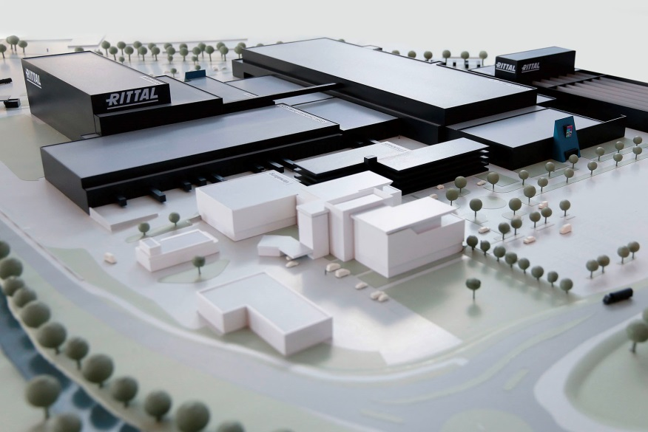
Fri162018100: Excellent progress is being made with the reorientation of the production structure. Four of the five works councils affected have concluded a redundancy programme with company management.
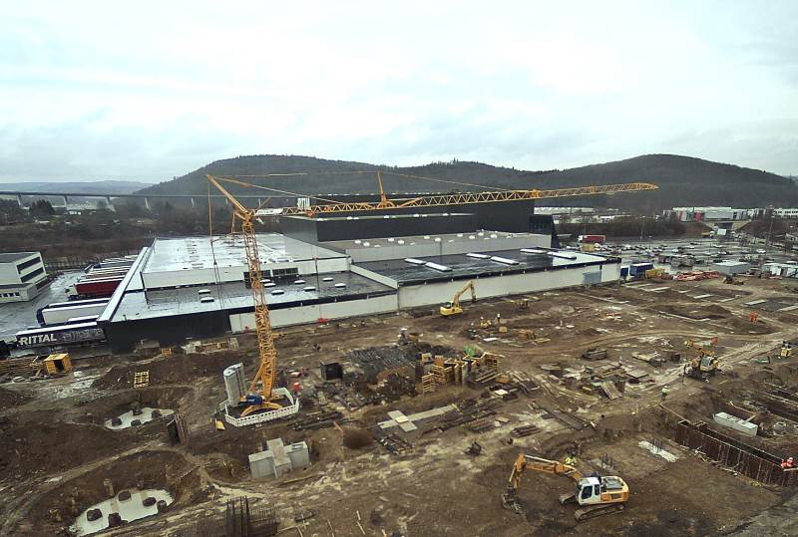
Fri172000900: Recent photo of the Rittal construction site in Haiger. The world’s largest compact housing plant will open here in 2018.
May be reproduced free of charge. Please name Rittal GmbH & Co. KG as the source.

About Rittal
Rittal, headquartered in Herborn, Germany, is a leading global provider of solutions for industrial enclosures, power distribution, climate control and IT infrastructure, as well as software and services. Systems made by Rittal are deployed across a variety of industrial and IT applications, including vertical sectors such as the transport industry, power generation, mechanical and plant engineering, IT and telecommunications. Rittal is active worldwide with 10,000 employees and 58 subsidiaries.
Its broad product range includes infrastructure solutions for modular and energy-efficient data centres with innovative concepts for the security of physical data and systems. Leading software providers EPLAN and Cideon complement the value chain, providing interdisciplinary engineering solutions, while Rittal Automation Systems offer automation systems for switchgear construction.
Founded in Herborn in 1961 and still run by its owner, Rittal is the largest company in the Friedhelm Loh Group. The Friedhelm Loh Group operates worldwide with 18 production sites and 78 international subsidiaries. The entire group employs more than 11,500 people and generated revenues of around €2.2 billion in 2015. In 2016, it was named one of Germany’s leading employers by the Top Employers Institute, for the eighth year running.
For more information, visit www.rittal.com and www.friedhelm-loh-group.com.

