Friedhelm Loh Group recognised for the ninth year running
Corporate Communications
Regina Wiechens-Schwake
Phone: +49 2772 505-2527
E-mail: wiechens-schwake.r@rittal.de
Dr Carola Hilbrand
Phone: +49 2772 505-2680
E-mail: hilbrand.c@rittal.de
Rittal GmbH & Co. KG
Auf dem Stützelberg
35745 Herborn, Germany
www.rittal.com

Friedhelm Loh Group named a top employer for its commitment to its people
The Top Employers Institute has declared the Friedhelm Loh Group a “Top German Employer” for the ninth year running. The Group passed a rigorous selection process and received this honour in 2017 thanks to its various skills development programmes, highly effective communications with employees, and value-driven corporate culture.
Herborn, Germany, 31 March 2017 – For the Friedhelm Loh Group, success goes hand in hand with strong values and a sense of community. The family-owned company has a global outlook and regional roots in Haiger (Germany). It aims for international growth and is firmly committed to a value-driven corporate culture. That is why the Top Employers Institute this year again voted the Friedhelm Loh Group one of Germany’s best employers. This accolade was chiefly the result of superlative scores in the categories “Skills development”, “Communications” and “Corporate culture”. “We are very proud of this title. It underlines the outstanding working environment that Friedhelm Loh Group offers employees, and the popularity of our skills development initiatives,” says Jörg Müller, the global player’s Senior Vice President for Human Resources. “But we don’t intend to stop here. We want to continue to improve working conditions for our staff,” he adds.
Every year, the Top Employers Institute recognises companies who excel in human resources management and strategy, devise creating employee development programmes, and offer a highly attractive working environment. The title of “Top German Employer” is only awarded to companies that complete an extensive certification process, fulfilling strict requirements in multiple categories. Firms must also pass an on-site audit to prove their credentials as a first-rate employer.
Similarly, the Group’s Monheim-based subsidiary, Eplan, performed exceptionally well in a separate audit, leading to recognition as a “Top German Employer” for the third time. Eplan was particularly commended for excellence in onboarding, performance management, career and succession planning.
Preparing staff for the challenges of Industry 4.0
This year the Top Employers Institute once again applauded the Friedhelm Loh Group for fulfilling its social responsibilities. Employees donate to regional charities annually and to international aid agencies on an ad-hoc basis. The Rittal Foundation supports local projects wherever the Group’s companies operate. Two areas that garnered particular acclaim were employee skills development and employee communications. The Group’s in-house training facility, the Loh Academy, has offered more than 25,000 seminars and workshops to date, including the “Leading with passion” programme, which lasts several months. The Academy’s innovative initiatives, such as the Opportunities Centre that encourages employees to discover their strengths and talents, found favour with the Top Employers Institute – and with junior staff. The Academy is responsible for some 70 StudiumPlus students participating in cooperative education programs. These combine classroom studies with hands-on work experience. The Group also employs more than 200 trainees. From early on, they are given real responsibility, sent abroad, or assigned leadership positions at a junior enterprise. “Motivated and engaged employees are key to our success. That’s why we continuously invest in their development,” explains Müller.
The Institute also praised in-house communications at the family-owned yet global company. The Group’s magazine, Rundblick, has kept the workforce informed of developments for six decades and was cited as a prime communications channel. Moreover, the Institute highlighted the exceptional practice of reporting on top management issues via the company intranet. News and information is shared freely and openly with employees at every level through articles, photo galleries and videos. “Effective employee communications helps us to develop genuine team spirit. And that is a critical success factor,” emphasises Regina Wiechens-Schwake, Corporate Communications Director.
Mr Müller is well aware that workplace digitisation will be a major issue going forward. “As our processes become increasingly integrated, all of us will develop new skills. This is an exciting task, and we will make sure all employees are fully prepared to master it. Together, we will equip ourselves to rise to tomorrow’s challenges,” he says.
(6,813 characters)
■
Caption(s)
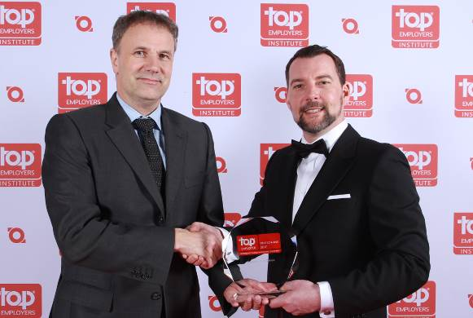
Firma Dateiname.jpg: The Top Employers Institute has declared the Friedhelm Loh Group a “Top German Employer” for the ninth year running. Jörg Müller (left), Senior Vice President for Human Resources, accepted the award from Steffen Neefe (right), Country Manager for the DACH region at the Top Employers Institute.
May be reproduced free of charge. Please name Rittal GmbH & Co. KG as the source.
Friedhelm Loh Group
A global player, the Friedhelm Loh Group (F.L.G.) invents, develops, and makes made-to-measure products and integrated solutions for manufacturers, distributors, and other businesses. Member companies of the Group lead their respective industries in innovation and quality. They include the world’s leading provider of modular platforms for enclosures, power distribution, climate control and IT infrastructure (Rittal); Europe’s number one supplier of software solutions for plant engineering, general engineering, and manufacturing; and a specialist in integrated manufacturing with state-of-the-art materials – steel, aluminium, and plastics.
The family-owned company maintains a worldwide presence, with 18 production sites and 78 subsidiaries. Managed by founder Dr Friedhelm Loh himself, the Group employs over 11,500 people and generated revenues of approximately €2.2 billion in 2015. It was named one of Germany’s Top Employers in 2016, for the eighth year in a row. Within the scope of a Germany-wide survey, Focus Money magazine identified the Friedhelm Loh Group as one of the nation’s best providers of vocational training.
For more information, visit www.friedhelm-loh-group.com.

