“Milestones in electronics”: Rittal honoured with award
Corporate Communications
Regina Wiechens-Schwake
Phone: +49 2772 505-2527
E-mail: wiechens-schwake.r@rittal.de
Dr Carola Hilbrand
Phone: +49 2772 505-2680
E-mail: hilbrand.c@rittal.de
Rittal GmbH & Co. KG
Auf dem Stützelberg
35745 Herborn, Germany
www.rittal.com

Rittal honoured as an electronics pioneer
Rittal has been recognised by trade magazine “Elektronikpraxis” as a “Milestone in Electronics”. In the context of the magazine’s 50th anniversary, the world’s provider of industrial enclosures, power distribution, climate control and IT infrastructure won the award in the category of enclosures and climate control. The jury praised Rittal’s decisive influence on Germany as an industrial location and its groundbreaking technologies.
Herborn, 7 July 2017 – The abilities to look both back and into the future were the decisive characteristics that enabled Rittal to impress when the “milestones of electronics” awards were handed out. On the occasion of the fiftieth anniversary of the “Elektronikpraxis” trade publication, the journal paid tribute to some 20 leading companies in the electronics industry for their services and solutions that are defining Germany as an industrial location. Rittal, a family business with a long-standing tradition, which develops energy-efficient products and intelligent value chains for the future, made a great impression on the jury. “Technology is changing rapidly. And electronics is its turbo-drive for innovation,” said Johann Wiesböck, editor-in-chief and publisher, outlining the significance of the companies so honoured.
During the magazine’s selection process, a jury of trade journalists intensively researched and discussed the most important people in the companies, their greatest achievements and their progress today. The most important aspect was the major role that the companies concerned play in Germany. Rittal is the most important milestone in the category of enclosures and climate control, according to the jury. The inventive spirit of Rudolf Loh, the founder of Rittal, and the consistent growth of the company brought about by his son Dr Friedhelm Loh had marked the beginning of standardised enclosure manufacturing. Rittal succeeded in achieving a further quantum leap towards greater efficiency and environmental protection when converting all its enclosure cooling units to innovative hybrid technology and CFC-free refrigerants. Today, the world market leader is developing efficient workflows in production that save time and money. “Today it is also important to us that our cooling units consume less and less energy and save carbon dioxide”, said Ralf Schneider, Head of Product Management and Business Development Climate Control at Rittal: “Our cooling units offer our customers cost-effective solutions and make an active contribution to climate protection.”
(2,634 characters)
■
Caption(s)
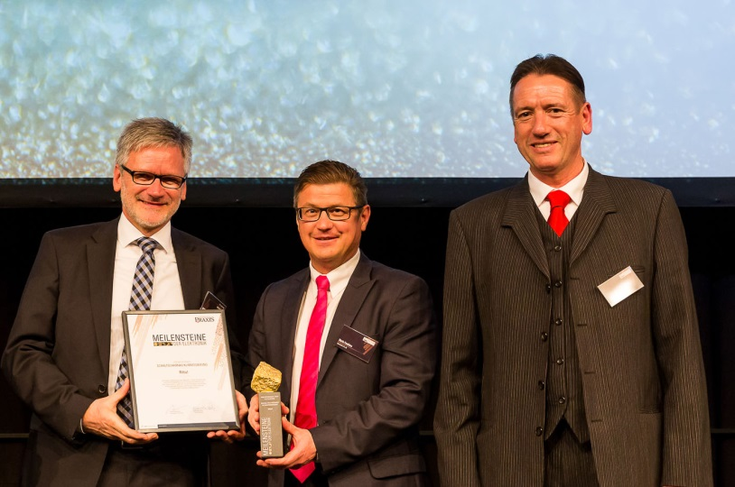
Fri172010500.jpg: During the anniversary celebrations in Munich’s Wappenhalle (coat-of-arms hall), chief editor Wiesböck (right) handed over the “Milestone of Electronics” to Rittal, represented by Martin Kandziora (centre), Head of Market Communication, and Ralf Schneider (left), Rittal’s Head of Product Management and Business Development Climate Control.
May be reproduced free of charge. Please name Rittal GmbH & Co. KG as the source.
About Rittal
Rittal, headquartered in Herborn, Germany, is a leading global provider of solutions for industrial enclosures, power distribution, climate control and IT infrastructure, as well as software and services. Systems made by Rittal are deployed across a variety of industrial and IT applications, including vertical sectors such as the transport industry, power generation, mechanical and plant engineering, and in IT and telecommunications. Rittal is active worldwide with around 9,300 employees and 58 subsidiaries.
Its broad product range includes infrastructure solutions for modular and energy-efficient data centres with innovative concepts for the security of physical data and systems. Leading software providers Eplan and Cideon complement the value chain, providing interdisciplinary engineering solutions, while Rittal Automation Systems offer automation systems for switchgear construction.
Founded in Herborn in 1961 and still run by its owner, Rittal is the largest company in the Friedhelm Loh Group. The Friedhelm Loh Group operates worldwide with 18 production sites and 80 international subsidiaries. The entire group employs more than 11,300 people and generated revenues of around €2.2 billion in 2016. In 2017, it was named one of Germany’s leading employers by the Top Employers Institute, for the ninth year running. Within the scope of a Germany-wide survey, Focus Money magazine identified the Friedhelm Loh Group as one of the nation’s best providers of vocational training for the second year in succession in 2017.
For more information, visit www.rittal.com and www.friedhelm-loh-group.com.

