The state of Hesse confers honorary professorship on Dr Friedhelm Loh
Corporate Communications
Regina Wiechens-Schwake
Phone: +49 2772 505-2527
E-mail: wiechens-schwake.r@rittal.de
Dr Carola Hilbrand
Phone: +49 2772 505-2680
E-mail: hilbrand.c@rittal.de
Rittal GmbH & Co. KG
Auf dem Stützelberg
35745 Herborn
Germany
www.rittal.com

A strong role model who creates value – Dr Friedhelm Loh awarded honorary professorship
A successful, family-run company, support for research and teaching, social and Christian commitment – entrepreneur Dr Friedhelm Loh is setting standards in business and science. The unyielding commitment of the family entrepreneur has now been honoured with a very special award. During an evening ceremony held at the Rittal headquarters on Stützelberg, Herborn, the German State of Hesse presented Dr Loh with the title of honorary professor for his countless services to the region.
Haiger, 24 November 2017 – “You are a very special Hessian,” declared Boris Rhein, Minister for Science and the Arts of Hesse, who said the state was very lucky to have him. Explaining the reasons for this special honour, the Minister drew reference to the foundations and hard work of Dr Loh who, he said, is one of the biggest champions of education and learning. On behalf of the German state of Hesse, he then conferred the title of honorary professor on the entrepreneur: “In addition to his successful business ventures, Dr Loh has also supported children, young people and employees in furthering their personal and professional development. That makes him a very worthy recipient of the title honorary professor.”
Speakers from the worlds of politics, wider society and the sciences came to Stützelberg to show their appreciation for the tireless entrepreneur during a celebration that was also attended by family members, friends and managers.
A values-based entrepreneur
“The German economy is also well placed thanks to your input,” said Hans-Jörg Bullinger, former President of the Fraunhofer-Gesellschaft and member of the Advisory Board of the Friedhelm Loh Stiftung. In his speech, he also described the unconventional ways that Dr Loh has gone about achieving his success: “You have a charismatic personality as a manager,” he said, before going on to describe how he has had an impact on the economy and industry. Bullinger pointed out that not only has he shaped a globally successful group, he has also helped the entire sector move forward in his role as a president and now an honorary president for life of the German Electrical and Electronic Manufacturers’ Association (ZVEI). Industry 4.0, networked production, the digital future – all these are issues that Loh has made his own and driven forward, he continued: “You make things that are new. Simply managing things that already exist is not enough for you.”
This drive, Bullinger added, has also led to the huge success of the group, because Dr Loh has always picked up on new developments and actively taken them forward: “He has been constantly on the look-out for better solutions and pursues unconventional approaches from disciplines that initially seem out of place.”
Finally, the speaker described Dr Loh as “one of the most capable managers and valuable people I know.” He is valuable, Bullinger explained, because he acts in accordance with deeply held values as an entrepreneur and committed Christian. Because he always creates value by appreciating value. And because he creates financial and social values where there were none beforehand.
Speaking for the company, Dr Karl-Ulrich Köhler, CEO of Rittal International, also thanked the family entrepreneur for his strong backing: “For you, trust and responsibility, future and tradition, belong together,” said Köhler. “Hesse, the people of the region and all of us in the company have a lot to thank you for.”
Scientific and social commitment
In his speech, Stephan Holthaus, a theologian and Professor for Christian Ethics and Apologetics at the Free Theological University of Giessen, thanked Dr Loh, a committed Christian, for staying true to his home region. Holthaus went on to point out how he has set a shining example in science, the social arena and in Christian foundations, whether in terms of financing endowed chairs System Technology and Shift Modules in Chemnitz, for Industry 4.0 in Giessen and for Social Work with a focus on Migration, Integration and cultural diversity in Kassel, or through the support he has shown for young talent.
As one of the founders of StudiumPlus the Friedhelm Loh Group has now been collaborating with Central Hesse University of Applied Sciences for more than 15 years to promote dual work/study programmes. Until today more than 200 students have graduated the program at the Friedhelm Loh Group: “Without you, the universities in our region wouldn’t be what they are today,” said Holthaus, summing up Dr Loh’s achievements and pointing to his deep faith as the root of his commitment: For you, entrepreneurial success always comes with a responsibility towards the wider community. You see what is entrusted to you as a loan from God that you should use to do good.”
Loh: “Everything I have been able to experience is a gift.”
Bringing the ceremony to a close, Dr Loh spoke with humility and gratitude: “I am blessed. Throughout my life I have followed the examples of others, first and foremost, my parents,” he said, thanking his wife and family, his staff and the people of the region for their confidence in him. “I am grateful to be seen as a role model for society. After all, role models are followed by others and thus shape public consciousness.”
He explained that, to him, the honorary professorship is above all an incentive to live up to his responsibility and do more for the common good: “Everything I have been able to experience is a gift from God – a gift that I am able to pass on,” he said, before turning his words into actions. On the occasion of the 50th anniversary, he had founded the Rittal Foundation to thank the region and set it up with a 5 million euro endowment. Until today the Rittal Foundation has donated more than one million euros for social, cultural and education projects in the region. To mark the conferment of the title, he is raising the capital of the Rittal Foundation to 20 million euros.
“We have a responsibility to disadvantaged people,” he emphasised. “The state can do a lot, but it cannot show neighbourly love. We are a society built on values. Besides all economic commitment I take that as my social responsibility.”
(5,870 characters)

■
Captions
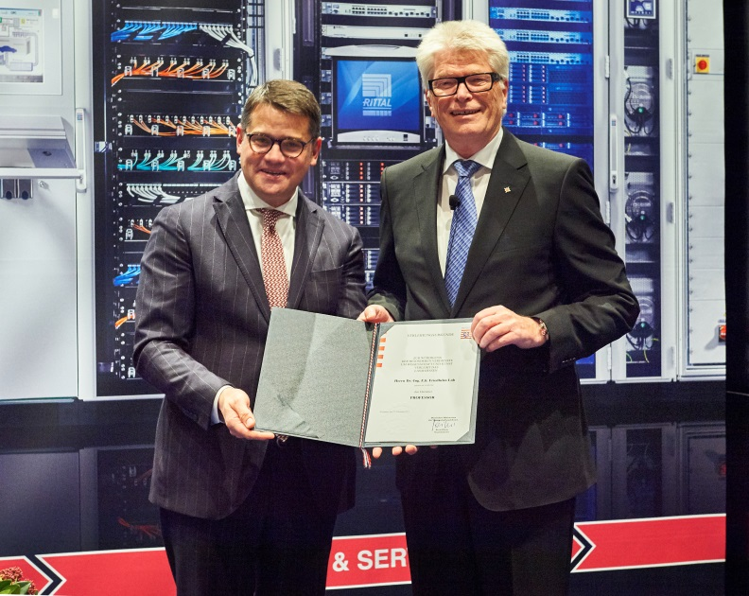
Fri172038800.jpg: A successful, family-run company, support for research and teaching, social and Christian commitment – entrepreneur Dr Friedhelm Loh is setting standards in business and science. Representing the German state of Hesse, Boris Rhein (left), Minister for Science and the Arts of Hesse, honoured the commitment of family entrepreneur Dr Friedhelm Loh by presenting him with the title of honorary professor.
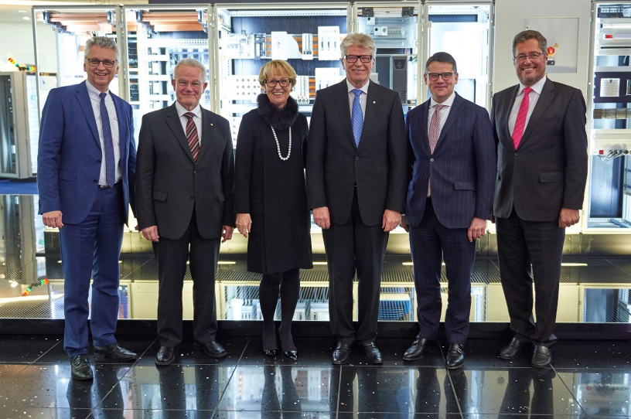
Fri172038700.jpg: In his speech, Professor Hans-Jörg Bullinger, member of the Advisory Board of the Friedhelm Loh Stiftung and former President of the Fraunhofer-Gesellschaft, emphasised the values-based company leadership that Dr Friedhelm Loh has shown: “Creating value by appreciating value.” From left: Prof Stephan Holthaus, Professor for Christian Ethics and Apologetics at Freie Theologische Hochschule Giessen (the Free Theological University of Giessen); Prof Hans-Jörg Bullinger, Deborah Loh, Dr Friedhelm Loh, Boris Rhein, Minister for Science and the Arts of Hesse; Dr Karl-Ulrich Köhler, CEO of Rittal International.
May be reproduced free of charge. Please name Rittal GmbH & Co. KG as the source.

Friedhelm Loh Group
A global player, the Friedhelm Loh Group (FLG) invents, develops, and makes made-to-measure products and integrated solutions for manufacturers, distributors, and other businesses. Member companies of the Group lead their respective industries in innovation and quality. They include the world’s leading provider of modular platforms for enclosures, power distribution, climate control and IT infrastructure (Rittal); Europe’s number one supplier of software solutions for mechanical and industrial plant engineering (Eplan, Cideon); and a specialist in integrated manufacturing with state-of-the-art materials – steel, aluminium, and plastics – (Stahlo, LKH).
The family-owned company maintains a worldwide presence, with 18 production sites and 80 subsidiaries. Managed by founder Dr Friedhelm Loh himself, the Group employs 11,300 people and generated revenues of approximately €2.2 billion in 2016. It was named one of Germany’s Top Employers in 2017, for the ninth year in a row. In a survey, Focus Money magazine and the Deutschland Test organisation identified the Friedhelm Loh Group as one of the nation’s best providers of vocational training for the second time in 2017.
For more information, visit www.friedhelm-loh-group.com.

