Professor Friedhelm Loh honours 222 employees for their long service
Corporate Communications
Regina Wiechens-Schwake
Phone: +49 2772 505-2527
E-mail: wiechens-schwake.r@rittal.de
Dr Carola Hilbrand
Phone: +49 2772 505-2680
E-mail: hilbrand.c@rittal.de
Rittal GmbH & Co. KG
Auf dem Stützelberg
35745 Herborn, Germany
www.rittal.com

Experience makes us stronger – the Friedhelm Loh Group honours its long-serving employees
The past and future gathered in one room as Professor Loh honoured 222 employees for their long-standing loyalty to the Group. Amongst them, they have notched up 10, 25 or 40 years on the factory floor or in administration, in sales or marketing. As Prof. Loh pointed out, they have helped to write the success story of the Friedhelm Loh Group. During the celebrations in the German town of Herborn, the owner and CEO of the Group also presented awards to the seven best apprentices and student interns.
Herborn, 19 December 2017 – During his annual speech to long-serving employees, Prof. Friedhelm Loh, owner and CEO of the Friedhelm Loh Group, emphasised: “You are an integral part of our success because success is only possible by working together.” Professor Loh was referring to every one of the 222 staff members attending the celebration held in the Rittal headquarters in Herborn. “Your experience and loyalty to the family business make you model employees. You make the company stronger!” In addition to presenting special awards to the Group’s best apprentices and student interns, Prof. Loh praised the staff, thanking them for both their long service and their constant willingness to learn. “Your combined service to the Group amounts to 3,540 years. Despite this, you never tire of adapting to the challenges the future brings. Your motivation helps drive the business forward.”

Stepping boldly into the digital future
While the employees were celebrating decades of working together and thinking back on developments and achievements, Prof. Loh looked ahead, saying: “2017 was a successful year for the Group and the outlook for 2018 is exceptionally good. We will seize this opportunity to construct our future in the rapidly changing world we live in.” Delving back into the history of Rittal and the Friedhelm Loh Group, he made it clear that change is nothing new for the family business. Founded in 1961, the Group has always been renowned for its willingness to take risks.
Even during its early years, Rittal achieved substantial growth, expanded abroad whilst always maintaining close contact with customers. The location of Herborn, Germany was decisive in the 1970s and ‘80s for the company’s growth. Between 1977, the year when employees clocking up 40 years’ service first started, and 1992, the starting year for those celebrating 25 years with the company, both staff and turnover figures increased eightfold. According to Prof. Loh: “It was during those years that we laid most of the foundations for further locations. That was in part down to your hard work.”
Looking at the present and into the future, Prof. Loh said he was certain that the employees’ expertise and experience would make the daring plunge into the digital future just as successful. “Software and hardware are merging – it’s a trend we are seeing both throughout the sector and within our own company. We are making bold investments in this direction because it is also our future.” With these words, Professor Loh was also addressing the apprentices and student interns who were honoured for achieving the best grades in their final exams. After all, they are the proof that taking pleasure in your work is just as important for achieving success as the work itself. All four apprentices also received awards for their grades from the Chamber of Industry and Commerce, making them some of the best in the district.
The new factories in Haiger and Ewersbach, the reconstruction carried out at the Hof and Rittershausen sites, new software solutions by Eplan and the growth of Stahlo in Dillenburg and Gera, as well as LHK’s expansion at the Heiligenroth facility – all of this will form the main focus for career starters and long-serving staff alike in the years ahead. “This is a highly exciting time for us and I am glad that we can benefit from your experience and dedication. Experience gives us courage and helps us to keep starting over and constantly move forward,” said Prof. Loh.
Social commitment counts
As the event drew to a close, Prof. Loh reminded staff that it is not just success and growth that are important, however: “I am extremely grateful that we are also setting high standards in terms of social commitment.” He recalled employees’ willingness to give donations during global catastrophes and at the end of the year. “Here in Germany, we have lived in peace for around 70 years now, which is something we shouldn’t forget. It is a privilege but also our obligation to do something good for those who have fallen on hard times. I am delighted that so many of you agree with me and I look forward to working with you for many years to come.
(4,819 characters)

Information boxes: Honoured by the Friedhelm Loh Group
40 years’ service (all Rittal): Rüdiger Arndt, Alfred Brenner, Mehmet Celik, Burkhard Dorndorf, Judith Hinkel, Peter Müller, Uwe Sälzer, Susanne Seibert, Osman Taskulak
The best apprentices of 2017: Sarah Klaus (Specialist for Warehouse Logistics, Stahlo), Jörn Reuter (Industrial Mechanic, Rittal), Jan Torben Ringer (Mechatronics Engineer, Rittal), Marie-Kristin Schmitz (Industrial Sales Representative, Rittal)
The best student interns on the StudiumPlus programme (all Rittal): Florian Köstler (Electrical Engineering), Felilx Michel (Business Studies), Giulia Rossner (Industrial and Mechanical Engineering)
■
Captions
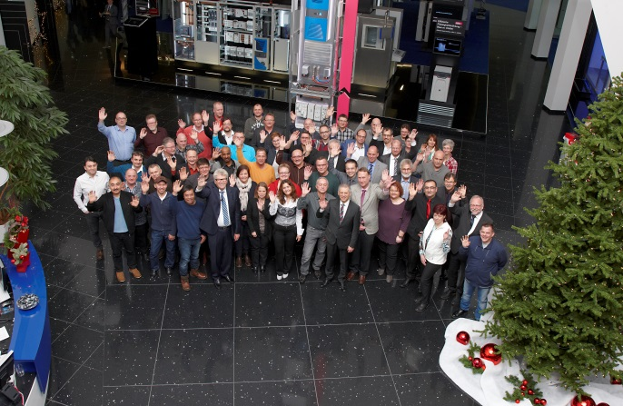
Fri172054000.jpg: Professor Friedhelm Loh honours 222 employees for their long-standing loyalty to the Group. Pictured above: Prof. Friedhelm Loh (front row, 4th from left) with the employees celebrating 25 or 40 years’ service.

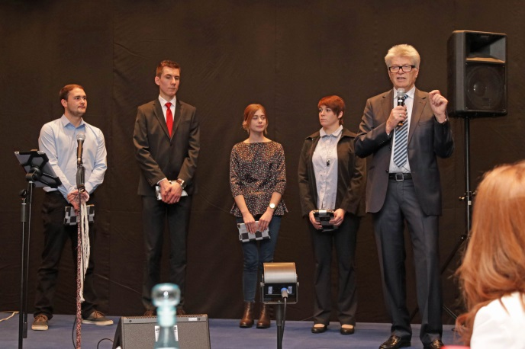
Fri172054100.jpg: Past and future gathered in one room as Prof. Loh (right) also presented awards to the best four apprentices. From left to right: Jörn Reuter, Jan Torben Ringer, Marie-Kristin Schmitz and Sarah Klaus.
May be reproduced free of charge. Please name Rittal GmbH & Co. KG as the source.

Friedhelm Loh Group
A global player, the Friedhelm Loh Group (FLG) invents, develops, and makes made-to-measure products and integrated solutions for manufacturers, distributors, and other businesses. Member companies of the Group lead their respective industries in innovation and quality. They include the world’s leading provider of modular platforms for enclosures, power distribution, climate control and IT infrastructure (Rittal); Europe’s number one supplier of software solutions for mechanical and industrial plant engineering (Eplan, Cideon); and a specialist in integrated manufacturing with state-of-the-art materials – steel, aluminium, and plastics – (Stahlo, LKH).
The family-owned company maintains a worldwide presence, with 18 production sites and 80 subsidiaries. Managed by founder Prof. Friedhelm Loh himself, the Group employs 11,300 people and generated revenues of approximately €2.2 billion in 2016. It was named one of Germany’s Top Employers in 2017, for the ninth year in a row. In a survey, Focus Money magazine and the Deutschland Test organisation identified the Friedhelm Loh Group as one of the nation’s best providers of vocational training for the second time in 2017.
For more information, visit www.friedhelm-loh-group.com.

