Rittal Cup raises money for the region’s charitable organisations
Corporate Communications
Regina Wiechens-Schwake
Phone: +49 2772 505-2527
E-mail: wiechens-schwake.r@rittal.de
Dr Carola Hilbrand
Phone: +49 2772 505-2680
E-mail: hilbrand.c@rittal.de
Rittal GmbH & Co. KG
Auf dem Stützelberg
35745 Herborn, Germany
www.rittal.com

“Hats off” to record-breaking donors and volunteers
Football brings people together, forges friendships and builds team spirit. The traditional Rittal Cup tournament run by the Friedhelm Loh Group goes one step further – with the teams playing for a good cause. This year, the sporting competition held in the Burbach Stadium in Ewersbach was even more special than usual. Besides celebrating its 25th anniversary, the tournament also raised the record sum of 10,000 euros for social initiatives in Dietzhölztal. The official cheque presentation has now taken place.
Herborn/Rittershausen, 19 December 2017 – Ambition, enthusiasm and team spirit were on show aplenty during the Rittal Cup 2017, staged by the Friedhelm Loh Group. Some 200 football players, split into 14 teams from the plants around the region and the international subsidiaries, played against one another in spring 2017 to win the coveted trophy and raise money for a good cause. Workers from Eplan, LKH and Rittal Czech Republic (to name just three) battled it out on the pitch in the company’s very own football championship. All of them had their sights set on lifting the trophy. But of course there could be only one winner, which was “RGS Montage” from the Rittershausen plant for the second year running.
All this football and fun also benefited a good cause. The players managed to raise more than 4,700 euros during the special anniversary tournament. The proceeds, which owner and CEO Professor Friedhelm Loh rounded up to the record-breaking sum of 10,000 euros, have now been officially presented to the four lucky recipients from around the Dietzhölztal region. “It’s a wonderful moment for you and for us to hand over the 2017 donation,” announced Norbert Peter, Plant Director at Rittershausen. He added that he had never had the pleasure of presenting such a large sum throughout the tournament’s history. The cheques went to the German Red Cross (DRK) in Dietzhölztal, the Dietzhölztal/Eschenburg welfare centre, SG Dietzhölztal football club and the “Neustart” (“New Start”) social project in Breitscheid.
“The voluntary work that your organisations perform is amazing. It’s hard to imagine that you do all this in addition to your regular jobs – hats off to you!” Peter remarked, as he thanked the volunteers from the associations and institutions for their dedication.
Support for the German Red Cross and welfare
The Dietzhölztal branch of the German Red Cross is planning to spend its share of the money on training and equipment – computer courses and head-to-toe uniforms consisting of a jacket, helmet, trousers, T-shirt and shoes for all of its team members, to be precise.
The Dietzhölztal/Eschenburg welfare centre was another of this year’s beneficiaries. It wants to use the money to set up a second group for dementia sufferers to provide a couple of hours’ respite for the relatives who care for them, as well as expanding the homecare it offers.
Rewarding social commitment
The Group has been helping SG Dietzhölztal to run its sports club for years. Thankfully, all of the proceeds raised by the club are used to fund the youth work performed by JSG Dietzhölztal. For example, the club has used donations to run a football day for the primary schools in Rittershausen and Ewersbach, giving the children the chance to earn a certificate. By all accounts, this proved to be a fantastic, motivational experience for the schoolchildren.
The fourth recipient of an anniversary donation was the “Neustart” project in Breitscheid. This charitable facility offers assistance to young people trying to overcome criminal and drug habits, in fact all sorts of problems in life. For example, it provides shared accommodation for six or seven young men from entirely different backgrounds who are determined to get their lives back on course. The centre says that the money will be used to repair various fixtures around the apartment building, such as windows and doors.
This sports tournament, which was launched by the Friedhelm Loh Group in 1992, has always been used to raise money for good causes. In fact, the German Red Cross in Dietzhölztal was also one of the first organisations to receive funds from the Rittal Cup. The tournament has continued to grow as the number of teams, players and spectators have all increased over the years.
(4,392 characters)

■
Caption(s)
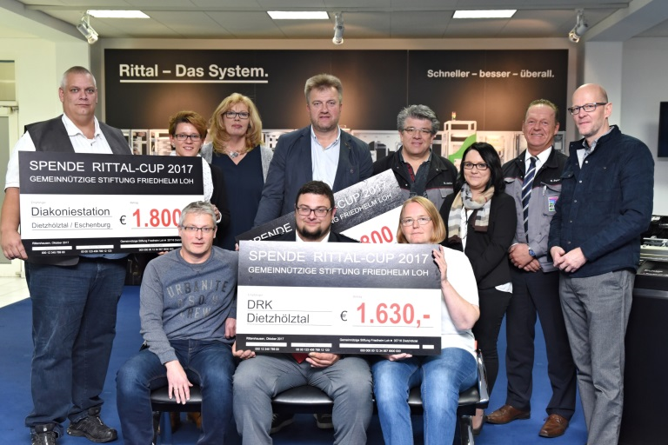
Fri172053700.jpg: Besides celebrating its 25th anniversary this year, the traditional Rittal Cup also raised the record sum of 10,000 euros for social initiatives in Dietzhölztal. Norbert Peter (second from right), Plant Director at Rittershausen, and Stefan Nadler (back row, fourth from right), Chairman of the Works Council at the Rittal plant in Rittershausen, handed over the donation to Kai-Uwe Pfeifer and Justyna Diehl from the Dietzhölztal/Eschenburg welfare centre (left), Arne Thielmann from the “Neustart” project in Breitscheid (at the back) and Marius Bergmann and Heidi Hofmann from the Dietzhölztal branch of the German Red Cross (at the front).

May be reproduced free of charge. Please name Rittal GmbH & Co. KG as the source.

Friedhelm Loh Group
A global player, the Friedhelm Loh Group (FLG) invents, develops, and makes made-to-measure products and integrated solutions for manufacturers, distributors, and other businesses. Member companies of the Group lead their respective industries in innovation and quality. They include the world’s leading provider of modular platforms for enclosures, power distribution, climate control and IT infrastructure (Rittal); Europe’s number one supplier of software solutions for mechanical and industrial plant engineering (Eplan, Cideon); and a specialist in integrated manufacturing with state-of-the-art materials – steel, aluminium, and plastics – (Stahlo, LKH).
The family-owned company maintains a worldwide presence, with 18 production sites and 80 subsidiaries. Managed by founder Prof. Friedhelm Loh himself, the Group employs 11,300 people and generated revenues of approximately €2.2 billion in 2016. It was named one of Germany’s Top Employers in 2017, for the ninth year in a row. In a survey, Focus Money magazine and the Deutschland Test organisation identified the Friedhelm Loh Group as one of the nation’s best providers of vocational training for the second time in 2017.
For more information, visit www.friedhelm-loh-group.com.

