Friedhelm Loh Group unveils new integration project
Corporate Communications
Regina Wiechens-Schwake
Phone: +49 2772 505-2527
E-mail: wiechens-schwake.r@rittal.de
Dr Carola Hilbrand
Phone: +49 2772 505-2680
E-mail: hilbrand.c@rittal.de
Rittal GmbH & Co. KG
Auf dem Stützelberg
35745 Herborn, Germany
www.rittal.com

Hand in hand – Friedhelm Loh Group gives untrained refugees a chance
Refugees with no certificates or qualifications and very limited German don’t stand much of a chance on the employment market. They are unlikely to find more than the odd casual or temporary job here and there. The new pilot project run by the Friedhelm Loh Group shows that even these candidates can be integrated in the workplace. The family-owned enterprise has offered two refugees direct entry into employment – because nothing motivates people better than work.
Herborn, 26 February 2018 – Youssef Almohamad (22) is now thoroughly accustomed to the procedure for changing shifts at the Rittal plant in Rittershausen. Once the slim young man and his co-worker have cast a quick glance at the roster, he quickly puts on his gloves and helmet and grabs the trolley. On his way to the frame welding robot, the rest of his colleagues welcome him with a hefty pat on the shoulder and shout a few instructions after him. Youssef’s refugee status plays no role – he’s simply part of the workforce.
He and his brother Hussein have been working at the plant in Dietzhölztal for just about half a year. “Everyone should have the chance to do something with their life,” believes Stefan Nadler, Chairman of the Works Council at the Rittal plant in Rittershausen and initiator of the Friedhelm Loh Group’s “Direct entry for refugees into the workplace” project. The special feature is that the two new recruits work full-time at the plant and take two lessons each day from a combination of German, maths and cultural studies. They are taught by their co-workers. In addition, they are acquiring part-qualifications in welding and assembly during the two years, as they work. “The aim is to get them up to speed for an apprenticeship in the space of two years – both linguistically and academically,” Nadler explains.
The Almohamad brothers struggled hard to make it to Germany from Syria, covering thousands of kilometres by foot, boat and train in the hope of finding a new, peaceful life. Both knew from the start that the main thing they needed was work. But without certificates and enough knowledge of German they hardly stood a chance of finding a job or apprenticeship. Apart from that, at 37 Hussein is too old for a lot of training companies. They both worked as tailors in Syria. The world of enclosures, steel profiles and mounting frames was still totally foreign to them two years ago. One thing they do have to offer is manual dexterity.
“I was particularly keen to see whether they really were motivated – and they were,” says Nadler, who got the go-ahead for his idea for the project directly from Prof. Loh, the owner and CEO of the Friedhelm Loh Group: “We are a family business and the largest company in the region. This comes with immense responsibility. Integrating refugees is a task for the whole of society. If we can demonstrate ways of achieving this and motivate other companies, then we will do that,” Prof. Loh says.
The two workers proved their worth within just a few months: “They are two of fifteen new appointments and were given exactly the same guidance as the rest at the start. Now they are working completely independently,” Nadler says, adding: “They are part of the team and are doing a very good job.” They have also already made social contacts via the project, he explains. The lessons with their co-workers are a particularly good way of breaking the ice in both directions.
The company is supported by the job centre and the Society for Economic Development, Training and Employment Initiatives (Gesellschaft für Wirtschaftsförderung, Ausbildungs- und Beschäftigungsinitiativen – GWAB) in the form of training for the team of trainers. “If a company comes to us with such an idea, we’re pleased to help put it into practice,” says Michael Roth, a recruitment agent at the Lahn-Dill job centre. He points out that the initiative by the Friedhelm Loh Group is performing ground-breaking work in the region, especially because management and staff are pulling together. This is why the job centre pays half the salary costs for the first year. “We also assist with preselecting applicants, organising workshops and providing instruction for employees in course modules,” Roth says. The GWAB provides training for the team of trainers.
When it comes to their lessons, the two new recruits’ eyes light up. As soon as they finish their shift, they bury their heads in their studies at the desk in the meeting room: “Our lessons help us a lot, especially with technical terms,” says Youssef, slowly reading out words such as “punched section with mounting flange” and “mounting plate” from the flash cards. “Our colleagues are very friendly. And we are enjoying ourselves,” his brother adds, as he climbs into an enclosure, where he has to stick the card with the next technical term in the right place. Within a few seconds, he has found what he’s looking for – the “cable junction box”.
(5,053 characters)

■

Caption(s)
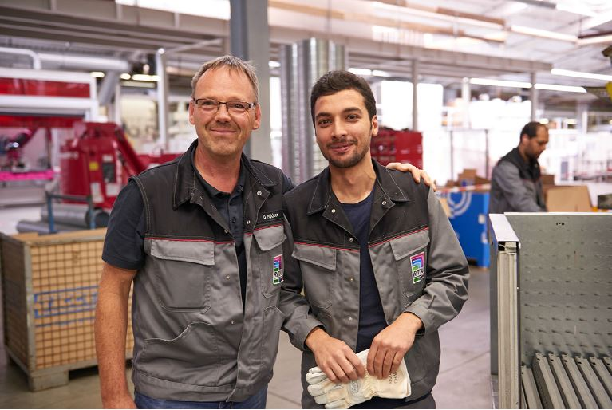
Fri172056800.jpg: Because nothing motivates people better than work – the Friedhelm Loh Group has given two unqualified refugees the chance of a job. Pictured above: Dieter Müller (left), Team Leader Fabrication at the Rittershausen plant, with new recruit Youssef Almohamad.
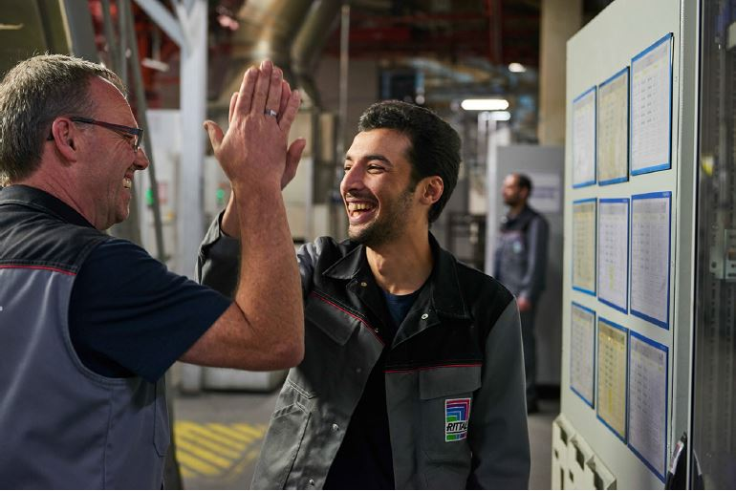
Fri172056900.jpg: Die Welt der Schaltschränke, Stahlprofile und Montagerahmen war Youssef Almohamad (r.) vor zwei Jahren noch völlig unbekannt. Was sie aber mitbringen, ist handwerkliches Geschick, merkt auch Dieter Müller (l.), Gruppenleiter Rohfertigung im Rittal Werk Rittershausen.
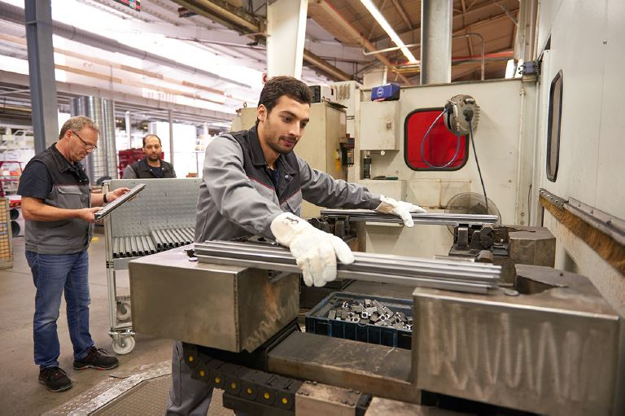
Fri172057000.jpg: The two workers proved their worth within just a few months: “They are two of fifteen new appointments and were given exactly the same guidance as the rest at the start. Now they are working completely independently,” says Stefan Nadler, who got the project off the ground.
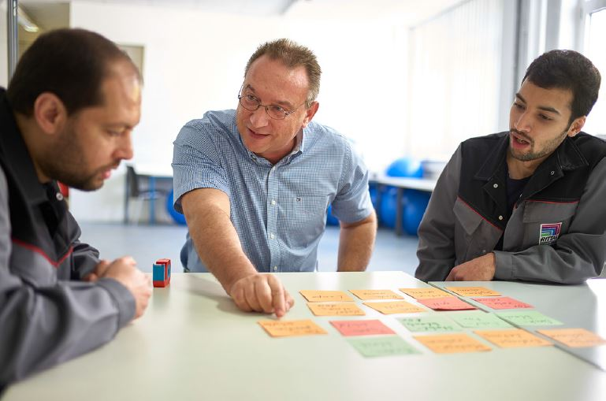
Fri172057100.jpg: The two refugees work full-time at the plant and take two lessons each day in either German, maths or cultural studies. They are taught by their co-workers.
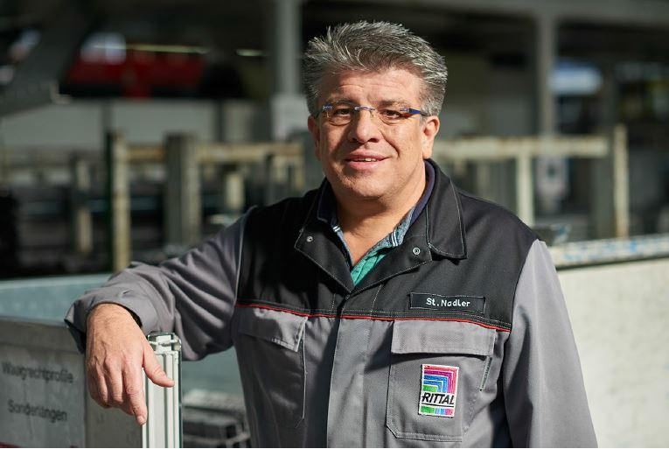
Fri172057200.jpg: “Everyone should have the chance to do something with their life,” believes Stefan Nadler, Chairman of the Works Council at the Rittal plant in Rittershausen and initiator of the Friedhelm Loh Group’s “Direct entry for refugees into the workplace” project.

May be reproduced free of charge. Please name Rittal GmbH & Co. KG as the source.

Friedhelm Loh Group
A global player, the Friedhelm Loh Group (FLG) invents, develops, and makes made-to-measure products and integrated solutions for manufacturers, distributors, and other businesses. Member companies of the Group lead their respective industries in innovation and quality. They include the world’s leading provider of modular platforms for enclosures, power distribution, climate control and IT infrastructure (Rittal); Europe’s number one supplier of software solutions for mechanical and industrial plant engineering (Eplan, Cideon); and a specialist in integrated manufacturing with state-of-the-art materials – steel, aluminium, and plastics – (Stahlo, LKH).
The family-owned company maintains a worldwide presence, with 18 production sites and 80 subsidiaries. Managed by founder Prof. Friedhelm Loh himself, the Group employs 11,300 people and generated revenues of approximately €2.2 billion in 2016. It was named one of Germany’s Top Employers in 2017, for the ninth year in a row. In a survey, Focus Money magazine and the Deutschland Test organisation identified the Friedhelm Loh Group as one of the nation’s best providers of vocational training for the second time in 2017.
For more information, visit www.friedhelm-loh-group.com.

