From finishing a construction site to performing the interior installation
Bye bye building site: Rittal Haiger plant is complete

Here and there a lonely site fence still stands on the site of Rittal’s Haiger plant. But not for much longer: The fences and cranes are gradually being dismantled and removed. Because now, on the heels of the Rittal Innovation Center and the Global Distribution Center, the new factory building has also been officially completed. Not in Shanghai and not in Chicago: Haiger will become Rittal’s location of the future following the largest investment in the company's history.

Haiger, 09 October 2018 – The authorities have put the Haiger plant through its paces in terms of safety and security, fire protection and escape routes. The result is that the construction site of the Rittal Haiger plant is no longer a building site at all. The construction work has been officially completed and approval to operate the plant has been awarded: “We were able to complete all the construction work within the planned time and budget – and there were no complaints at all from the authorities,” reports Carsten Röttchen, Managing Director International Production at Rittal.

But completed doesn’t quite mean the same as finished: Now the interior installation work is starting at a plant that is to become the world's most modern enclosure manufacturing centre: “We will be installing more than 100 high-tech machines and plant components before production can start. This is the next mammoth task that our team has to complete,” says Röttchen.

Together with the Rittal Innovation Center and the Global Distribution Center, Haiger is becoming a showcase location for the future. In all, nearly 1,000 staff will be employed there. Rittal is investing more than €250 m in the region, the largest investment in the company’s history. And it’s worth it: Production will start on the 24,000-m² site in 2018. Starting in 2019, around 9,000 enclosures will be rolling off the production lines every day.

(1,942 characters)
■
Caption(s)
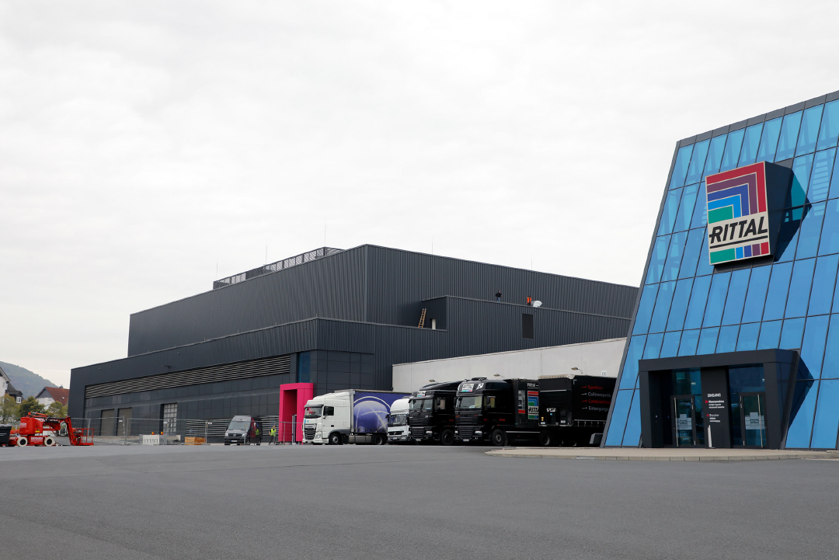
fri18930400.jpg: Here and there a lonely site fence still stands on the site of Rittal’s Haiger plant. But not for much longer: The fences and cranes are gradually being dismantled and removed.

Corporate Communications
Regina Wiechens-Schwake
Phone: +49 2772 505-2527
E-mail: wiechens-schwake.r@rittal.de
Rittal GmbH & Co. KG
Auf dem Stützelberg
35745 Herborn, Germany
www.rittal.com

