Rittal Innovation Center
Corporate Communications
Regina Wiechens-Schwake
Phone: +49 2772 505-2527
E-mail: wiechens-schwake.r@rittal.de
Hans-Robert Koch
Phone: +49 2772 5052693
E-mail: koch.hr@rittal.de
Christian Abels
Phone: +49 2772 505-1328
E-mail: abels.c@rittal.de
Rittal GmbH & Co. KG
Auf dem Stützelberg
35745 Herborn, Germany
www.rittal.com

Rittal Innovation Center welcomes 10,000th visitor
In July, the Haiger-based Rittal Innovation Center welcomed its 10,000th visitor three years after its opening. The great interest visitors have shown in live presentations and training courses underscore the high demand for innovations in panel building and switchgear manufacturing. Rittal, Eplan and Cideon showcase consistent implementation of Industry 4.0 concepts located here on a floor space of more than 1,500 square metres. The presentation and training centre, which is unique in the industry, is constantly being further developed and expanded.
Herborn/Haiger, 07 August 2019 – Can we apply the concept of Industry 4.0 to panel building and switchgear manufacturing? Which process stages can be become significantly more efficient? Is it possible to manufacture batch sizes of just one efficiently? Panel building and switchgear manufacturers are facing these questions all over the world, as efficiency and cost pressures drive the need for solutions that are practical and quick to deploy. “We want to provide our customers with meaningful guidance on how to keep on expanding their value-added processes,” explains Jan-Henry Schall, Head of the Rittal Innovation Center. “The great interest of people in our Innovation Center, with 10,000 visitors since September 2016, shows that there is a great demand for solutions that help to streamline processes in panel building and switchgear manufacturing. The focus of our interested visitors is on exchanging technical information with experts.”

Hands-on presentation of the value chain
To help achieve this, customers and visitors can see, experience and try out the latest solutions for their own value chains at this innovation and training centre, and discuss them with experts from the Friedhelm Loh Group. In order to give them a hands-on and understandable experience, the Friedhelm Loh Group set up the fictitious manufacturing operation. “This operation gives people a real-world understanding of the solutions we can offer during the individual process stages – starting with engineering, through production planning, goods receipt, machining, assembly, wire processing and wiring to the finished switchgear. Industry professionals can thus quickly recognise the advantages and how they can benefit from them,” explains Jan-Henry Schall.
Visitors will gain an insight into virtual prototyping using the latest software solutions from Rittal and Eplan for electrical design, resulting in a completely digital switchgear system. Interfaces to the commercial processes and in particular to the subsequent production at the switchgear manufacturer represent another important component of the presentation. Visitors can also have a closer look at Eplan and Rittal technology that lends itself to production, i. e. the workshop of switchgear manufacturers, ranging from fully automated to partially automated systems and digitally supported solutions for manual process stages.
New IT live cases
Rittal is constantly expanding and updating the design of the Innovation Center. The company is currently expanding its live demonstrations in the field of “digitalization of value chains” area. “We will pool Rittal’s expertise in IT infrastructure with solutions from our sister companies Innovo Cloud and German Edge Cloud and demonstrate them by using new live-use cases. We are thus presenting further future-driven industry 4.0 solutions from the Friedhelm Loh Group in the field of digitalization," says Jan-Henry Schall.
Surprise for ProSiebenSat1 employee
A group of visitors from the German satellite broadcaster ProSiebenSat1 Media SE were in for a surprise on 4 July 2019. Gunnar Scharf, one of its members, was the 10,000th visitor to the Rittal Innovation Center. The IT expert received a certificate and a gift from Jan-Henry Schall. “I felt honoured to be the 10,000th visitor of the Rittal Innovation Center. I think Rittal has fully understood the relevance of Industry 4.0 for its customers, ” wrote Gunnar Scharf in the guest book. Further inspiring entries of the visitors in the guest books document the uniqueness of the innovation and training centre. An African visitor group wrote: “Here we found the answer we were looking for. Thank you very much.” And a German group sums up their visit as follows: “Our shopping list just got longer and longer. Very interesting applications.”
(4,394 characters)
■

Caption(s)
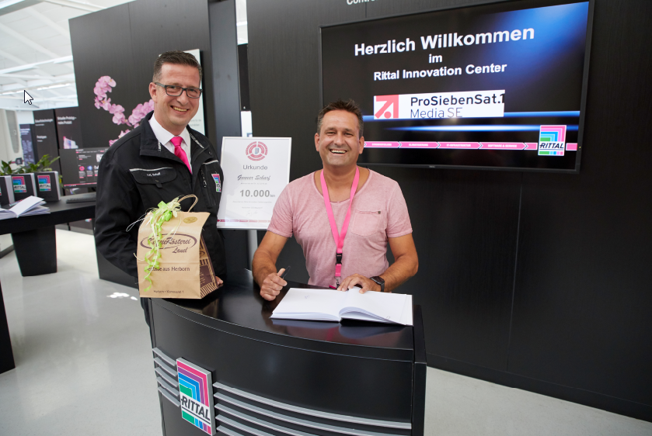
Image 1 (fri192023200.jpg): Gunnar Scharf from ProSiebenSat1 Media SE (right) is the 10,000th visitor of the Rittal Innovation Center. As a surprise, he is congratulated and receives a gift from Jan-Henry Schall, Head of the Rittal Innovation Center.
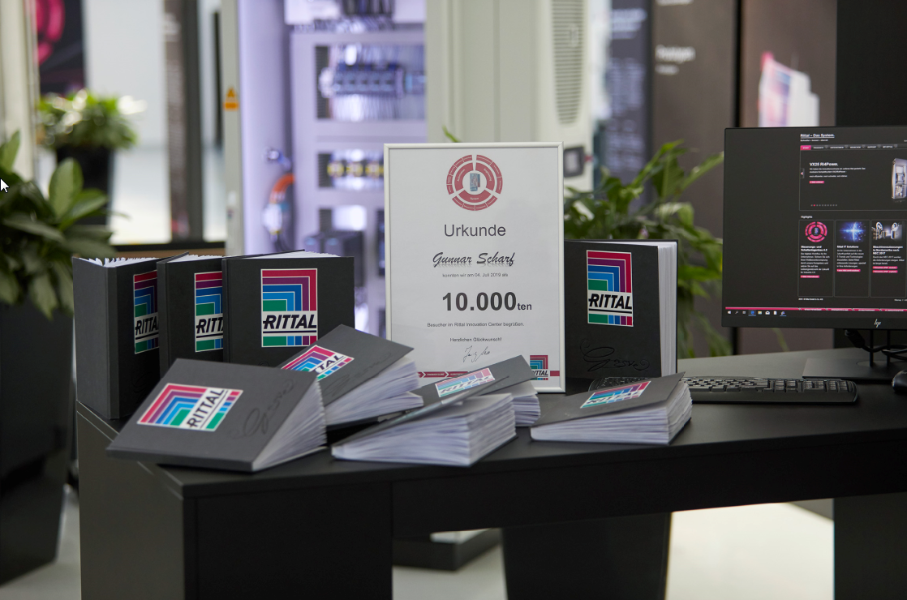
Image 2 (fri192023500.jpg): Full guest books with inspiring and positive visitor entries document the uniqueness of the Rittal Innovation Center.
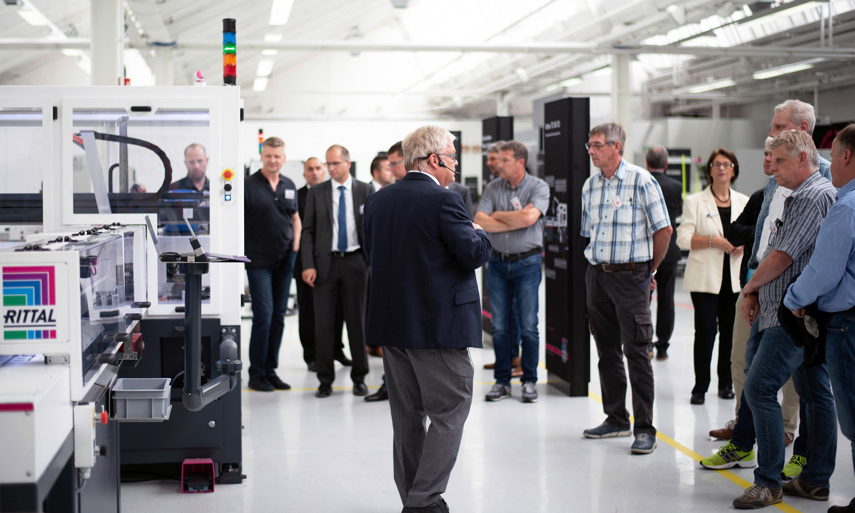
Image 3 (fri191405200.jpg): The Rittal Innovation Center is a crowd-puller, giving customers insights into the latest automation technology for panel building and switchgear manufacturing, for example.
May be reproduced free of charge. Please name Rittal GmbH & Co. KG as the source.

About Rittal
Rittal, headquartered in Herborn, Germany, is a leading global provider of solutions for industrial enclosures, power distribution, climate control and IT infrastructure, as well as software and services. Systems made by Rittal are deployed in over 90 per cent of all industries across the world, including machine building and plant engineering, food and beverages, and IT and telecommunications.
The international market leader’s product portfolio includes configurable enclosures, with data available across the entire production process. Smart Rittal cooling systems, with up to 75 per cent lower power and CO₂ consumption, can communicate with the production landscape, enabling predictive maintenance and servicing. The offering also includes innovative IT products, from IT racks and modular data centres, to edge and hyperscale computing solutions.
Leading software providers Eplan and Cideon support the value chain, providing interdisciplinary engineering solutions, while Rittal Automation Systems offers solutions for switchgear. Within Germany, Rittal can supply products on demand within 24 hours – with precision, flexibility and efficiency.
Founded in 1961, Rittal is the largest company in the owner-operated Friedhelm Loh Group. The Friedhelm Loh Group is active worldwide, with 18 production sites and 80 international subsidiaries. It has more than 12,000 employees and posted revenues of 2.6 billion euros in fiscal 2018. In 2018, the family-run business was named one of Germany’s leading employers by the Top Employers Institute, for the tenth year running. Within the scope of a Germany-wide survey, Focus Money magazine identified the Friedhelm Loh Group as one of the nation’s best providers of vocational training for the third time in 2018.
For more information, visit www.rittal.com and www.friedhelm-loh-group.com.

