Bachelor students of the Friedhelm Loh Group receive their finals certificates
Corporate Communications
Dr Carola Hilbrand
Phone: +49 2772 505-2527
E-Mail: hilbrand.c@rittal.de
Steffen Maltzan
Phone: +49 2772 505-2680
E-mail: maltzan.s@rittal.de
Rittal GmbH & Co. KG
Auf dem Stützelberg
35745 Herborn, Germany
www.rittal.com

Well-earned applause: Twenty-one students celebrate graduation
- Loh Group students awarded their bachelor’s degrees.
- In a digital graduation ceremony, coordinators and management got together to recognise all the graduates’ outstanding achievements.
- The young professionals look forward to new challenges as specialists within the Group or on the master’s degree programme.
Herborn, 17 February 2021 – A significant milestone on life’s journey: Twenty-one bachelor students on the Friedhelm Loh Group co-operative education programme are celebrating their successful degree results and crowning their three-and-a-half years of work and study with impressive certificates. Grateful congratulations, personal profiles and reliving the time spent studying together made the digital graduation ceremony a personal celebration for all graduates despite their physical distance from each other.
With their certificates in their pockets, the young talents are ready for the challenges of the future: While 16 of them will start off as specialists at Rittal, LKH and Loh Services, two other young professionals will continue their skill development in the Friedhelm Loh Group’s dual study master’s programme. Three graduates will be leaving the Group to start a full-time master’s degree programme.
Self-confidence, enthusiasm and courage
“You are the future of our Group. We will need motivated talents like you so that we can realise our future potential,” stressed Uwe Scharf, Rittal Managing Director Business Units and Marketing, at the digital event, congratulating the newcomers on their special achievements: “You have every reason to be self-confident. You have completed your studies, so be proud of that and continue to develop yourself and your strengths. Accept any change as an opportunity for further development.”
There are many changes taking place in the Friedhelm Loh Group. One recent example of the great potentials is the recently bundled expertise of three cloud and edge computing start-ups in the new German Edge Cloud subsidiary. “Friedhelm Loh Group is thus a pioneer of digital transformation in the manufacturing industry, which presents exciting perspectives for you as young employees and for the entire corporate group,” Mr. Scharf added. For example, the company offers a variety of positions for young talent in every sector, ranging from purchasing, sales, development, production and IT – now also as a scrum master, cloud architect or data scientist.
Twenty-one reasons to celebrate
At the ceremony, student spokesperson Sebastian Menn, an Industrial Engineering graduate with Rittal and new technical assistant to the Friedhelm Loh Group’s IT Director, stressed the special nature of the year, which had been marked by great professional and private cohesion. Foreign assignments in India, England or the USA, successful group projects and the creative implementation of their own ideas proved the students’ strength. “By graduating, we now have a foundation upon which we can build everything we want. So go out there and help shape things,” said Sebastian Menn to motivate his fellow students, who were looking forward to new challenges in departments such as Logistics, IT, Human Resources and Marketing.
Study coordinator Anke Wojtynowski-Scharf was also delighted at the students’ success: “In recent years, you have evolved both professionally and personally and can now look forward to a promising future. Stay inquisitive and carry on learning because no one can take knowledge away from us.”
Background information on promoting young talent
Ever since it was founded, the family business has placed great emphasis on promoting young talent. Every year, several dozen young professionals get started on careers in the technical and commercial sectors. They include both trainees in 18 apprenticeship occupations, for example, warehouse logistics specialists, production mechanics and mechatronics engineers for refrigeration technology, and students on eleven degree courses on the “StudiumPlus” programme with the Technical University of Central Hesse. The combination of theory and hands-on work experience, international career prospects and “lifelong learning” in the context of Industry 4.0 are the focus for the 230 young professionals currently taking part.
The company’s training facility, the Loh Academy, backs training and further development with various qualification schemes, for example, specifically preparing employees for the digital transformation in the workplace. Located next to Rittal’s factory in Haiger, the world’s most modern digitally integrated enclosure production facility, the future specialists are also boosting their professional and personal development, both in the training workshop and at the junior competence centre.
(4,864 characters, including background information)
■
Caption(s)
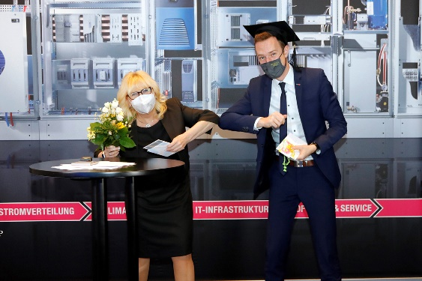
Image 1 (fri21200300.jpg): Study Coordinator Anke Wojtynowski-Scharf (left) congratulated the student representative and newly qualified industrial engineer Sebastian Menn on behalf of the other 20 bachelor graduates who watched the digital graduation ceremony in front of their Pcs.
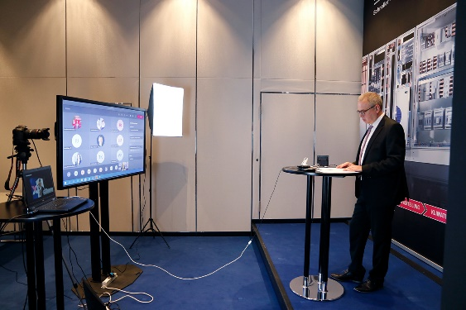
Image 2 (fri21200400.jpg): Uwe Scharf, Rittal Managing Director Business Units and Marketing, is delighted with the students' outstanding achievements: “You are the future of our Group. We will need motivated talents like you so we can realise our future potential.”
May be reproduced free of charge. Please name Rittal GmbH & Co. KG as the source.

Friedhelm Loh Group
A global player, the Friedhelm Loh Group (F.L.G.) invents, develops, and makes made-to-measure products and integrated solutions for manufacturers, distributors, and other businesses. Member companies of the Group lead their respective industries in innovation and quality. They include the world’s leading provider of modular platforms for enclosures, power distribution, climate control and IT infrastructure (Rittal); Europe’s number one supplier of software solutions for plant engineering, general engineering, and manufacturing; and a specialist in integrated manufacturing with state-of-the-art materials – steel, aluminium, and plastics (Stahlo und LKH).
The family-owned enterprise maintains a worldwide presence, with 12 production sites and 96 subsidiaries. Managed by founder Prof. Friedhelm Loh himself, the Group employs 12,100 people and generated revenues of €2.6 billion in 2019. In 2020, it was named one of Germany’s leading employers by the Top Employers Institute, for the twelfth year running. Within the scope of a Germany-wide survey, Focus Money magazine identified the Friedhelm Loh Group as one of the nation’s best providers of vocational training for the fifth time in 2020.
For more information, visit www.friedhelm-loh-group.com.

