Friedhelm Loh Group annual donation
Corporate Communications
Dr. Carola Hilbrand
Phone: +49 (0)2772/505-2527
Email: hilbrand.c@rittal.de
Steffen Maltzan
Phone: +49 (0)2772/505-2680
Email: maltzan.s@rittal.de
Rittal GmbH & Co. KG
Auf dem Stützelberg
35745 Herborn
www.rittal.com

Friedhelm Loh Group donates record sum of 220,000 euros
- The Friedhelm Loh Group’s traditional annual donation supports both regional and international charitable organisations.
- Employees and members of management make joint donation.
- The group has made an annual charitable contribution to good causes for several decades.
Herborn, Germany, 14 April 2021 – In 2020, Friedhelm Loh Group employees gave hope in especially hard times – through their support for charities Caritas-Werkstätten Westerwald-Rhein-Lahn, Oberlausitz Kinderhilfe, Debora Foundation India and eight further non-profits. Their contributions were made within the scope of the Friedhelm Loh Group’s traditional annual donation – and this past year, the initiative was more important than ever. FLG employees, together with members of management, raised a record sum of 220,000 euros.
Prof. Friedhelm Loh thanked FLG staff for their dedication and donations. “I am proud of our employees’ exemplary sense of social responsibility in difficult times. We are grateful that we have a good life, and want to support people who urgently need assistance.” Their contribution goes to local charities operating close to the group’s sites, as well as international aid organisations – eleven non-profits in total.
“We’re doing it – together”
Part of the donation benefits Caritas-Werkstätten Westerwald-Rhein-Lahn. These workshops empower people with mental, physical or psychological disabilities to gain employment opportunities. This includes e.g. training via simulation walks to improve road safety and prevent falls at the workshop. Armin Gutwald, Managing Director of Caritas-Werkstätten, states: “We thank Friedhelm Loh Group’s employees for their outstanding support and their commitment to the community. With your contribution, you are upholding the spirit of the Caritas 2021 campaign: We’re doing it – together.”
A helping hand for younger patients
A portion of the FLG donation went to Oberlausitz Kinderhilfe. This non-profit organisation focuses on the provision of medical care and psychosocial support, in particular for chronically ill children requiring hospital treatment, and their parents. One key project is the child-friendly design and furnishing of the children’s hospital in Bautzen. In addition, Oberlausitz Kinderhilfe provides financial aid for parents’ accommodation at the hospital. Chairman Dr Ulf Winkler thanks FLG for their contribution: “We are delighted to receive such a generous donation from the employees of Friedhelm Loh Group. This will allow us to redesign the corridors on the children’s ward and fund physical therapy equipment.”
Aid in times of coronavirus – and beyond
Providing a helping hand beyond national borders is part and parcel of being a group with global operations. In line with this philosophy, part of the donation went to Debora Foundation India. Founded in 2018, the organisation is named after Debora Loh, the wife of Prof. Friedhelm Loh. It gives support to people from one of the country’s poorest castes, the Dalit, in particular through education and the construction of a school. However, the coronavirus pandemic has recently prompted a shift in focus to emergency aid. The FLG donation allows the foundation, in cooperation with International Justice Mission, its partner in India, to provide thousands of people with urgently needed supplies, including food and hygiene products. Deborah Loh thanks the staff for their dedication: “I am very grateful that our work enables us to provide targeted assistance to people in need. Together, we can break the cycle of poverty.”
A tradition of social responsibility
Social responsibility, supporting the community and providing help to others has been part of the Friedhelm Loh Group’s DNA since its establishment over 60 years ago. The dedication of its employees and members of management is demonstrated year after year by the annual donation campaign. In the last 20 years alone, the family-owned enterprise has raised over five million euros for good causes. In 2011, Prof. Friedhelm Loh established the Rittal Foundation to mark the 50th anniversary of Rittal, the group’s largest member company. The foundation supports charities and projects in education, church-based welfare work, integration, and culture and science – and has given nearly two million euros since its inception. As Prof. Friedhelm Loh emphasises: “We are all part of the society we live in. We all have a responsibility, and we stand together – with and for the most vulnerable members of our community. And as a group, we take this to heart.”
(4,637 characters)

■
Captions
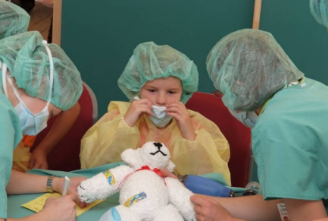
Bild 1 (fri21202000.jpg): An Oberlausitz Kinderhilfe project focuses on the child-friendly design of and resources for the children’s hospital in Bautzen – for example with toys, a children’s library, and bright, colourful walls.
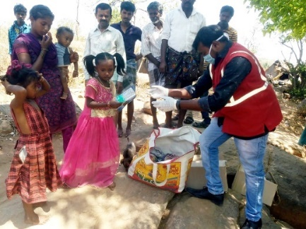
Bild 2 (fri21202100.jpg): During the coronavirus pandemic, Debora Foundation India has concentrated on emergency aid. In recent months, it has provided supplies to help hundreds of families in the country’s south make it through these difficult times.
May be reproduced free of charge. Please name Rittal GmbH & Co. KG as the source.

Friedhelm Loh Group
A global player, the Friedhelm Loh Group (F.L.G.) invents, develops, and makes made-to-measure products and integrated solutions for manufacturers, distributors, and other businesses. Member companies of the Group lead their respective industries in innovation and quality. They include the world’s leading provider of modular platforms for enclosures, power distribution, climate control and IT infrastructure (Rittal); Europe’s number one supplier of software solutions for plant engineering, general engineering, and manufacturing; and a specialist in integrated manufacturing with state-of-the-art materials – steel, aluminium, and plastics (Stahlo und LKH).
The family-owned enterprise maintains a worldwide presence, with 12 production sites and 96 subsidiaries. Managed by founder Prof. Friedhelm Loh himself, the Group employs 12,100 people and generated revenues of €2.6 billion in 2019. In 2020, it was named one of Germany’s leading employers by the Top Employers Institute, for the thirteenth year running. Within the scope of a Germany-wide survey, Focus Money magazine identified the Friedhelm Loh Group as one of the nation’s best providers of vocational training for the fifth time in 2021.
For more information, visit www.friedhelm-loh-group.com.

