Friedhelm Loh Group recognised for the tenth year running
Corporate Communications
Regina Wiechens-Schwake
Phone: +49 2772 505-2527
E-mail: wiechens-schwake.r@rittal.de
Dr Carola Hilbrand
Phone: +49 2772 505-2680
E-mail: hilbrand.c@rittal.de
Rittal GmbH & Co. KG
Auf dem Stützelberg
35745 Herborn, Germany
www.rittal.com

Friedhelm Loh Group again nominated one of “Germany’s Top Employers”
For the tenth year in a row, the Top Employers Institute has honoured the Friedhelm Loh Group as one of Germany’s best employers. During a rigorous investigation process, the family-owned enterprise scored top marks in 2018 with exceptional employee orientation, such as establishing modern working conditions and offering extensive training projects. As a result, the Friedhelm Loh Group can deservedly call itself a “Top German Employer” again.
Herborn, 10 April 2017 – Values, social commitment and the permanent further training of employees have been vital to the Friedhelm Loh Group for over 50 years. The family-owned enterprise is at home locally in Haiger and worldwide, with everyone working together to ensure the company’s success. This is because innovation and international growth play just as large a role as tradition and community. That is why the group has again been voted one of the best employers in Germany – for the tenth time in a row. Above all, it was able to convince the Top Employers Institute, above all though outstanding results in the categories of Benefits and Performance Management, as well as in Training and Development.
“Certification as ‘Top Employer’ proves that the Friedhelm Loh Group is a positive role model in terms of employee orientation. It is an important award for us as an employer,” said Jörg Müller, Senior Vice President for Human Resources with the Group: “We are very proud of it and will continue to work to make the working environment attractive to our employees and to optimise working conditions.”
Since 1991, the Top Employers Institute has been honouring exemplary employers worldwide who put staff first. Based on extensive analyses, the institute awards businesses with an outstanding human resources management and strategy that are committed to ensuring that their employees can develop both personally and professionally. Companies have to meet high requirements in a number of different categories and undergo a rigorous process of certification.
Employee qualification
Special praise was given to the areas of performance management, training and development. The Group’s in-house training facility, the Loh Academy, has offered more than 25,000 seminars and workshops since 2002, including the “Leading with passion” programme, which lasts several months. The Academy is currently accompanying the digital transformation of the world of work and is qualifying commercial employees to make them ready for the changing work processes in the production environment that Industry 4.0 demands. “Further training for employees is not only critical to the company's success, but above all a crucial factor in keeping up with the developments in the industry. That is why we are continually investing in their further qualification,” Mr Müller explained.
This also applies to the next generation. The Loh Academy is supervising 50 students on the StudiumPlus programme of the Friedhelm Loh Group’s and the Central Hesse University of Applied Sciences (THM), as well as 200 apprentices within the Group. They are taking responsibility for their own projects, gaining experience through stays abroad or are being given a senior position at a junior company.

Ideal working conditions
The Top Employers Institute also praised the range of innovative benefits on offer and the establishment of exemplary working conditions at the global player. For example, the “Operational health management” project is currently being implemented at the Rittal works at Rittershausen, the production site of the largest Friedhelm Loh Group company. The objective is to take measures to actively promote the health of the employees at an early stage, for example by further improving the ergonomic quality of workplaces. “Ideal working conditions mean that people evolve during their professional and private lives,” added Steffen Neefe, Country Manager for the DACH group of German-speaking countries at the Top Employers Institute: “Our detailed study has shown that the Friedhelm Loh Group has set up an outstanding employee environment and is continuously working to improve it.”
The aim for the future is to continue preparing employees for new challenges that will arise in connection with digitization and Industry 4.0 in the world of work. “As working processes become increasingly networked, will all need to develop further. This is an exciting task that we want to solve comprehensively for our employees in the years to come,” Mr Müller said, with an eye to the future.
(4,642 characters)

■

Caption(s)
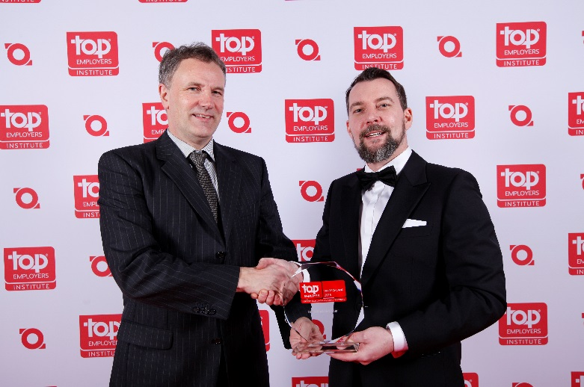
Fri182000400.jpg: Steffen Neefe, DACH Country Manager of the Top Employers Institute (right), presents Jörg Müller, Senior Vice President for Human Resources at the Friedhelm Loh Group, the “Top Employer 2018” award.
May be reproduced free of charge. Please name Rittal GmbH & Co. KG as the source.

Friedhelm Loh Group
A global player, the Friedhelm Loh Group (FLG) invents, develops, and makes made-to-measure products and integrated solutions for manufacturers, distributors, and other businesses. Member companies of the Group lead their respective industries in innovation and quality. They include the world’s leading provider of modular platforms for enclosures, power distribution, climate control and IT infrastructure (Rittal); Europe’s number one supplier of software solutions for mechanical and industrial plant engineering (Eplan, Cideon); and a specialist in integrated manufacturing with state-of-the-art materials – steel, aluminium, and plastics – (Stahlo, LKH).
The family-owned company maintains a worldwide presence, with 18 production sites and 80 subsidiaries. Managed by founder Prof. Friedhelm Loh himself, the Group employs 11,300 people and generated revenues of approximately €2.2 billion in 2016. In 2017, it was named one of Germany’s leading employers by the Top Employers Institute, for the ninth year running. Within the scope of a Germany-wide survey, Focus Money magazine identified the Friedhelm Loh Group as one of the nation’s best providers of vocational training for the second time in 2017.
For more information, visit www.friedhelm-loh-group.com.

